

***SSIQ Recovery Guide***

Windows 10 Enterprise 2016

Recovery User Manual

3/26/2021

***Introduction :***

Razberi ServerSwitchIQ units have a recovery partition that is included with the unit. This factory default image resides on a partition of the main system hard drive as the “R: Drive”. SSIQ units shipped after 6th March 2017, contain a restorable factory image.

Using the backup procedure, a recovery image can be created, allowing a restore of the unit after installing all desired applications and settings. This allows recovery of the system into the exact state and configuration as was implemented at time of system going live.

Please be aware that a system recovery image is specific to the machine, and hardware it was created on. Copying the recovery image to another SSIQ, even with the same hardware will not work. This is because system recoveries contain a GUID which is specific to an algorithm which uses hardware serial numbers to generate that GUID. The same applies to the source of the recovery image, it cannot be copied to other hard drives to be restored later.

***Recovery Overview:***

Before starting, this overview will outline the major steps to complete the recovery process.

The first step will be to prepare a USB flash device to boot the system in a recovery environment. Once the USB is created, the unit can be booted from the USB flash device. A Windows 10 Advanced Recovery environment will load. The steps in this manual outline the use of Advanced Recovery environment to restore the SSIQ Unit. Once complete, the unit will reboot and load to the state of which the recovery image was created.

***Recovery process:***

1.) The first item required is a blank 512MB or larger USB flash drive. If the drive is not empty of any files this process will erase and overwrite the USB drive.

2.) On a workstation other than the system you are recovering, download the USB burn tool SSiQ_Recovery_Win10IOT.exe These files are provided to you from Razberi Technical Support. The file may be zipped, (SSIQ_Recovery.zip) if so unzip to a location on your workstation.

3.) To prep the USB flash drive, insert the USB drive into the workstation that contains the recovery files, locate and execute: SSiQ_Recovery_Win10IOT.exe.

1. Once the program is open, the you will be presented with this window

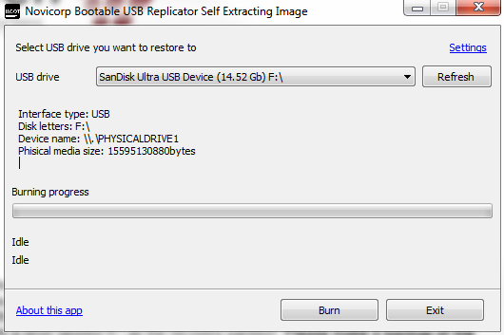

**Figure 1**

5.) In the „USB drive‟ selection, please select the USB flash drive that is inserted in the workstation. If not available, re-insert USB and click Refresh

6.) Once selected, click on “Burn‟ and let the wizard continue to finish.

7.) Once completed, eject the USB drive from your workstation.

***Recovery process: (continued)***

4.) Please insert the USB into the Razberi unit

a. Use the front or back ports on the Razberi, the back ports (blue USB 3.0) are faster. For Rugged Razberi Units, there are only USB ports on the rear and they are all USB 3.0.

b. Please make sure that the Razberi unit also has a keyboard, mouse and monitor. And shutdown the unit if not already powered off.

5.) Power up the machine while tapping the “DEL” key to access the BIOS.

**IMPORTANT NOTE:**

**Step 6a. is to be used with all Razberi ServerSwitch products and Razberi Rugged units manufactured before 8/8/2017 and with Rugged product serial numbers prior to RZ08RQ104000**

**\*\* STEP 6B IS FOR RUGGEDIZED UNITS ONLY\*\***

**Step 6b. is to be used only for Razberi Rugged units that were manufactured after 8/8/2017 with unit serial numbers starting with RZ08RQ104001 and ending RZ08RQ111000. Rugged units with serial number above RZ08RQ111001 will use step 6a.**

6a.) When in BIOS, press the “LEFT ARROW KEY” to access the “SAVE & EXIT” page, then use the down arrow key to navigate “BOOT OVERIDE”, then select the USB device (UEFI: *USBDRIVE*) *USBDRIVE* = the name of your specific USB drive you have inserted.

6b.) When in BIOS, right arrow over to the boot tab, arrow down to Hard Drive BBS Priorities, and Enter. Next select Boot Option 1, press Enter. Select USB Disk Device, press Enter. Next press the ESC key and arrow to Save and Exit. Arrow down to the SMI USB Device Boot Override, with it highlighted press Enter.

7.) Once the system boots from the USB, you will see the below screen to select preferred language.



**Figure 2**

8.) Once the keyboard option has been selected, the user will be presented with the below screen.

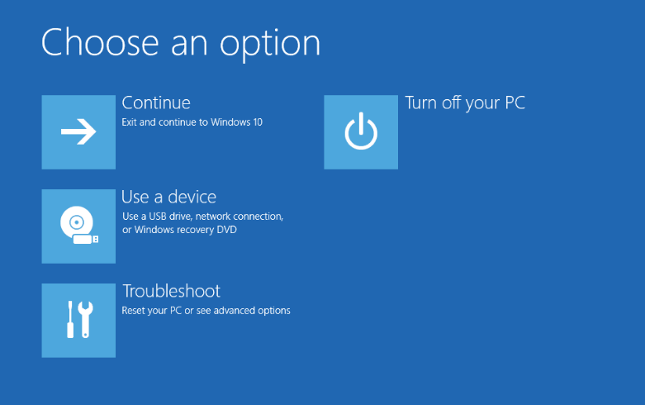

**Figure 3**

9.) To begin the restore process for resetting the unit to the factory default settings click “Troubleshoot”

***Recovery process: (continued)***

10.) The Advanced options are now displayed, select the “System Image Recovery” option, click it.

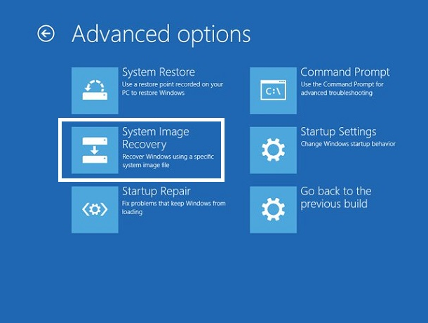

**Figure 4**

11.) In “System Image Recovery” tool the user is presented with selecting which windows environment they wish to recover, on your SSIQ you will select “Windows 10”.

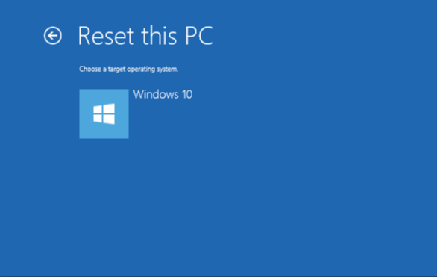

**Figure 5**

12.) The “Re-image your computer” tool will be presented and will discover the recovery volume, and populate the data fields as per when the computer was manufactured. The recovery volume is listed as D: drive here in the recovery environment, this is correct. It will be drive R: in Windows.

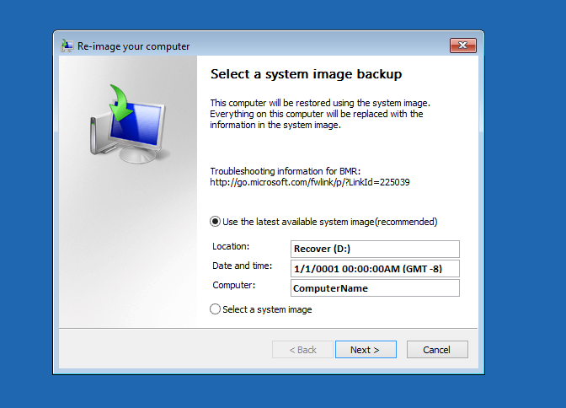

**Figure 6**

13.) Click Next, Next and Finish.

14.) The computer will overwrite the C Drive with the recovery image. This takes about 5 minutes, once complete the system will restart. Once complete the operating system will be in the state at which the last backup was created. If no other backup was created, it will be the factory image.