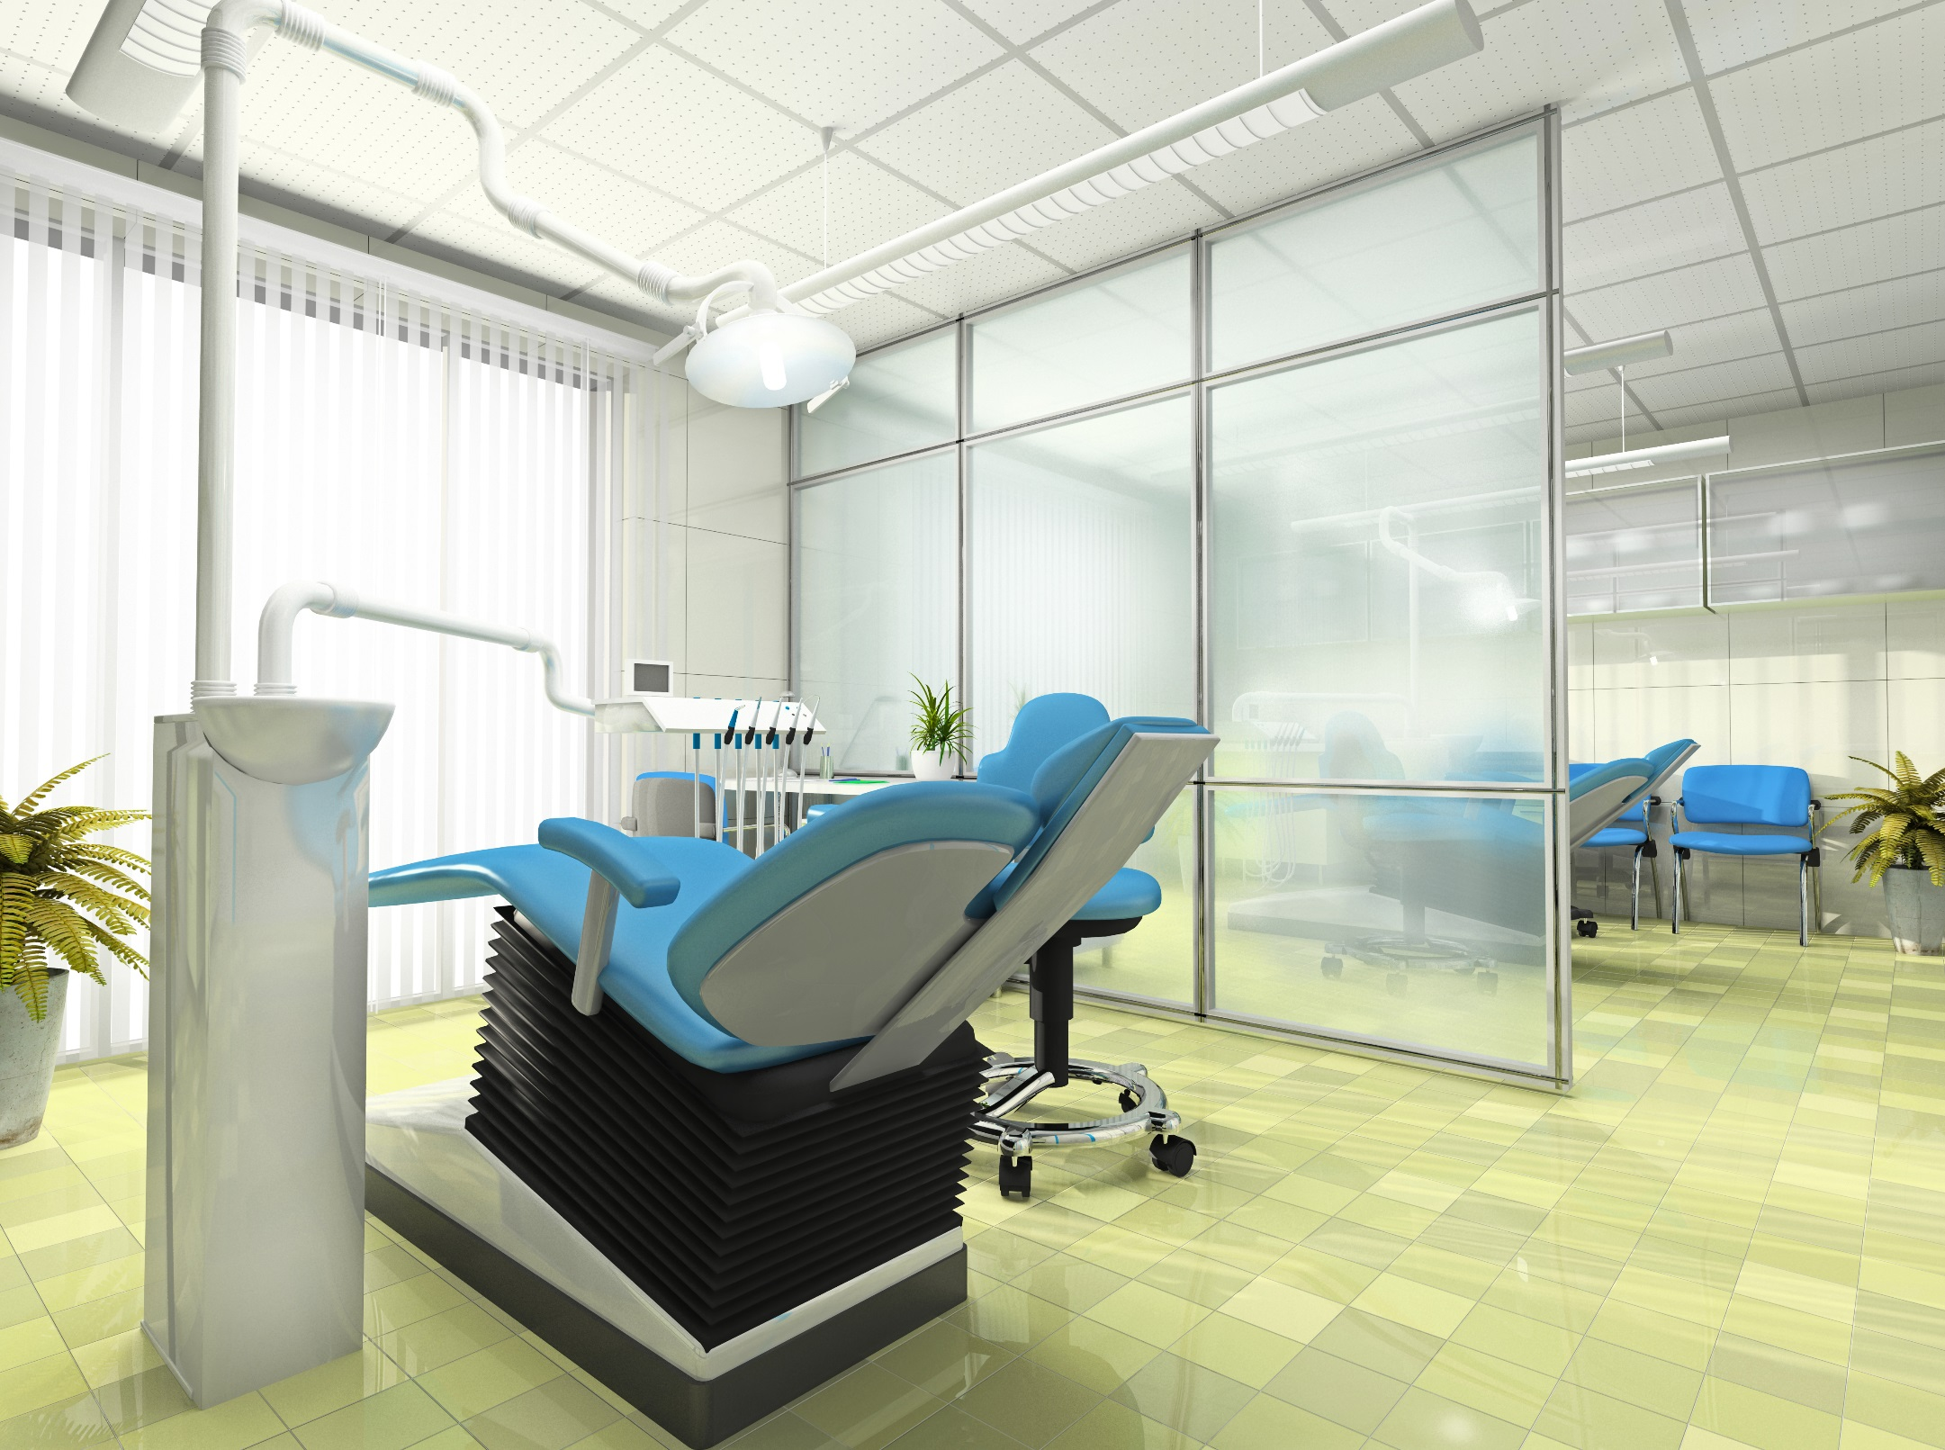

RecallMaxTM COVID-19   
 Recovery and Beyond

Re-opening Announcement

Table of Contents

Your Re-openning Announcement 3

Annuncement Recommendations 3

Sample Announcement 4

**Disclaimer* Information provided contains generalized COVID-19 precautionary health measure information for reference purposes only and should not be used without review and modification to accommodate specific dental college or health authority COVID-19 regulatory measures in your area. This information is not intended to be a substitute for professional advice and is being made available for reference purposes only. RecallMaxTM disclaims any and all liability to any party for any direct, indirect, implied, punitive, special, incidental or other consequential damages arising directly or indirectly from any use of this information.**

**Your Re-opening Announcement**

In addition to informing patients of your re-opening and welcoming patients back, reassuring patients regarding the continued safety of their dental appointments is a top priority in your initial communication once bans are lifted.

Safety measures will need to be explained, and patients will need to be informed of changes to clinic, scheduling, and appointment procedures affecting them. This includes informing patients of COVID-19 appointment screening protocols.

This represents a great deal of information to try to convey to patients in a re-opening announcement and could become confusing for patients. Our recommendation is to provide patients with a summary of high priority information in re-opening announcements, supplemented by a visit guide patients can access for more detailed information. **(See COVID-19 Recovery Resources – COVID-19 Patient Visit Guide for sample.)**

**Announcement Recommendations**

Your announcement can be sent to patients using RecallMax TM  Announcement feature. It can also be posted to your website or social media channels where patients can review or download the information.

The announcement sample on the following page has been provided in a Word file format, so it can be easily edited to reflect the safety measures adopted by your office and other information you feel is important to convey to your patients. Safety measures including instructions related to having patients wait in their vehicles or outside of offices until their appointments begin which some offices are following are included.

We have outlined in **blue** print, local area information you would insert into the guide and practice and procedure information you may wish to provide. Once you are done, copy and paste into your RecallMaxTM  announcement creator. This information can also be copied and pasted onto practice stationary and posted to your website and social media channels, provided as a handout, or sent to patients requesting information as a PDF.

The announcement sample outlines a range of precautionary measures offices are adopting across the dental profession and **should not be used without review and modification to comply with the specific dental college or health authority COVID-19 regulatory measures in your area.**

**Sample Announcement**

**Dear Patient,**

We hope all is well with you and your family during these challenging times.

Many of our patients have been forced to wait for dental care due to the COVID-19 pandemic, and we appreciate everyone’s understanding while we were closed to prevent the spread of the virus. We are committed to providing for the dental needs of our patients and fully restoring services as soon as possible.

We are happy to say our office will reopen for patient treatment on (date) and our hours of operation will be (insert office hours). We are now scheduling dental appointments, and taking extensive precautionary measures to ensure the safety of our patients and staff that we outlined below.

First, we are fully compliant with infection control procedures set by (state / provincial) (dental college or regulatory body) as well as health regulations set by (state / provincial) (CDC / public health or infection control governing body).

We have also changed our appointment procedures and taken other safety measures to provide a safe dental appointment. These include;

* Patients will be required to complete a COVID-19 questionnaire before their appointments.
* For social distancing, patients will be asked to wait in their vehicles or outside of the office until appointments begin.
* Patients will be pre-screened prior to their appointments and again at the entrance to the office.
* Temperature checks will be taken upon entering the practice.
* Disposable face masks and hand sanitizer will be provided upon entrance that patients will be asked to use.
* Modifications have been made to reception and waiting areas to provide for social distancing.
* Magazines, children’s toys, and other items that are difficult to disinfect will be removed from waiting areas.
* The number of patients at any given time in the practice will be limited and appointments will be staggered.
* Common areas including restrooms will be cleaned and sanitized throughout the day.
* Appropriate personal protective equipment (PPE) will be worn by all clinical and administrative staff.
* Staff will be screened for COVID-19 symptoms on a daily basis.
* Treatment rooms will be completely sterilized before patients are seated - extra time will be scheduled in-between appointments to allow for the thorough cleaning and disinfection of treatment rooms and equipment.
* During treatment, our team will strictly follow guidelines set by (CDC, public health, and dental governing bodies).

In addition to the procedures above, we have prepared a (COVID-19 Patient Visit Guide) providing additional details that can be viewed or downloaded from our website at (www.practice name.com).

The safety of our patients is our top priority, and our entire dental team is committed to ensuring your safety and comfort in receiving dental care from our office.

We are looking forward to reconnecting with our patients and providing for your dental needs.

If you have any questions or concerns related to your care after reviewing this information, please contact us directly.

Sincerely,

(Practice Name) and Team