**High Sensitivity Troponin**

**Huddle Message**

There is a new test in town that is going to be a **game changer** for our patients, staff, physicians and organization. The test is called High Sensitivity Troponin (HS TnI). So what’s the difference between the Troponin we have now and the new HS TnI? The obvious answer is sensitivity… so how sensitive is it? Think about these comparisons.

* Weight in ounces is much more sensitive than weight in pounds.
* Time in seconds is much more sensitive than time in hours.

**Studies performed at organizations that use the HSTnI report the following benefits**.

|  |  |
| --- | --- |
| * Earlier, safer rule-out of CP without NSTEMI * Faster turnaround time in ER * Avoid missing small MIs * Earlier diagnosis of NSTEMI | May also lead to:   * Reduction in stress tests * No increase in catheterizations * Potential cost savings |

**HS TnI Facts**

|  |  |
| --- | --- |
| * Can be detected in most healthy individuals | * There are only whole numbers (no decimals) |
| * There are no positive or negative results | * Measurement occurs at hours 0–1 and +/- 3 |
|  |  |
|  |  |

**Chest Pain Facts**

Not all injuries are myocardial infarctions (MI) and not all MIs are Acute Coronary Syndrome (ACS).

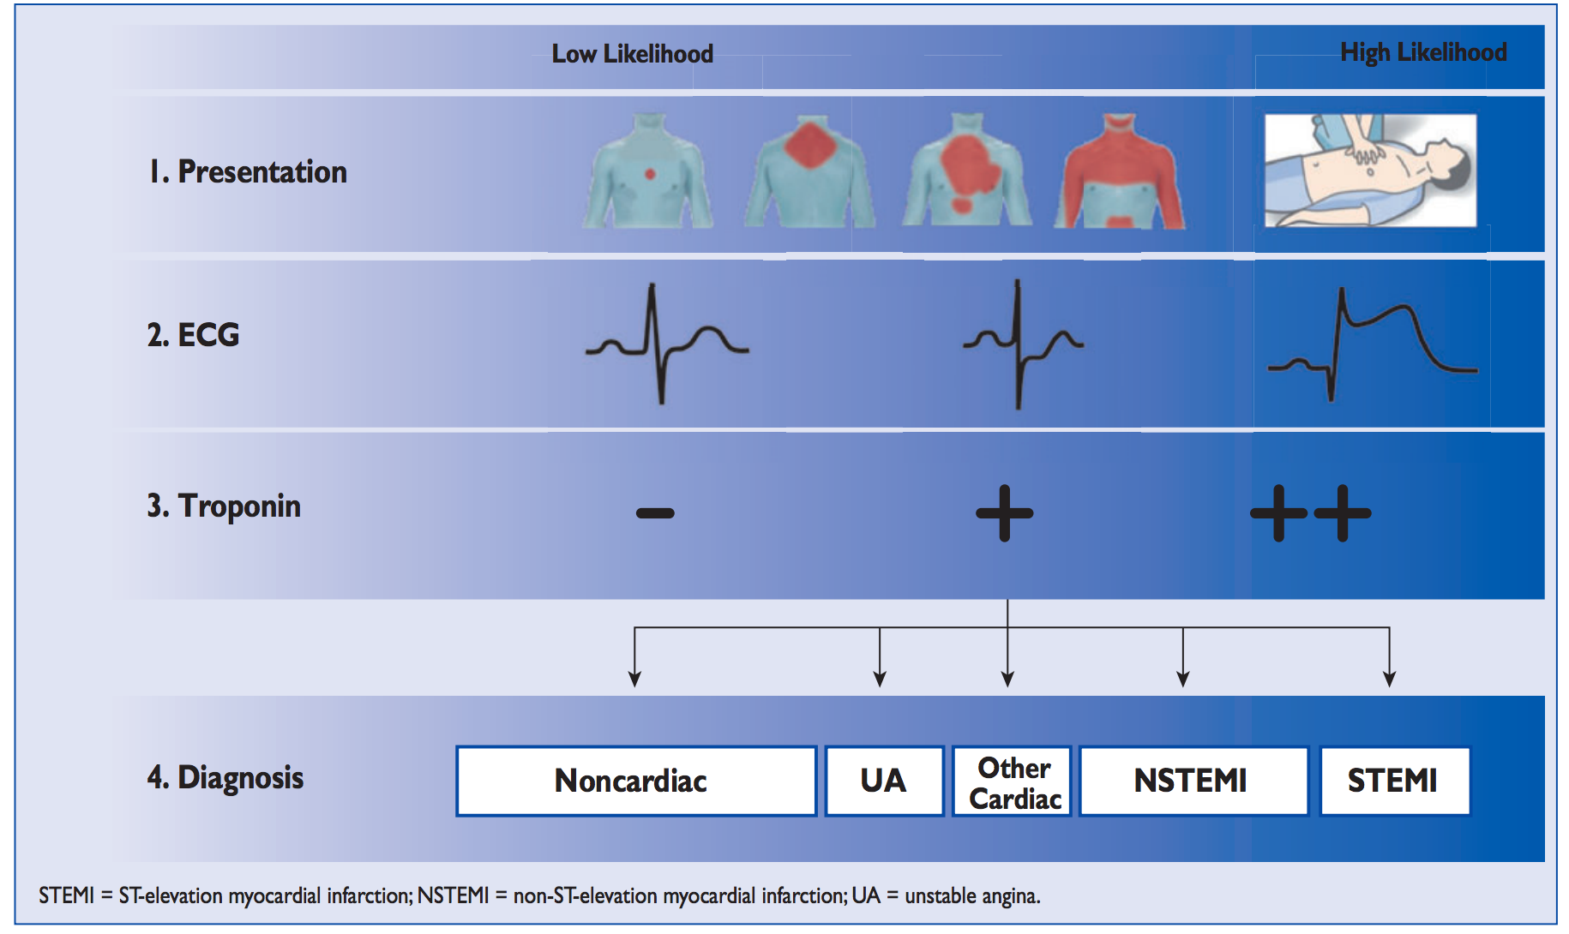

**Case Study: Current TnT versus HS TnI (indicates the sensitivity of the new test)**

|  |  |  |
| --- | --- | --- |
| 60 year old female with no prior medical history except alcohol abuse with two (2) day history of exertional CP, nausea and diaphoresis | | |
| **Time** | **Regular Troponin** | **High Sensitivity Troponin** |
| 0 - hour | < 0.01 | 64 |
| 6.5 - hours | < 0.01 | 83 |
| 9 - hours | 0.04 | 110 |
| The patient developed an anterior T wave inversion on 12 Lead EKG. Cardiac catheterization demonstrated her left anterior descending (LAD) artery was 80% occluded. The patient had a percutaneous coronary intervention (PCI). | | |

**HS TnI Protocol: Clinical Judgement Supersedes the Protocol**

* Measurement **changes from** hour 0-2-4 **to** hour **0–1–3 (3 dependent upon values & delta)**
* HS TnI tests require a dark green top tube filled to the top (1/2 filled minimum)
* Laboratory staff will call critical values of **> 107 ng/L** to nursing staff
* Nursing staff will call critical values to physician staff

**Note**: HS-TnI may be elevated in patients with chronic diseases such as heart failure and CKD. However, during acute events, a significant change or delta will be noted.

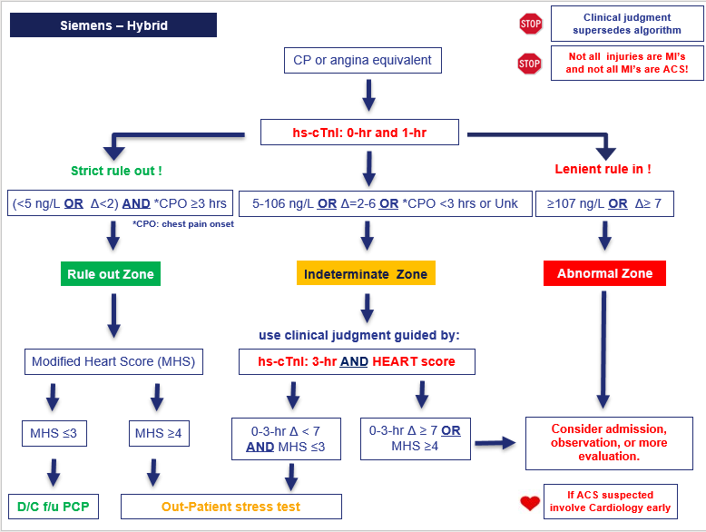

If you have comments or questions please contact your Chest Pain Coordinator.

CPO: Chest Pain Onset; NSTEMI: Non-ST Elevation Myocardial Infarction; STEMI: ST Elevation Myocardial Infarction