

**EHR**

**Update**

Dialysis Charging Education

**PROCESS**

* **Complete the SLED/SCUF, HD or PD documentation.**
* **At the end of the documentation the nurse will be directed to a screen to enter the charge.**
* **Charges are generated when these queries are documented:**

1. **SLED/SCUF: “SLED/SCUF hepatitis B status verified:”**
2. **HD: “Dialysis stop time:”**
3. **PD: “PD fill start time:”**

**Complete the SLED/SCUF, HD or PD treatment documentation per usual.**

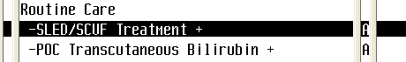

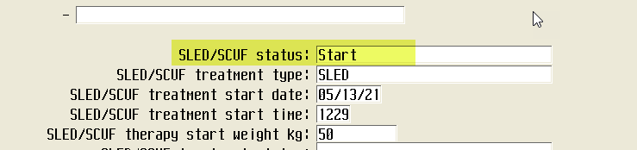

**After filing the documentation, you will be led to Order Management. Enter the Ordering Provider and Order Source of “Z” for department process.**

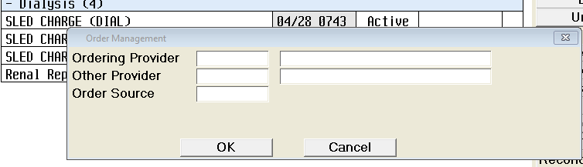

**Then click ‘Submit’ and the charge for the treatment is created.**

