Note to Users:
- This template is used for CoreValue Advisor Software customer training and support, and in Drive Growth: the Business Advisor Bootcamp, offered through the NACVA
- This template, Strategic Project Plan, is built based on the 3 Dimensions of Business Growth, and is intended to help CoreValue-powered advisors create a valuable deliverable using the CoreValue Deep-Dive Analysis and Executable Growth Plan
- The Pro Tip footnotes have specific instructions which will guide your use of CoreValue resources when creating your own deliverable
- We train advisors to be peers to the CEO, in two roles: Architect, and General Contractor
  - The Architect is the operational analyst completing the Deep-Dive Analysis, educating the CEO about the ‘what’ and ‘where’ of operational weakness
  - The General Contractor manages project execution, holding the senior team accountable to success
- Remember, project planning and execution do not require subject matter expertise in any of the growth and equity value drivers. If you have expertise in key areas - for example, CPAs and Fractional CFOs have expertise in financial reporting, operating reports, margin, etc. - write down your superpower, and leverage it in your engagements
- No one knows more about their company than your client, and specific subject-matter expertise should exist inside the company; mentor through gaps with on-demand consulting expertise - look to your referral network, or call on the CoreValue-powered advisor community for help
We are glad to help with questions, please email support@corevalueforadvisors.com.

Strategic Project:
Create Predictable Profit and Cash Flow

Table of Contents
Section 1: Introduction and Executive Summary 3
Toplift LLC Vision and Strategy: 3
Business Objective: Create Predictable Profits and Cash Flow 3
Current Situation 4
Project To Date 6
‘Launchpad’ Project Plan 6
Section 2: Growth and Equity Value Drivers 8
Senior Management: Confidence in Management Processes 52% 9
Human Resources: Confidence in People Processes 48% 10
Recurring Revenues: Confidence in Recurring Revenue 49% 11
Margin: Confidence in Creating Margin Advantage 36% 12
Financial and Operating Reports: Confidence in Financial Reporting Process 65% 13
Sales Plan and Sales Process: Confidence in Performance 61% 14
Operations: Confidence in Future Performance 68% 15
Customer Satisfaction: Confidence in Measuring and Maintaining 40% 16
‘Project Launchpad’ Timeline 17
Appendix 1: Scope of Engagement, Fees 18
Appendix 2: Suggested Tasks to Remove Bottlenecks to Growth 19

Section 1: Introduction and Executive Summary

Toplift LLC Vision and Strategy:
[This is pulled from the Client’s business profile/web page. If the client does not have a Vision and Strategy statement, choices are (1) a consulting project to define the client’s vision and strategy, which is inserted here, or (2) to use one of the 3 Dimensions of Business Growth as the Vision, with this document serving as the internal strategic plan]

Business Objective: Create Predictable Profits and Cash Flow
To improve operational performance so as to better execute the company’s Vision and Strategy, the CEO and Senior Team have hired GrowthDrive to prepare and manage this project. The project has been named ‘Launchpad’, through which the senior team intends to:
- Improve operational performance,
- Such that Toplift can predictably and sustainably generate profit of $600M (3Q21 annualized),
- With positive cash flow,
- Reaching this objective by August 31, 2021
Because the ultimate measure of business success is Enterprise Value, the potential value growth for relevant equity value drivers is calculated and discussed throughout.
By successfully achieving Project Launchpad's goals, Toplift will create several options including the option to pursue Predictable Revenue Growth. Predictable Profit and Cash Flow is the launchpad for growth; this project is the first phase towards Toplift’s 3 year strategic goal of increasing EBITDA to $725M and equity value to $3.6MM.

Current Situation
Chart 1: Business Detail for Toplift Inc.
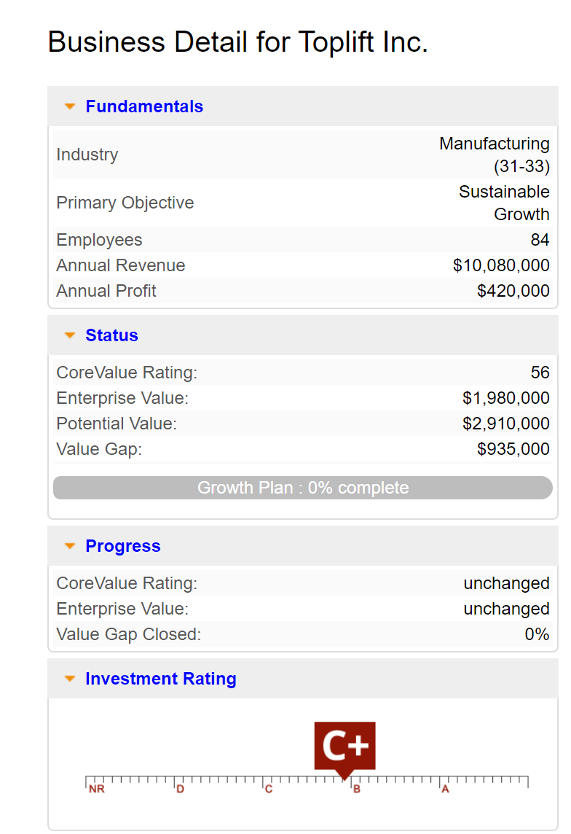
‘Business Detail’ Terminology
Primary Objective: Toplift has stated a long-term goal of creating Sustainable Growth. The first step toward this goal is creating predictable profit and cash flow, which provides the launchpad for funding growth.
CoreValue Rating 56: The CoreValue Rating is a score of operational strength. Think of the CoreValue Rating as a Confidence Index. Toplift’s CoreValue Rating of 56 means we can be 56% confident that Toplift can predictably generate revenues and profits going into the future. A high rating means the business presents a low risk profile.
Enterprise Value: this is a calculation of the value a financial buyer would place on Toplift after completing due diligence. Due diligence is designed to identify company-specific risks. Enterprise Value is the value of the company net of the cost of risk.
Potential Value: this is Toplift’s equity value to a financial buyer if Toplift could be valued at the top end of the industry’s normalized range of trading multiples. Reaching the Potential Value is accomplished in significant part by achieving a CoreValue Rating ~80 at today’s Gross Revenue and EBITDA.
Value Gap: the Value Gap is calculated by subtracting Enterprise Value from Potential Value. The Value Gap is the cost of company specific risks: Potential Value net of Risk Discount equals Enterprise Value.
Investment Rating C+: The investment rating measures transparency. C+ means Toplift can generate most but not all of the documentation a lender or investor would request during due diligence. Since outside capital is not currently sought, GrowthDrive recommends a secondary focus on this rating. The primary focus is creating predictable profits and cash flow; as Launchpad is executed GrowthDrive will also focus on increasing the investment rating, efficiently delivering additional return from the project.

Chart 2: Overview of Current Growth and Equity Value Driver Scores. Toplift must increase the rating of eight key areas from status quo to 7.
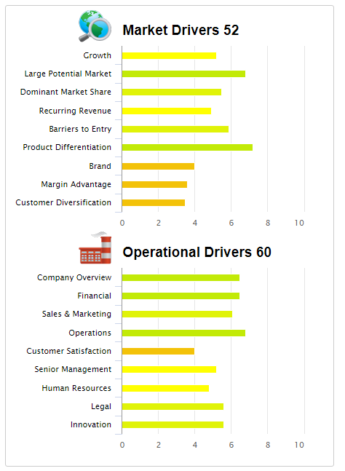
Chart 3: Red Flag Threats to Growth and Equity Value which must be neutralized - see Senior Management in Section 2:1.
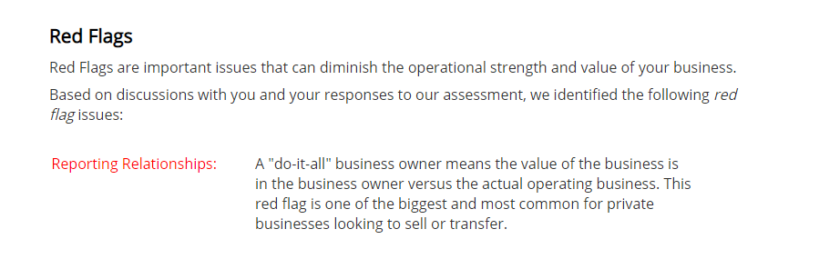

Project To Date
To date, GrowthDrive has:
- Met individually with each Toplift Senior Manager to analyse business performance and confirm team alignment
- Met with the Senior Team to perform a Deep-Dive Analysis of Toplift operations
- Facilitated a workshop with the Toplift Senior Team to analyze and discuss roles and responsibilities, and to get team consensus on improving performance. Results of this workshop helped create Chart 4: Growth Driver Goals and Accountability; and will be incorporated into Toplift’s “Roles and Accountability” Organizational Chart, with enhanced job descriptions.
- Results of the Deep-Dive Analysis are the building blocks for this Strategic Project ‘Launchpad’ Plan

‘Launchpad’ Project Plan
There are 8 high-priority Growth and Equity Value Drivers which must each achieve a rating of 7 or higher to help Toplift create predictable profits and cash flow.
Project Timeline and Success Metrics: Sprints
This project is divided into eight sprints. A sprint is a subset of the overall plan that will be completed, reviewed, and implemented.
- The sprints are sequential and mutually supportive
- The initial goal is to pass the threshold 70% confidence rating in each process
- Higher confidence will be achieved over the long term
- Note: It is critical that once threshold confidence is achieved, it is maintained and increased into the future.

Chart 4: Growth Driver Goals and Accountability
Growth Driver: | Accountable | Current Score | Target Score | Best Practice Goal:
Senior Management | CEO | 52 | 70 | The business has an aligned senior team in place that understands the company Vision and Strategy, and is accountable to successfully executing the Strategy.
Human Resources | President | 48 | 70 | The business has the ability to find, develop, and retain quality individuals, with well-defined roles and accountability that enables success in all aspects of your business.
Recurring Revenues | CFO | 49 | 70 | The business can rely on a portion of future revenue from contractually committed customers.
Margin | CFO | 36 | 70 | The business enjoys gross and net margins greater than the industry norm.
Financial & Operating Reports | CFO | 65 | 70 | The chart of accounts clearly reflects the business Toplift is in, enabling fast and effective communication both internally and externally, and Toplift routinely generates the standard set of three statements (income, balance sheet and cash flow). Financial operating reports are routinely generated and used by management to review the business's performance and make operational decisions.
Sales Plan & Process | President | 61 | 70 | The business has a sales plan and repeatable sales process to deliver revenue goals that are well-developed, managed, and executed.
Operations | President | 68 | 70 | The business has the ability to deliver on the sales promises made to the marketplace and to do it in a systematic and process-driven manner.
Customer Satisfaction | CEO | 40 | 70 | The business tracks and uses key measures to meet customer expectations at all levels.

Section 2: Growth and Equity Value Drivers
This section lists each of the eight high-priority growth and equity value drivers which are strategic imperatives for creating predictable profits and cash flow. They are:

- Senior Management: Confidence in Management Processes 52%
- Human Resources: Confidence in People Processes 48%
- Recurring Revenues: Confidence in Recurring Revenue 49%
- Margin: Confidence in Creating Margin Advantage 36%
- Financial and Operating Reports: Confidence in Financial Reporting Process 65%
- Sales Plan and Sales Process: Confidence in Performance 61%
- Operations: Confidence in Future Performance 68%
- Customer Satisfaction: Confidence in Measuring and Maintaining 40%

Senior Management: Confidence in Management Processes 52%
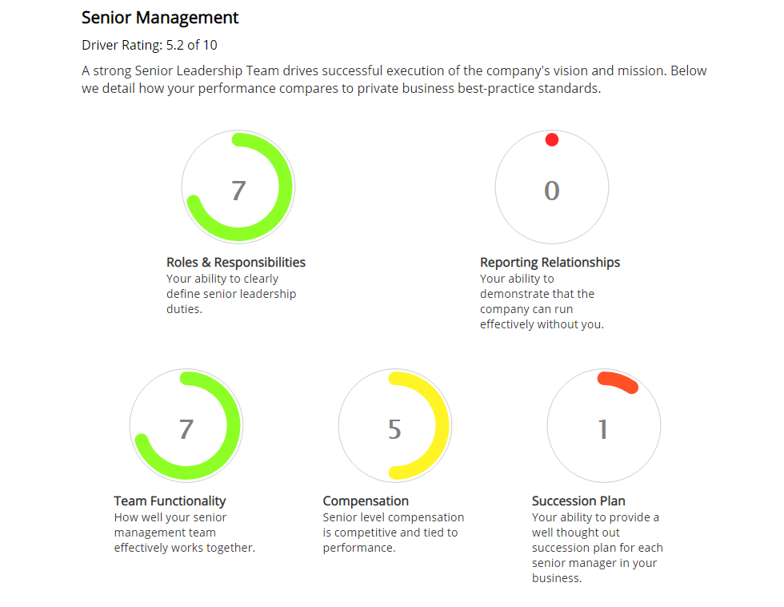
Project Goals: a strong senior leadership team drives successful execution of the company’s vision and strategy. We intend to:
- Refine accountability for the senior team to successfully execute business processes. See Financial and Operating Reports.
- Delegate key CEO accountabilities to Senior Team, freeing time for the CEO to focus on new and evolving strategic goals, and on increasing equity value.
- Compensation is not adequately tied to performance: evolve compensation plan, including ability to participate in increased equity value
- Create a personnel plan for each senior manager that ensures a smooth continuation of the business in case a change in senior management occurs
- Strengthening the Senior Management rating with neutralize the Reporting Relationships Red Flag

Human Resources: Confidence in People Processes 48%
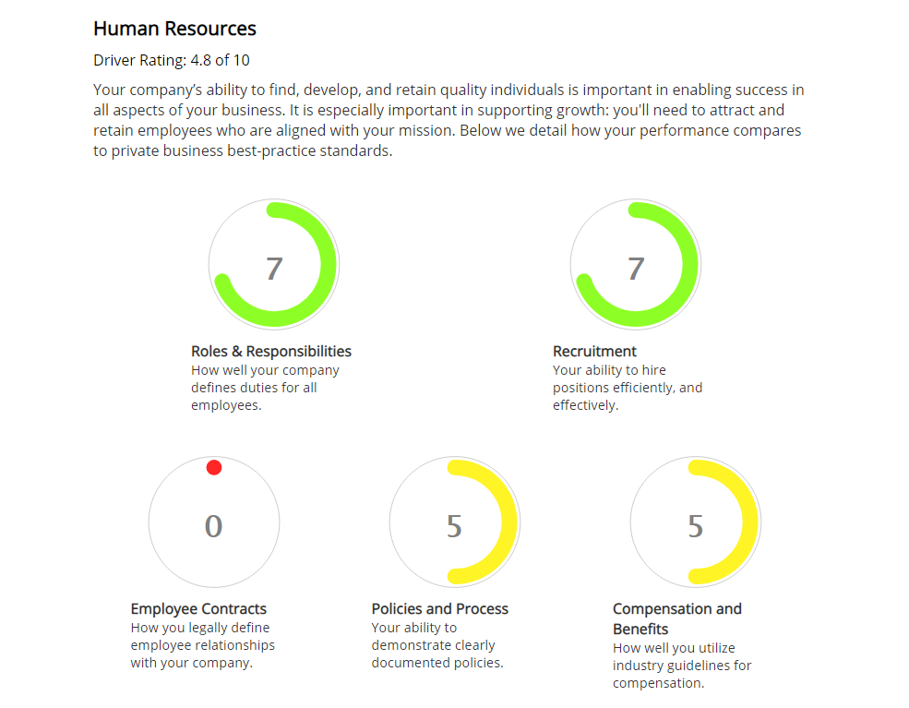
Project Goals: it is critical that employees understand the company vision and strategy, and their role in successfully achieving Toplift’s goals. We intend to:
- Roles and Responsibilities: Review and update as necessary taking into account Operating Reports and Senior Team accountability. See Financial and Operating Reports.
- Recruitment has a score of 7, and will simply be monitored to maintain this score.
- Employee contracts are not relevant in this industry. However, Non-Disclosure, Non-Compete and Non-Raid provisions are relevant, as are ‘work for hire’ protections ensuring Toplift processes and innovations created by employees in their work capacity are protected as company intellectual property.
- Policies and Process: complete review with the objective of complying with best practices in documentation, record keeping, issue resolution, and regulatory compliance.
- Compensation will be reviewed and updated as necessary to align with industry best practices for pay scale and individual performance, as well as tied to overall corporate performance.

Recurring Revenues: Confidence in Recurring Revenue 49%
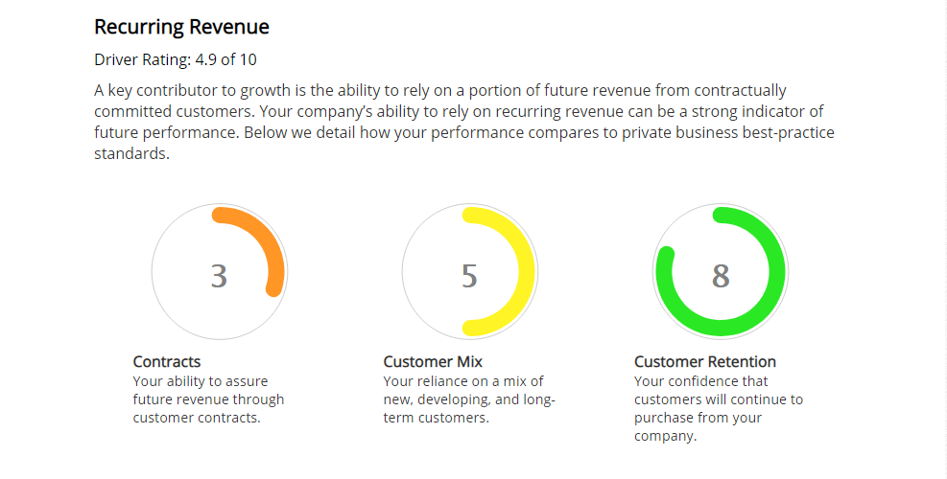
Project Goals: Recurring Revenues are a key contributor to predictable profits and cash flow. We intend to:
- Create contracts and other assurances of future revenue that accounts for over 75% of annual revenues
- Implement a process ensuring Toplift has a mix of new, developing and long-term customers
- Articulate 3 reasons why customers will continue to purchase from Toplift; these will be directly linked to other growth drivers

Margin: Confidence in Creating Margin Advantage 36%
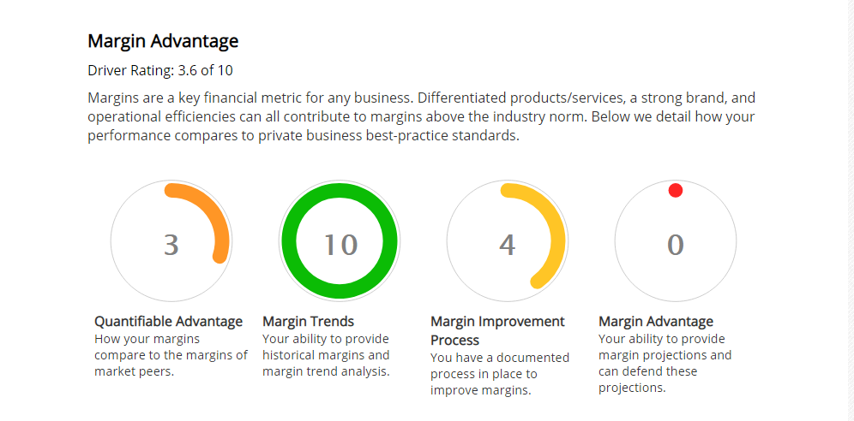
Project Goals: Launchpad will result in creating predictable profit and cash flow. Margin is the source of profit and cash flow. Sustainably exceeding industry gross and net margins is a strategic imperative of Launchpad. We intend to:
- Gain a clear understanding of Toplift gross and net margins as they compare to the industry niche
- Implement a documented, rigorous process to constantly improve margins
- Implement a forward-looking, defensible process to ensure future margin advantage

Financial and Operating Reports: Confidence in Financial Reporting Process 65%
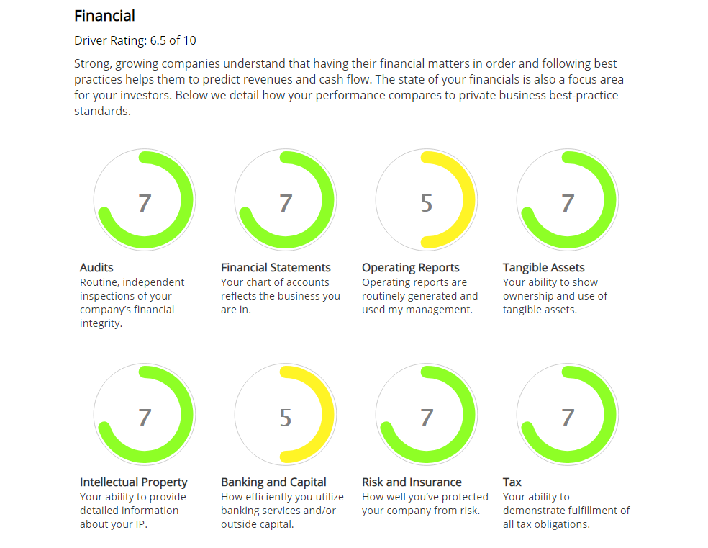
Project Goals: ‘Predictability’ of profit and cash flow depends on accurate forward-looking Operating Reports which are used to forecast financial results. In turn, backward-looking Financial Reports - P&L, Balance Sheet, and Cash Flow - must each be prepared timely and accurately. The goal is to accurately forecast financial results. We intend to:
- Review previous 12 months financial reports for accuracy; implement any required changes in financial reporting to ensure near-perfect accuracy
- Implement a process to deliver financial reports to the CEO (for review and distribution) as follows: P&L and Balance Sheet by the 5th business day of the month; Statement of Cash Flow by 12:00 noon the first working day of each week
- Operating Reports: identify the top 6-12 metrics which track business success, analyze these as trends, and implement a trend improvement process; the result must be a list of performance predictors allowing the accurate forecasting of profit and cash flow
- Efficiently utilize banking services, with the ability to obtain and manage outside capital (debt or other)

Sales Plan and Sales Process: Confidence in Performance 61%
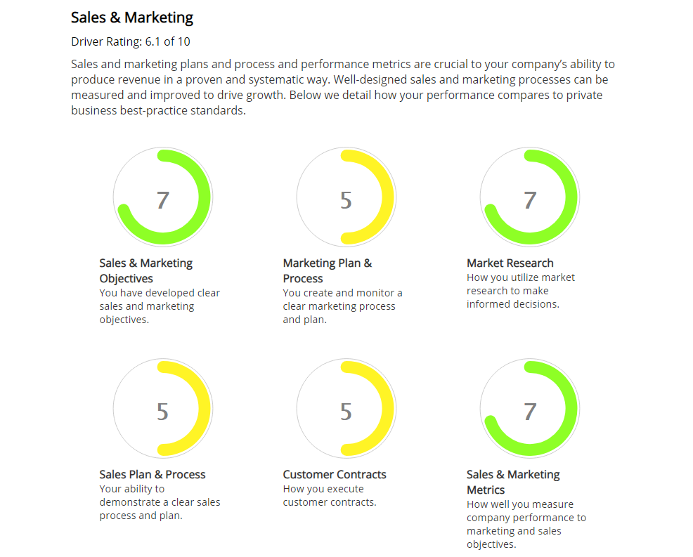
Project Goals: focus of this project is on sales, as opposed to marketing. Sales can connect high Customer Satisfaction to Recurring Revenues. Coupled with a quantified sales process in which the opportunity pipeline accurately predicts new gross revenue (see Operating Reports), the sales organization will become the tip of the ‘predictability’ spear. We intend to:
- Implement processes enabling a score of 10 in Sales Objectives
- Implement a Sales Plan and Repeatable Sales Process to deliver Toplift’s revenue goals that are well-developed, managed, and executed
- Sales Objectives: regularly measure how well the company is meeting its sales (and marketing) objectIves, including the accuracy of the Sales Pipeline, Revenue against Plan
- Implement a documented process to measure sales performance

Operations: Confidence in Future Performance 68%
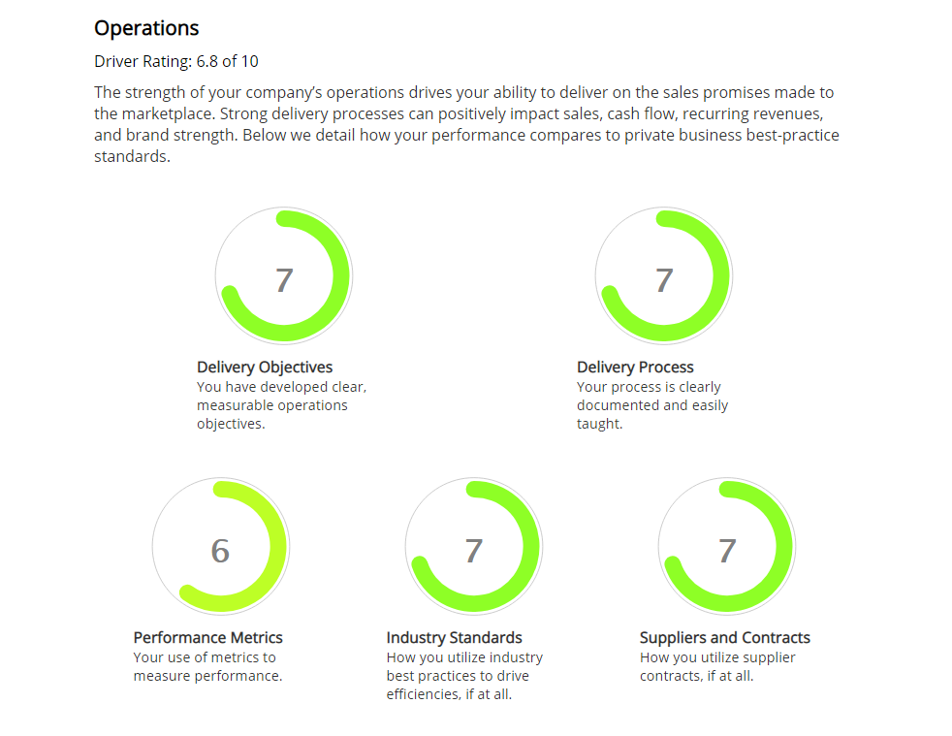
Project Goals: Recurring Revenues and High Customer Satisfaction both depend on Operations delivering on the promises made to the market by Sales, and doing so in a proven and systematic way. We intend to:
- Create metrics to track core aspects of the delivery process and we use them regularly
- Monitor each Operations sub-driver to ensure their rating remains ~7
- Communicate routinely with Sales and Finance to create a closed loop of opportunities, operational delivery, and financial results

Customer Satisfaction: Confidence in Measuring and Maintaining 40%
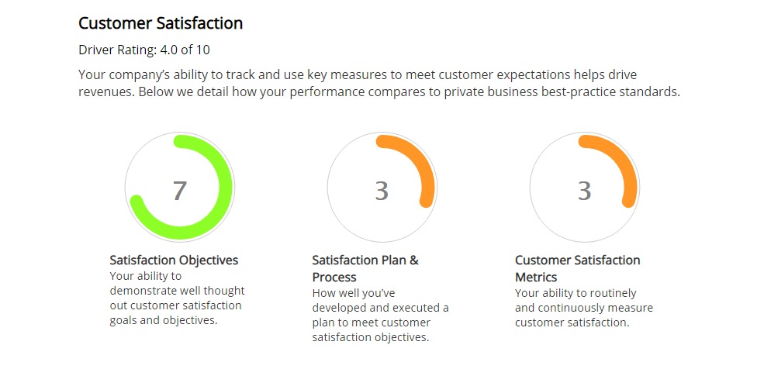
Project Goals: although a lagging indicator, Customer Satisfaction requires quality in line with value and customer expectations, accurate commitments from sales, and efficient delivery by operations. High customer satisfaction makes sales easier, promotes recurring revenues, and helps increase margins. We intend to:
- Confirm, and evolve as required, customer satisfaction goals
- Communicate Customer Satisfaction Goals internally and externally
- Develop and execute a plan to meet customer satisfaction objectives
- Routinely and continuously measure customer satisfaction
- Base additional company-wide discretionary compensation to a ratio of high customer satisfaction scores and net margin

‘Project Launchpad’ Timeline
The project is being executed in eight sprints over the next 3 quarters (9 months).

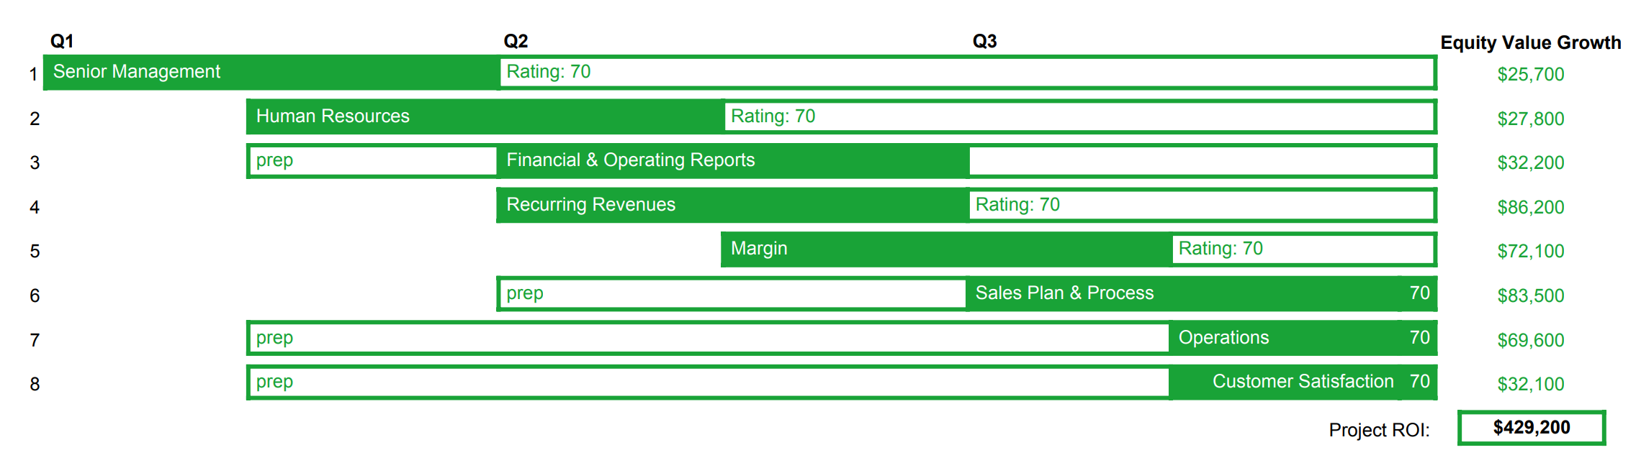

- Senior Management and Human Resource best practices will be implemented in Project Q1
- These are the building blocks for the balance of the project
- Once implemented, each area will be monitored to maintain the 70 rating
- Several areas require sprint prep, as indicated; since accountability is shared across the senior team, demands are spread over time allowing each senior manager to balance this project with their existing responsibilities
- Project Launchpad’s return on investment, as measured in captured equity value, is $429,200

Appendix 1: Elements of ‘Scope of Engagement’ and ‘Fees’
Appendix 2: Suggested Tasks to Remove Bottlenecks to Growth and Equity Value (Full List)

Appendix 1: Scope of Engagement, Fees
[Varies based on engagement. Engagement Letters and Contracts should be approved for use in engagements by the advisor’s attorney. The following is for discussion purposes only, to illustrate potential services and fees, and is not intended for use with clients:
GrowthDrive Advisors has been retained by Toplift LLC to provide the following services:
- Analysis of Toplift Operations
  - The analysis results were presented to management on November 12, 2020; attached as Appendix 1
- Strategic Project Planning: GrowthDrive has developed the timeline and supporting success metrics to reach the defined Launchpad goals, which are presented together in this Strategic Project Plan
- Preparing for Project Execution: Senior Management Roles and Responsibilities Workshop. This 2 hour workshop facilitated by GrowthDrive provides for senior management input and discussion about the best team architecture for plan execution. Based on the workshop GrowthDrive, working with the CEO, will create an updated Organizational Chart, including Job Descriptions and Accountabilities (role-based success metrics)
- Strategic Project Execution: GrowthDrive will work with the senior team, providing coaching and execution support. This includes scheduled meetings and individual/team coaching. ‘Launchpad’ Execution Meeting Schedule:
  - Every 2 weeks for the first 3 months
  - Monthly thereafter
  - On demand, as reasonably requested by the CEO
- Fees:
  - Analysis and Report: $7,500, paid in full
  - Flat-fee engagement, including Workshop, Strategic Planning, and Execution Support: $60,000, paid on the first of each month in equal monthly retainers of $5,000. No early termination; renewal at Toplift LLC discretion
  - Additional Budget: Toplift has agreed to allocate an additional $20,000 of discretionary funds to be applied as needed by the CEO to supporting projects]

Appendix 2: Suggested Tasks to Remove Bottlenecks to Growth
Suggested Tasks are identified actions you can take to grow and improve the value of your business. The CoreValue Task List is a complete list of suggestions we offer to improve your Value Gap. We list them below in descending order sorted by value gap.
Some tasks will be quick to accomplish, inexpensive, less disruptive, and have a high ROI –- we believe you should do those first. They get you moving quickly, drive momentum, and provide you and your team real measurable improvements.
Category | Value Gap |  | Suggested Task
Contracts | $59,100 | 6.3% | Lock Down Your Customers  Where possible, execute contracts with your most important customers so you have some guarantee of future revenue. If contracts are difficult or not feasible in your industry, get creative and think of ways to ensure future business. Do you have a hot location that drives traffic and your business? Then get a long-term lease. Do you have happy customers? Create a loyalty program to ensure they keep coming back to buy from you versus your competitors.
Margin Advantage | $22,500 | 2.4% | Project Your Future Gross/Net Margins  Create projections showing improving gross and net margins, and be able to support your assumptions behind these rosy projections.
Capital | $19,300 | 2.1% | Document And Organize All Capital Agreements  Organize and document agreements with all investors/parties (both internal and external) who provided capital to the company in any form. It's a good idea to have a Cap Table for your company which shows on one chart how your company is capitalized.
Future Customer Diversification | $16,900 | 1.8% | Document A Plan To Diversify Your Customer Base  Even if you have revenue concentration with just a few customers now, document a plan on how you will add new customers over time and reduce your reliance on just a few customers.
Market Definition | $15,800 | 1.7% | Quantify The Size Of Your Market  Determine how big your market is ($). If you don't have the data on hand, there are many on-line resources you can tap. You can even extrapolate the market size, as long as you document your assumptions.
Competitive Monitoring | $14,100 | 1.5% | Document How You Monitor Competition  Take the time to document how your company monitors competition.
Proof of Differentiation | $13,500 | 1.4% | Quantify The Uniqueness Of Your Products/Services  Quantify the uniqueness of your product or service. For example, if you have a product that is uniquely reliable, take a look at your return rates. For a service that touts quick turnaround time, quantify how quickly you deliver this service versus your competitors, etc.
Capital Barriers Documentation | $11,300 | 1.2% | Document Capital Barriers  Document and organize critical capital barriers to entry, especially if you suspect that the capital barriers are fairly high for your market.
Financial Differentiation | $11,300 | 1.2% | Improve Your Gross Margins  Demonstrate that you have quantitative proof of differentiation, by product or service, and make sure that you can show a pricing and/or cost advantage over its competition.
Trend Analysis | $11,300 | 1.2% | Document And Diversify Your Customer Base  Diversify your customer base, and make sure to document your progress over time. Showing growing diversification, even if you still have significant customer concentration now, will at least show you're moving in the right direction.
Process | $10,700 | 1.1% | Create A Process To Tap And Protect Innovations  Create and document a process to encourage, capture, and protect innovation among your employees.
Margin Improvement Process | $10,100 | 1.1% | Document Your Process To Improve Margins  Document your process for improving margins. Make sure your process includes a way to continually track and measure progress.
Succession Plan | $9,600 | 1.0% | Create Succession Plans For All Senior Managers  Create a personnel plan for each senior manager that ensures a smooth continuation of the business in case a change in senior management occurs.
Legal Barriers Documentation | $5,600 | 0.6% | Document Legal Barriers  Document and organize your legal barriers to entry: licenses, and/or contracts, plus patents, trademarks and/or copyrights that clearly define the protection and the extent of the protection (this protection may include regulatory protection).
Market Barriers Documentation | $5,600 | 0.6% | Document Market Barriers  Document and organize your market barriers to entry. Make sure to include how you created these market barriers and how you will protect them. Examples include brands, licenses, trade secrets, exclusive agreements, location, etc.
Company Story | $4,700 | 0.5% | Communicate Your Company's Story  First, make sure you can succinctly give an "elevator pitch" or a 1 minute topline summary on your company (what it does, the history, why it is successful, etc). Then, make sure everyone in your company understands your company's story and can communicate it clearly (both written and orally) as well. Having everyone aligned around the basic information about your company is essential; it's the glue that holds a company together and ensures that there is a consistent message to the outside world.
Strategic Direction | $4,500 | 0.5% | Create A Strategic Plan For Your Company  Create a strategic plan that supports the owner's personal goals. This plan should include a vision and mission, business model, business goals, objectives, and an executable plan (tactics).

Pro Tip: if internal expertise is not up to this portion of the project, consider on-demand HR expertise to audit and update HR processes and to mentor existing staff.
Pro Tip: this goal paraphrases the highest
Pro Tip: To further understand the importance of stated intent by leadership, see Commander’s Statement of Intent, Call Sign Chaos: Learning to Lead, Mattis and West 2019. See also Turn the Ship Around, Marquet 2012.
Pro Tip: In lower middle market companies the CEO often holds a critical role in sales. Resist the temptation to make others accountable for sales success. Rather than delegating sales, consider mentoring others to adopt the CEOs successful habits and slowly democratize these into the organization. This reduces risk and positions the company for growth.
Pro Tip: These screenshots were taken from the Growth Strategy Report. Pros also often use the Operational Value Report, especially when they want to illustrate the link between process and equity value.
Pro Tip: CoreValue Discover, the initial assessment of company strength and value, can be used individually with team members by emailing each a link. The results are then compared by the advisor. Typically, Discover is completed first by the CEO, then by the senior team. This also serves to educate the senior team about business process best practices.
Pro Tip: the CoreValue Software ‘Projections’ module helps run ‘What if?” scenarios. Here, hitting goal is based on S.M.A.R.T objectives of 10% Net Margin; average 20% annual growth, and increasing the CoreValue Rating to >70. See CoreValue Driver ‘Sales & Marketing’ 12:1:2 “Your objectives are S.M.A.R.T. (specific, measureable, ambitious, realistic, and timely) and include priorities, milestones, and targets.”
Pro Tip: definition of CoreValue Rating see CoreValue Advisor Knowledgebase: CoreValue Rating
Pro Tip: definition of Investment Rating see CoreValue Advisor Knowledgebase: Investment Rating
Pro Tip: Workshops and other consulting projects can be planned by using the CoreValue Executable Growth Plan for topic and success metric guidance.
Pro Tip: screenshot from Business Review: Reports: Rating. For a definition of Red Flags, Investment Rating and other terms visit www.corevalueforadvisors.com/knowledge
Pro Tip: in CoreValue Software, see Company Overview: Strategic Direction.
©2020 ‘3 Dimensions of Business Growth’ and related materials are protected intellectual property of George Sandmann and/or Drive Growth LLC. All rights reserved. www.drive-growth.com
Pro Tip: Increasing and/or maintaining the CoreValue score for relevant growth drivers can serve as a success metric. Compliance would be peer reviewed amongst the senior team.
Pro Tip: this is a straight copy-and-paste from the final section of the CoreValue Software “Operational Value Report”. To view, in the Client section of your CoreValue Advisor Dashboard click on the desired client, then click the ‘Operational Value Report’ button and scroll to the last section.
‘Predictable Revenue Growth’ is Dimension 2 fo the 3 Dimensions for Business Growth. ©2020 George Sandmann and Drive Growth LLC, www.drive-growth.com

