The safety and health of our members, team members, and guests are always Crunch's top priority. San Francisco now requires gyms and health clubs to admit patrons who are fully vaccinated against COVID-19, which means two doses of the Pfizer or Moderna vaccine and one dose of Johnson & Johnson (Janssen). We will begin accepting proof of vaccination status at all San Francisco Crunch locations starting August 20th and electronically through our secure link below today, August 17th . Per the City’s mandate, we will limit gym access to only those vaccinated beginning August 20th.

After August 20th, all gyms and fitness centers in San Francisco will restrict facility access to those who are not fully vaccinated against COVID-19 under the city’s mandate. Masks must be worn at all times while in the gym.

We will note proof of vaccination status on your member account for future visits. There are two ways to do this:
- The easiest way to provide proof of vaccination is to pre-validate your status before coming to the gym. We invite you to upload your proof of vaccine via this unique link before August 20th. This link is unique to your membership, do not pass this email to others.
LINK
Please give our team up to three business days to process your information.
We will temporarily store that information while our Member Services team verifies the documentation. Once our verification is complete, we will delete your file upload.
- Or, beginning August 20th, you can provide proof of vaccination in-club with one of the following three options:

1 | 2 | 3
Showing your CDC COVID-19 Vaccination Card  (or a photograph of the card) | Digital COVID Vaccine Record | Approved Private App
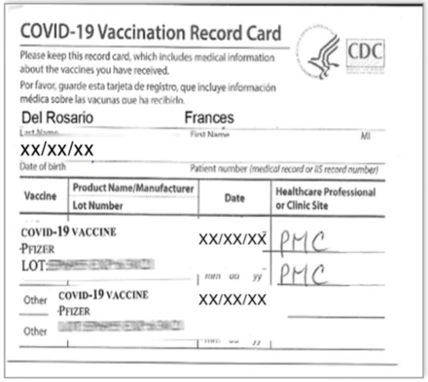 | 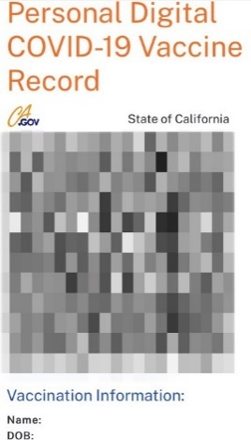 | 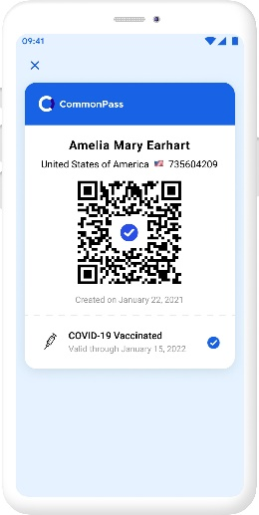

You are only required to show proof of your COVID-19 vaccination status once. When you provide your proof in-club, we will review but not make or store a copy of your vaccination card. If you forget your documentation, you can still access the club until August 20th. After that date, you must provide proof of vaccination status to access the gym.

Click here for more information about the San Francisco mandate.

