Now Introducing: DeliverNow

A new on-demand delivery option for your parts orders!

We want to make sure you get the right [Insert OEM] parts – and fast! To get parts to you quickly, we are now offering a NEW delivery option when you order through RepairLinkShop.com.

What do you need to do?
It's easy! Simply order [Insert OEM] parts through RepairLinkShop.com to take advantage of this same-day delivery option. When you place your order, let us know in the "Delivery Preference" menu that you need "ASAP Delivery."

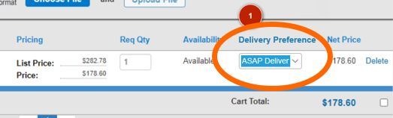

Order your parts now at RepairLinkShop.com

