- Happy #RadTechWeek Facebook feed image:
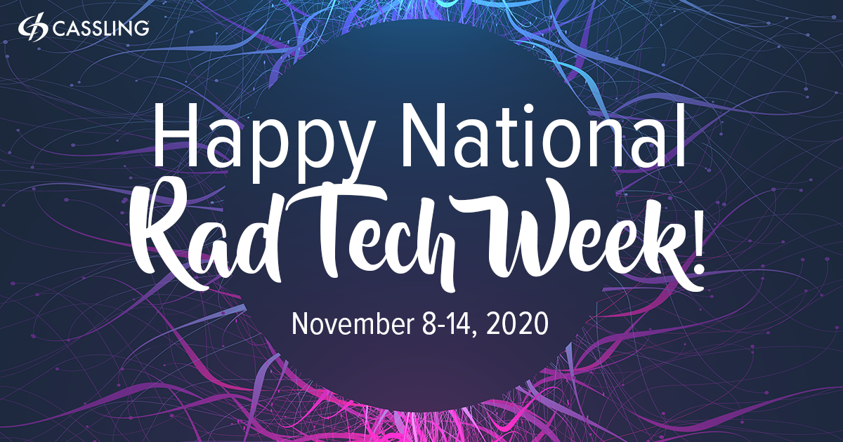

- #Radiology Facebook feed image:
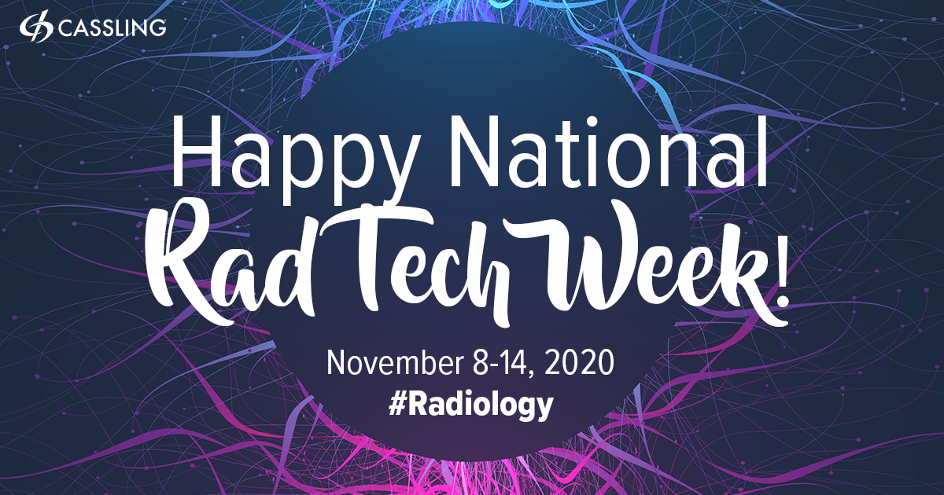

- #NuclearMedicine Facebook feed image:
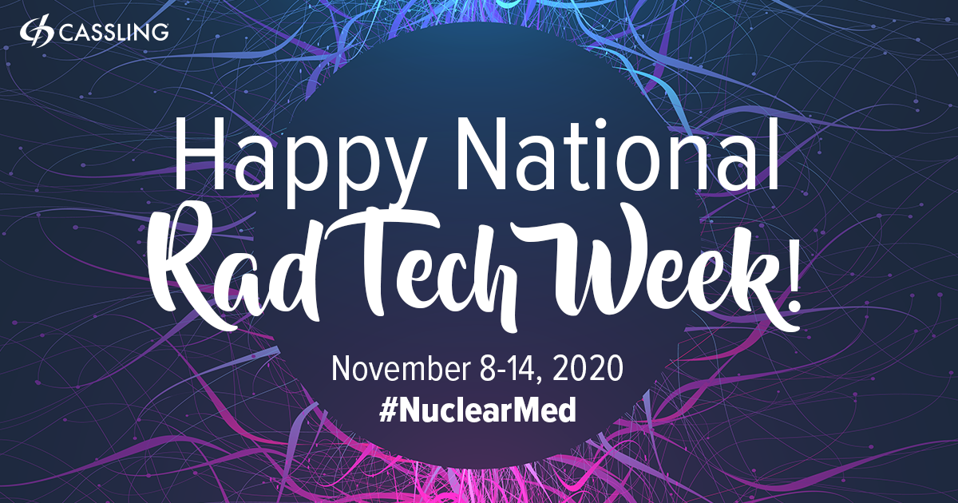

- #Mammography Facebook feed image:
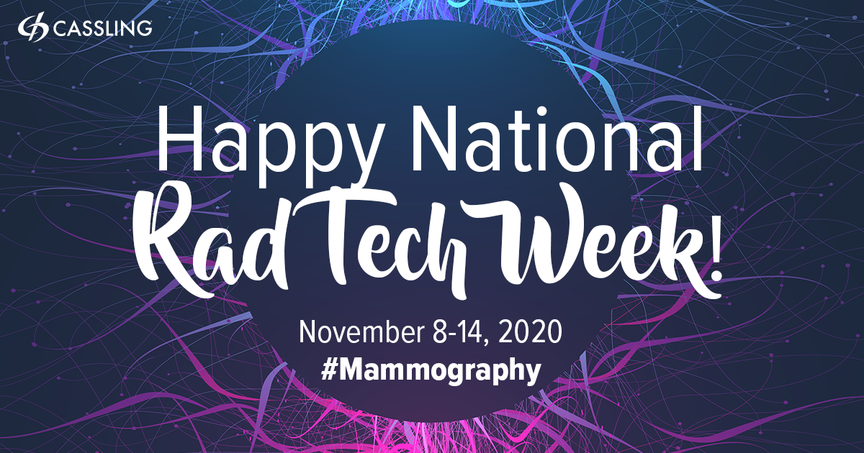

- #ComputedTomography Facebook feed image:
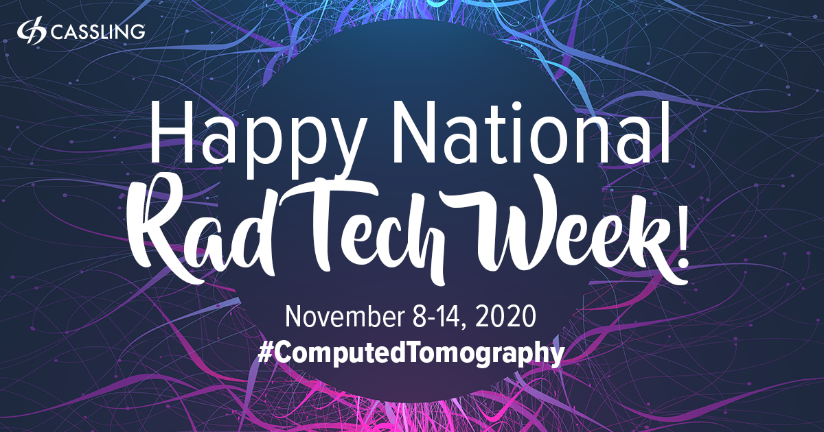

- Thank you Facebook feed image:

- #EmitExcellenceEveryday Facebook feed image:

