horizontal line****

**FitLot Program Planning Guide**

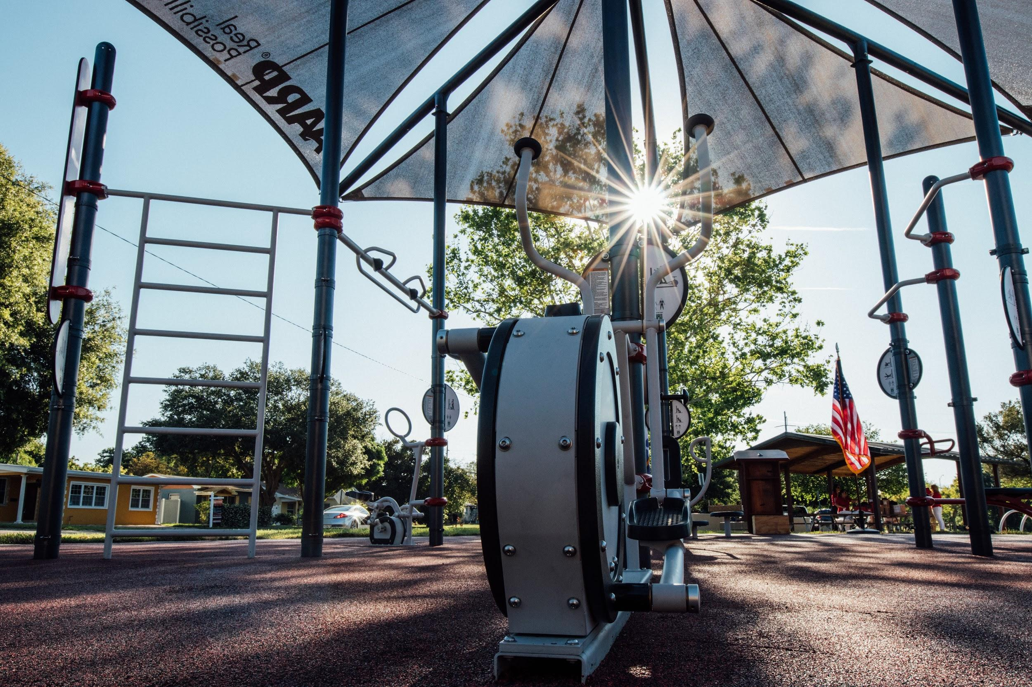

Activate Your

AARP Sponsored Outdoor Fitness Park

**Table of Contents**

# Introduction

# Grant Timeline

# Planning Classes

# Budget Breakdown

# Coach Requirements

# Structure of a FitLot Class & Responsibilities of a FitLot Coach

# COVID-19 Considerations

# FitLot Program Contact



Introduction

Let’s activate your AARP Sponsored Outdoor Fitness Park! Your FitLot was designed to be inclusive of all adult ages and abilities. FitLot, Inc’s mission is to help you build a community and culture of fitness that spreads beyond the edge of your new fitness park. This guide will show you how your grant dollars can be utilized to provide high quality, no-cost community classes led by qualified local fitness professionals. This unique outdoor fitness park, along with free classes, creates opportunities for any community member to learn how to safely and properly use their new fitness equipment. FitLot is here to support you along the way.

*The following information was previously shared in the program grant agreement.*

**Purpose of Grant:**

Your recreation department will use the grant to program your AARP Sponsored Outdoor Fitness Park. These funds will be used to engage community members in physical activity by hiring certified fitness professionals to lead no-cost, community FitLot Method classes at the outdoor fitness park.

|  |  |
| --- | --- |
| **Grant Use #1 - Fitness Class Funding**  **$3,510.00**  ***(renewable in year 2 and 3 according to terms)*** | **Grant Use #2 - Facebook Outreach Campaign $500.00**  ***(one-time)*** |
| * To be used by municipality to provide at least fifty-four (54) community fitness classes each grant period; funds are used to pay local fitness professionals and cover some administrative costs for the fitness classes * Municipality shall not begin Fitness Classes until one (1) week after the Facebook Outreach Campaign begins for the outdoor fitness park. | * To be used by municipality to promote the outdoor fitness park and class registration to community members using a ten (10) week templated Facebook campaign (provided by FitLot). * Funds shall be used to boost the templated outreach campaign through Facebook’s promotion/marketing platform. |

**Obligations of the Municipality & FitLot, Inc.**

* Your municipality will be solely responsible for program management - including all community coach staffing, outreach, participant recruitment/registration, and scheduling.
* For the first grant period, funds must be used within eighteen (18) months from the date funding is received by your department. Subsequent funding periods will be renewed on an annual basis.
* FitLot will provide the funding, social media outreach toolkit, coaches training system, and a registration system for the Fitness classes.

**For questions about program implementation, please reach out to programs@fitlot.org.**

Program Grant Timeline

|  |  |
| --- | --- |
| **What** | **To-Do** |
| **Agreement Review** | Review and execute grant agreement. Then return to Grants@FitLot.org |
| **FitLot Distributes Funds** | FitLot mails your grant funds via check |
| **Program set up** | Visit [FitLot.org/hub](http://fitlot.org/hub) for all the information you will need to successfully set up and organize your FitLot classes |
| **Onboarding Forms** | Fill out the [Program Onboarding Form](https://docs.google.com/forms/d/e/1FAIpQLScktM2BDxSxdLhzswJDtqeta21ko1nISx7AFFD1goMxC6IKHA/viewform) and [Class Schedule Template](https://f.hubspotusercontent00.net/hubfs/4039355/Program%20Materials/FitLot%20Class%20Schedule%20TEMPLATE.xlsx) to share important information FitLot will need to organize your registration system and park page.  *Review [this checklist](https://f.hubspotusercontent00.net/hubfs/4039355/Program%20Materials/Program%20Onboarding%20Checklist.pdf) before starting form to ensure you have all the info |
| **Unique Park Webpage** | FitLot will send you your parks unique FitLot landing page link |
| **Registration System Access Granted to City Admin** | Your City’s Program Manager will be invited to register their Eventbrite account and publish classes. |
| **Begin 10-week Outreach Campaign** | **One week prior to your first class**, start promoting your FitLot Program with the10-week templated Facebook (FB) Outreach Campaign linked at FitLot.org/hub. Use the $500 “social media” grant funds to “boost” posts. |
| **Your FitLot Classes Begin** | A minimum of 54 Classes with 8+ registrants and participants are led by FitLot Neighborhood Coaches during each funding period. |
| **Complete the 10-week Facebook Campaign** | Download and complete the [Facebook Outreach Campaign Reporting Spreadsheet](https://f.hubspotusercontent00.net/hubfs/4039355/Program%20Materials/FitLot%20Facebook%20Campaign%20&%20Reporting%20Template%20for%20Hubspot.xlsx)to report on your 10-week social media campaign. |
| **Grant Renewal: Year 2 & 3** | Any unused funds must be donated by your department to your local YMCA or a health-focused local non-profit, as approved by AARP and FitLot at the end of each grant cycle.Funds for the remaining 2 years of the grant period are determined annually by FitLot and AARP based on execution and fulfillment of the grant requirements. |

Planning Your FitLot Classes

FitLot Classes are designed so adults of all ages and abilities have the opportunity to work with a local fitness professional and be part of building an active community.

There are three types of one-hour classes this grant supports. The goal is to incorporate each of these class types into your normal program seasons.

**FitLot Class Types**

|  |  |
| --- | --- |
| **FitLot Method Introduction Classes** | * Participants learn proper form, safe equipment use, and the format of FitLot’sCircuit Training classes in a slower-paced instructional setting. * FitLot suggests participants attend an introductory class before registering for an ongoing 8-week FitLot Method Circuit Training Session or a drop-in class. * FitLot suggests offering intro classes once a month during program seasons. |
| **FitLot Method 8-Week Series** | * Participants develop a routine practice of physical activity under the guidance of a fitness professional and alongside a committed group of community members who are also working to achieve a more active lifestyle.      * Encourage participants to attend 70% of the classes **hosted twice a week for the 8-week series.** *8 weeks is recommended, though a minimum of 6 weeks and a maximum of 10 weeks is acceptable.* |
| **FitLot Method Drop-In Classes** | * Participants can do a full 1-hour FitLot workout without having to sign up for the commitment of an 8-week series of classes. |

**Tips for Creating your FitLot Program Schedule**

The calendar and charts below are examples, guides or suggestions. When creating your FitLot Program schedule, the main goals are:

* Provide at least 54 classes each grant year and according to the grant terms (within 18-months for the first grant period).
* Provide a combination of each class type per program season.
* Set up your program schedule in a way that best integrates with your climate and your department’s typical recreation seasons.
* Start your FB Outreach Campaign at least one week before the start of your first FitLot Program classes.

**Sample Program Schedule**

Ultimately, your outdoor fitness class schedule will be determined by many factors. Below are some suggestions and examples to help you create a successful programming year. Here are some key factors to consider:

**FIRST:** Determine two seasons during the year you can offer 9-weeks of outdoor fitness classes.

* **Example:** Season 1 (Spring) April 14 - June 22
* **Example:** Season 2 (Fall) August 14 - October 22

**NEXT:** Develop your calendar to include all 3 class types.

|  |  |  |
| --- | --- | --- |
| **(3) FitLot Intro Classes**  Schedule at least one class prior to the start of the 8-Week Series | **(16) Series Classes over 8 weeks**  Schedule classes twice per week and at least 48 hours apart. Registrants should commit to attending 70% of classes. | **(8) Drop-In Classes**  Schedule 1 per week, every week of the 8-week Series. |

**How many classes do you have scheduled? Remember, 54 total!**

|  |  |  |  |  |  |
| --- | --- | --- | --- | --- | --- |
| **# of FitLot Method Intro Classes**  **3** | **+** | **# of FitLot Method 8-week Series Classes**  **16** | **+** | **# of FitLot Method Drop-In Classes**  **8** | **= 27** |

**THEN:** Plan your social media outreach schedule. It should be a 10-week campaign with 2 posts each week.

|  |  |  |
| --- | --- | --- |
| **Season #1 (Spring)** | | **Season #2 (Fall)** |
| **Start Facebook Campaign:**  Post #1 and Post #2 should be made at least one (1) week *prior to* the first FitLot Class in your first 9-week Season.  **End Facebook Campaign:**  Post #19 and Post #20 should be visible on your FB page during the last week of classes. | | **You are not required to run another 10-week Facebook Outreach Campaign for the second 9-week Training Season of FitLot classes**, but you are free and encouraged to continue to use the social media toolkit and posts for future FitLot Programs that are supported by this program grant. |

**Sample Calendar for 9-Week FitLot Program Season #1**

|  |  |  |  |  |  |  |  |
| --- | --- | --- | --- | --- | --- | --- | --- |
|  | | | | | | | |
|  | **MON** | **TUES** | **WED** | **THUR** | **FRI** | **SAT** | **SUN** |
| **START Outreach Campaign** | **14**  **FB Post #1** | **15** | **16** | **17**  **FB Post #2** | **18** | **19** | **20** |
| **Intro Week 1** | **21**  **FB Post #3** | **22**  **Intro Class** | **23** | **24**  **FB Post #4** | **25** | **26** | **27** |
|  | **MON** | **TUES** | **WED** | **THUR** | **FRI** | **SAT** | **SUN** |
| **Week 2** | **28**  **FB Post #5** | **29**  **8-week Series Class** | **30**  **FB Post #6** | **1**  **8-week Series Class** | **2** | **3**  **Drop-In Class** | **4** |
| **Week 3** | **5**  **FB Post #7** | **6**  **8-week Series Class** | **7**  **FB Post #8** | **8**  **8-week Series Class** | **9** | **10**  **Drop-In Class** | **11** |
| **Week 4** | **12**  **FB Post #9** | **13**  **8-week Series Class** | **14**  **Intro Class**  **FB Post #10** | **15**  **8-week Series Class** | **16** | **17**  **Drop-In Class** | **18** |
| **Week 5** | **19**  **FB Post #11** | **20**  **8-week Series Class** | **21**  **FB Post #12** | **22**  **8-week Series Class** | **23** | **24**  **Drop-In Class** | **25** |
| **Week 6** | **26**  **FB Post #13** | **27**  **8-week Series Class** | **28**  **FB Post #14** | **29**  **8-week Series Clas** | **30** | **31**  **Drop-In Class** |  |
|  | **MON** | **TUES** | **WED** | **THUR** | **FRI** | **SAT** | **SUN** |
| **Week 6** |  |  |  |  |  |  | **1** |
| **Week 7** | **2**  **FB Post #15** | **3**  **8-week Series Class** | **4**  **Intro Class**  **FB Post #16** | **5**  **8-week Series Class** | **6** | **7**  **Drop-In Class** | **8** |
| **Week 8** | **9**  **FB Post #17** | **10**  **8-week Series Class** | **11**  **FB Post #18** | **12**  **8-week Series Class** | **13** | **14**  **Drop-In Class** | **15** |
| **Week 9**  **End of FB Campaign** | **16**  **FB Post #19** | **17**  **8-week Series Class** | **18**  **FB Post #20** | **19**  **8-week Series Class** | **20** | **21**  **Drop-In Class** | **22** |

Program Budget Breakdown

The FitLot Program Grant of $3,510 for the fitness classes is meant to support your Parks and Recreation Department in hosting high-quality, publicly-accessible outdoor fitness classes. These funds should support the hiring of local fitness professionals at $30-40 an hour as well as the administrative costs of managing this program.

A budget of $3,510 breaks down to $65 a class for 54 classes. We suggest paying a maximum of $40 an hour to your coaches and allocating $25 a class towards administrative costs. This budget of $40/$25 allows at least 54 classes to be hosted at the park each year, the minimum requirement.

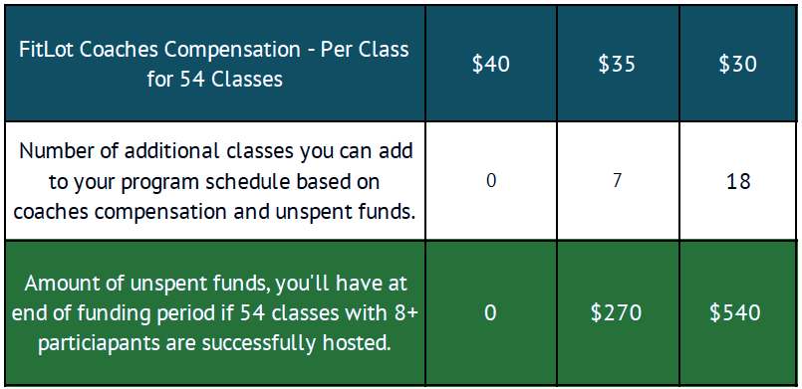

Please ensure payment for instruction falls in line with your standard practices to allow for long term sustainable programming. If less administrative support is needed to manage this program, admin dollars can be applied to hosting additional classes at the park. Admin funds can be utilized to purchase FitKit Resistance bands, which are needed to fully activate the park. Each coach should be equipped with 3 combo sets (a set of medium and heavy resistance bands) which can be ordered at [FitLot.org/FitKit](https://fitlot.org/fitkit/).

Any unspent coaches compensation funds can be used to host additional classes during the funding term. If your department is unable to utilize all of the funds during the funding period we ask that any remaining unspent funds be donated to a local health serving 501c3 before we disburse your following funding period grant.

**What Counts As a Qualifying Class?**

To fully qualify for the 54 classes sponsored by AARP, there must be at least 8 registrants and 8 participants. These guidelines help ensure the grant funds awarded will have the most community impact possible. Below is a chart to better understand what will, and will not, qualify as one of your 54 sponsored classes.

|  |  |
| --- | --- |
| **IF...** | **THEN...** |
| 8+ people register, but less than 8 people actually attend a class | **This counts as one of the 54 classes.**  The coach is paid the coaching fee, but the admin funds ($25) are forfeited. These admin dollars are considered unspent funds to be donated at the end of the grant term. |
| 8+ people register, and 8 people or more actually attend a class | **This counts as one of the 54 classes.**  The coach is paid the coaching fee, and you actualize the admin funds. No amount ($65/class) would go toward unspent funds. |
| If fewer than 8 people register, but 8 people or more actually attend a class | **This counts as one of the 54 classes.**  The coach is paid the coaching fee, and you actualize the admin funds ($25). No amount of the $65 would go toward unspent funds. |
| If fewer than 8 people register and less than 8 people actually attend a class | **This does not count as one of the 54 classes.**  Either cancel the class in advance, increase your registration outreach efforts, or pay for the coaches time out of a separate budget i.e. admin support funds previously actualized. The coach is not paid the coaching fee from grant funds and admin funds are forfeited for this class. The admin dollars are considered unspent funds to be donated at the end of the grant term.  Before the grant term ends, you have an opportunity to add another class to reach the goal of 54 qualifying classes. |
| If a class is cancelled due to weather or other extenuating circumstances | **This does not count as one of the 54 classes.**  You have the opportunity to reschedule a qualifying class to reach 54 classes per grant term. |

FitLot Neighborhood Coach Requirements

## A FitLot Neighborhood Coach...

1. Must hold a currently valid personal training or group fitness instructor certification through one of the organizations below*:
   * **AASFP** (Asian Academy for Sports and Fitness Professionals), **ACE** (American Council on Exercise), **ACSM** (American Council on Sports Medicine), **ACTION** (Action Personal Trainer Certification), **AFAA** (Aerobics and Fitness Association of America), **AFPA** (American Fitness Professionals and Associates), **BCRPA** (British Columbia Recreation and Parks Association), **canfitpro** (Canadian Fitness Professionals Inc), **BOC** (Board of Certification for the Athletic Trainer), **CHEK** (Corrective Holistic Exercise Kinesiology Institute), **CI** (Copper Institute), **FAI** (Functional Aging Institute), **CSEP** (Canadian Society for Exercise Physiology), **IFPA** (International Fitness Professionals Association), **ISSA** (International Sports Sciences Association), **NAFC** (National Association for Fitness Certification), **NAFTA** (National Aerobics & Fitness Trainers Association), **NASM** (National Academy of Sports Medicine), **NBHWC** (National Board for Health & Wellness Coaching), **NCCPT** (National Council for Certified Personal Trainers), **NCEP** (National College of Exercise Professionals), **NCSF** (National Council on Strength and Fitness), **NESTA** (National Exercise & Sports Trainers Association, Inc), **NETA** (National Exercise Trainers Association), **NFPT** (National Federation of Professional Trainers), **NPI** (National Posture Institute), **NSCA** (National Strength and Conditioning Association), **NSPA** (National Strength Professionals Association), **PTAG** (Personal Training Academy Global), **REPs** (Register of Exercise Professionals) **NZ & UAE**, **SCW** (Sarah’s City Workout), **W.I.T.S** (World Instructor Training Schools)
2. Should have consistent availability to lead classes for the duration of a programming season
3. Recommend having 2 or 3 coaches trained and prepared to lead classes
4. Should complete FitLot’s online training at <https://fitlot.org/become-a-coach/> before teaching any classes
5. It is ideal for the coaches to have experience working with seniors or leading community fitness classes

***\*Please obtain and save a copy or verification of each coach’s certification document***

*\*The listed organizations are fitness training certifying bodies that IDEA Health & Fitness Association recognizes as an approved continuing education provider. IDEA Health & Fitness Association is a 36 year old membership association and leading resource for fitness and wellness professionals. If you do not see a certification on this list, we recommend sending your coach through one of the certification programs listed above.*

Class Structure & Coaches Responsibilities

The following is an overview for program managers to better understand the coaches’ responsibilities and functions that are expected within the grant requirements.

**Setting Up For Class**

1. Coach should arrive at least 15 minutes before class is scheduled and be prepared with: bluetooth speaker, circuit training timer app, playlist, and 3 sets of FitKit Resistance Bands. The coach should check park equipment for any damage and functionality, sanitize park equipment, and do a sweep for trash or other hazards.
2. The coach must check-in or register ALL participants using the Eventbrite Organizer app & confirm they have a signed liability waiver.
3. As long as there is one participant, start on time and make sure to end on time.

**Introducing & Beginning the Workout**

1. The coach should introduce him/herself as a FitLot Neighborhood Coach, including name and training experience. Next, the coach will explain the format of the 1 hour workout: the timer, warm up, circuit training and cool down/stretch.
2. Set timer: 40 seconds work / 20 seconds transition (example setting)
3. 4-6 warm up movements.
4. Count the number of participants and then set them each at a station.
5. Demonstrate and explain the movement at each station. What the movement is, proper posture, what muscles they are using. Clearly explain each exercise and then have the participant demonstrate proper form. Correct form until proper.

**Workout Circuit Training Structure & Rounds**

1. In total, participants should go through 22--28 stations (Performing 1 exercise per station). The coach works participants around the FitLot from large muscle groups to smaller muscle groups. Coach should vary muscle groups between movements. Upper body, lower body, core, cardio. Repeat.

**Cool Down & Class Wrap-Up**

1. 4-6 minutes of cool down stretches
2. After stretches are complete invite the group to continue stretching anything they need and make announcements:
3. The coach should remind participants that they can support this program by bringing a friend/spreading the word; and remind participants of upcoming programs and to follow the recreation department's Facebook page or scheduling platform for more information about programming, events, and cancellations.
4. The coach ends the workout by thanking everyone for coming to the FitLot Workout.

**Post-Class Duties**

1. The coach should double check the participant list to ensure its accuracy

COVID-19 Considerations for Safe Instruction of FitLot Classes

**COVID-19 and Public Safety**

All AARP Sponsored Outdoor Fitness Park Programming should only be held in strict compliance with applicable law, regulation, and industry guidance, including but not limited to COVID-19 regulations promulgated by state and local governments and applicable COVID-19 guidance released by the Centers for Disease Control and Prevention.

FitLot, Inc. Program Contact:

|  |
| --- |
| For questions about FitLot Program implementation, development, or other partnerships with FitLot:  **Adam Mejerson**  **Executive Director**  **FitLot, Inc.**  [**adam@fitlot.org**](mailto:adam@fitlot.org) |