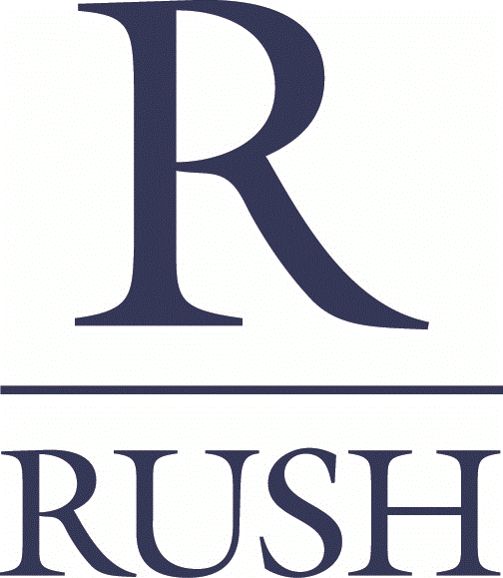

REAL ESTATE TRANSACTION ADMINISTRATOR

Department: The Rush Companies
Reports To: Controller

Job Summary

The Rush Companies consist of 7 core companies with more than 30 years’ experience and a strong reputation for timely delivery of quality commercial buildings and single-family homes throughout Puget Sound. Our teams are focused on doing incredible things every day in support of our Vision of Building an Exceptional Future, TOGETHER. We stand proud of our collective efforts that allow us to create communities where people love to live and work.

The Real Estate Transaction Administrator, working with the Controller, will provide support to all seven of Rush’s core Companies and their collective efforts related to business expansion, maintenance and compliance. Essential tasks include but are not limited to; the formation of new LLC’s and management of existing LLC’s, oversight of select banking transactions, confirmation that lender documentation is complete and recorded, investor documentation, insurance management and reporting for all responsibility areas, as needed.

Essential Duties & Responsibilities

- Ability to read and edit detailed real estate legal and financial documents to include, but not limited to, Purchase and Sale Agreements, leases, promissory notes, loan documents, contracts, settlement statements and financial statements
- Maintain lender documentation by filing new loan documents and removing old ones, gathering quarterly liquidity amounts from select bank accounts, keeping various electronic files for lenders
- Manage documents for external investor loans
- Ensure that files critical to the existence, legal history and operation of The Rush Companies are maintained, current, secure and easily accessible
- Obtain, track and close out construction/development bonds and assignment of funds
- Work with external counsel and Secretary of State in formation of new, and closure of, LLC’s and manage comprehensive list of LLC’s and operating agreements
- Update and/or initiate contractor license information
- Manage and maintain company insurances and update coverages with routine business changes and updates
- Track information related to company vehicles such as insurance, ownership, VIN’s, purchase and sale transactions, and Good-To-Go account management
- Manage the “deals” files and ensure all associated paperwork is organized and filed. Update each file with subsequent documentation such as tax returns and investor information

Minimum Qualifications

- Demonstratable understanding and working knowledge of commercial and residential real estate (terms, documents, valuation methods, deliverables, etc.)
- Paralegal degree or experience preferred
- Thorough commitment to comprehensive completion of all assigned work, accurate reporting, filing methods, and timeliness
- Interaction with banking institutions, and title and escrow companies that indicates and supports claim that candidate has a strong overview of services performed by each and knows the basic workings from personal experience
- Has demonstrated success in working with state agencies such as Secretary of State and Department of Licensing
- Intermediate user of all MS Office Suite products
- Strict personal commitment to professional business conduct and confidentiality in all dealings

Essential Qualities

- Candidate must possess commitment to honesty, integrity and professionalism
- Strong sense of urgency
- Superior organizational skills
- Ability to plan and follow through
- Be resourceful. Always willing to ask questions and research topics to make informed decisions
- Possesses overall good work habits, not limited to but including reliability and timeliness

Physical Requirements
The physical demands of this job are consistent with a clerical type position. Must be able to lift up to 25 pounds on occasion.

How to Apply:

Please send cover letter and resume via the link in this posting or send via U.S. mail to:

The Rush Companies
c/o Human Resources
6622 Wollochet Dr.
Gig Harbor, WA 98335

Equal Opportunity & Drug-Free Employer

Disclaimer: This job description is only a summary of the typical functions of the job, not an exhaustive
or comprehensive list of all possible job duties and responsibilities.

