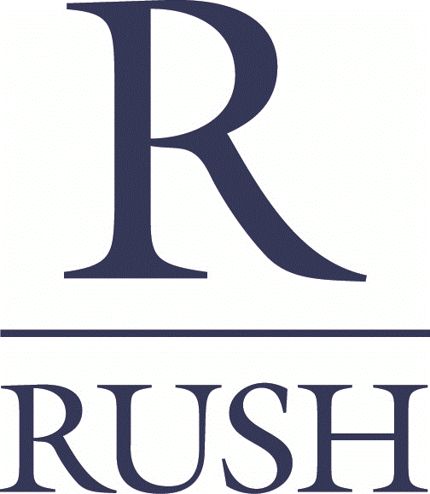

ASSISTANT SUPERINTENDENT
Department: Rush Commercial Construction
Reports To: Superintendent
FLSA Classification: Exempt
Date: 9/28/20

Job Summary
Rush Commercial Construction, Inc., is currently seeking an Assistant Superintendent to join a well-established regional construction company that specializes in Class A office, healthcare, multifamily developments and senior housing. The ideal Assistant Superintendent will have experience managing a portion of the construction process, supporting the site Superintendent. The Assistant Superintendent is responsible for representing the company and its Guiding Principles while ensuring that company policies are adhered to with regard to safety, scheduling, quality, budgeting and customer service/satisfaction. This candidate must demonstrate strong collaboration capabilities coupled with outstanding organization and time management skills.

Essential Duties & Responsibilities
- Read, understand, and communicate regarding construction drawings and peripheral documents
- Utilize knowledge of construction practices
- Understand and identify constructability issues before they stop the work
- Be proactive in problem solving, offer a solution at the time the challenge is presented
- Proven track record demonstrating self-motivation and ability to operate independently
- Forecast production schedule
- Maintain a clean, safe, and secure job site
- Regular “on time” attendance
- Able to work Saturdays and possibly Sundays when needed
- Willing and able to follow directions
- Ethical, honest, and accountable
- Meet milestone dates, floor/roof structure, dry-in, etc
- Ensure quality control of materials and mechanical attachments in accordance with structural design
- Safeguard materials against loss damage and minimize waste
- Maintain daily tool log including, but not limited to, ladders, scaffolds, lasers, calibration, extension cords, and mechanical guards

Supporting Duties & Responsibilities
- Assist Superintendent to forecast long lead items by assessing schedule or accelerating current schedule
- Chair, or be present at the weekly safety meeting

Job Requirements
Education

High school diploma or equivalent combination of education and experience
Experience
- Minimum of 5 years related construction experience
- Completed 1 job as a foreman with oversight from a higher-level supervisor

Special Skills
Requires experience with hand and power tools on a project jobsite; knowledge of proper lifting protocol and able to wear personal protection equipment (including eye protection, head protections, reflective outerwear and proper footwear)
- Certifications and/or Licenses
First Aid and CPR trained, CESCL, and 30 Hour OSHA
Physical Requirements
The physical demands of this job require transporting materials at various job sites, operating equipment/machinery, and performing construction-related tasks on an active construction site
Our team members at The Rush Companies have a strong reputation for exercising integrity, good judgment and sound business practices in our dealings with clients, consultants, subcontractors and suppliers. We are committed to selecting only those individuals who share in our loyalties while also maintaining our standards of quality and safety.

For more information about The Rush Companies or the application process, go to:
http://www.therushcompanies.com/rushcareers

How to Apply:
Please send cover letter and resume to jobs@therushcompanies.com or via U.S. mail to:
The Rush Companies
c/o Human Resources
6622 Wollochet Dr NW
Gig Harbor, WA 98332

Equal Opportunity & Drug-Free Employer

Disclaimer: This job description is only a summary of the typical functions of the job, not an exhaustive
or comprehensive list of all possible job duties and responsibilities.

