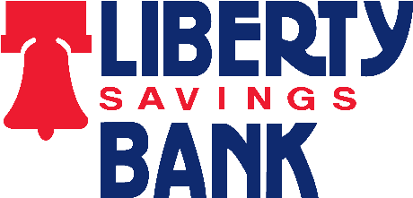

INCOMING INTERNATIONAL WIRE INSTRUCTIONS

The following instructions apply to incoming international wires. For information regarding outgoing wires, please call your local Liberty Savings Bank Financial Center or Freedomline® at (800) 436-6300.

Non-US Denominated Currency (Foreign Currency Wire)
If the incoming wire is being sent in non-US denominated currency, contact your local Liberty Savings Bank Financial Center or Freedomline® directly. Please be prepared to provide the country of origin and the currency type for the incoming wire. There are various banking channels through which wires originated in foreign currencies are directed. The channels used for international wires vary based on the country of origin and the currency. The representative will contact Liberty's wire processing area to determine the specific Swift Code/ABA instructions for your incoming non-US denominated wire.

US Dollar Wire from a Non-US Bank
If the incoming wire is being sent in US dollars from a non-US bank, it may be sent through the intermediary bank of your choice. Popular choices for intermediary banks include BNY Mellon and JP Morgan Chase. Below is example information you may use for the direction of your incoming US dollar wire from a non-US bank.

BNY Mellon Swift: IRVTUS3N RT: 021000018
JP Morgan Chase Bank
Swift: CHASUS33 RT: 021000021

Beneficiary Bank
RT: 242272324
Liberty Savings Bank 2251 Rombach Ave Wilmington, OH 45177

For Further Credit To:
< Customer Name >
< Customer Address >
< Customer Account Number> Description: < As Applicable >

Beneficiary Bank
RT: 242272324
Liberty Savings Bank 2251 Rombach Ave Wilmington, OH 45177

For Further Credit To:
< Customer Name >
< Customer Address >
< Customer Account Number> Description: < As Applicable >

