**Understanding Reserve Studies**

**Do we really need a reserve study?**

-the short answer is yes; not only is it a best practice but it provides the Board with a professionally prepared guide for capital projects

1) review by professional engineer of common elements and their current condition

a) detailed list of all common elements

b) life expectancy and current place in life cycle

c) list of short-term repairs

d) projected future costs of replacement

e) assigns a value to the required annual contribution to reserves

**Board responsibility**

1. Review the common element list with management and assess if it is comprehensive.
2. Does the life expectancy and current evaluation of the condition of common elements seem correct-use your knowledge of the building and common sense as a guide.
3. Address any issues with the engineer-this is a dynamic document. The Board has power in the equation.

Best Practice: When signing a contract make sure to include a meeting with the engineer to review the study.

Best Practice: Some reserve study companies offer an add-on spreadsheet that can be updated in between studies. If you have a committed Board member, this might be a useful tool to keep items updated.

**What are Reserves?**

**-**Long-term savings

-Restricted equity (also call “designated”) because should only be spent on projects outlined in the reserve study

-Money for capital projects

As an illustration to help understand what they are, think of reserves like a 401K plan. When you “save” money to a 401K plan you think of the following:

-you save the money each month for future needs

-the monthly “expense” is actually not a regular expense (the money does not go to someone else), but rather the money is moved to a different account

-the money is supposed to be used only at specific times and for specific purposes

-the cash is still on the balance sheet and represented as equity, but it is “restricted equity” (i.e. to be used for specific purposes)

All of these same items apply to what reserves are. See the illustration showing a comparison of a personal income statement and balance sheet and that of an association.

**Where Can We See Our Reserves on the Financials?**

-Reserves are on the Statement of Revenue and Expenses

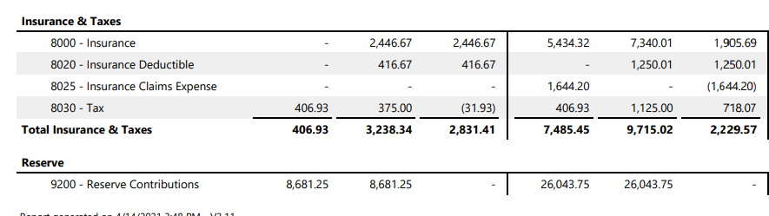

and the Balance Sheet

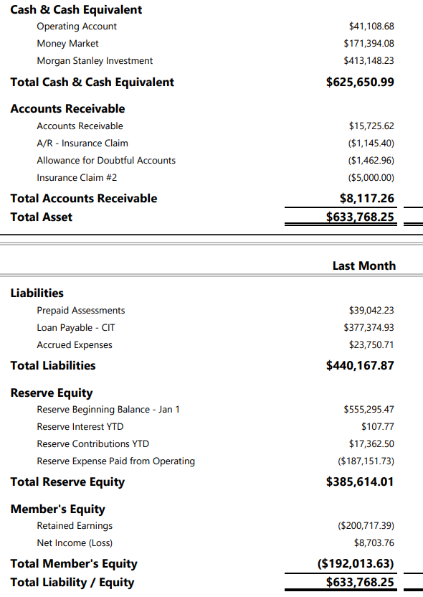

**How Do Reserve Balances Go Up and Down?**

-monthly contribution

-expenditures

-borrowing from reserves

**What is a capital budget?**

-the capital budget is comprised of capital projects and should be projects outlined in the reserve study

-projects not in the reserve study should not be considered as capital projects because no money has been saved for projects outside the reserve study

-CAVEAT: the Board can include items outside the reserve study in a capital budget as long it understands that this may cause other projects to be underfunded

-if a capital budget item will cost significantly more than the amount in the reserve study, the Board should address this and consider if a special assessment is called for; the decision can be made in light of overall cash balances and future capital projects

Best Practice: Create a capital budget separately from the operating budget in the budget process.

**How to use the reserve study?**

Reserve study highlights

-**list of physical elements**

a) review the list and make sure the list includes all items

-**life expectancy, current age, replacement cost**

a) review the list and make sure your experience correlates with what the report says

-**cash flow vs. component method vs. inflation adjusted**

a) component means collecting the full amount for each item every month

b) cash flow method means having enough cash on hand in any given year to be able to pay for that year’s suggested capital expenditures

c) in most cases the cash flow method number will be lower

-**chart of cash flows**

a) beginning balance on 1/1 + reserve contribution amount to be added + interest earned – capital expenditures = ending balance at 12/31

b) the ending amount is a reference number used when asked “does the association have enough in reserves?”

c) however, this number is influenced by whether or not the association spent the amounts listed for capital projects (unspent funds should be added to the end of year balance or if projects cost more than listed, that amount must be subtracted)

-**chart/list of annual projects**

a) this list is an easy-to-read list of capital projects by year

b) Boards should review these each year as part of the budget process and determine if they will proceed with the projects

-**the important number and what it means for the association**

a) in the Executive summary will be a listing of the amount the reserve study is projecting the association needs to save each year to pay for future capital projects

b) if the amount is significantly more than the current amount being saved, the Board can consider a plan to phase in the increases to prevent sticker shock

**How often should we perform a reserve study?**

-most areas in our area have no rule or law on this except:

-VA- associations are required to have a reserve study update every five years and disclose it to owners

-in PG and MO counties (MD) associations are required to have a reserve study update every five years AND fund reserves at the required levels

-***Best Practice*** is to update the reserve study every five years and follow the recommendations

**Why is it important to update the reserve study?**

-the beginning balance of the updated reserve study will be the actual cash balance at the time; this means that any amounts over- or under-collected will be calculated into the new annual contribution in the reserve study

-this is important because it reflects the real experience of the community

-an update also provides a chance to reflect any recent experiences the association experienced-including adding items, deleting items, and updating costs with any recently obtained data

**Reserve Study Companies**

Good for smaller buildings, not too much detail, simple presentation

ETC [www.etc-web.com](http://www.etc-web.com) 410-312-4761

Property Diagnostics, Inc. [www.pdireserves.com](http://www.pdireserves.com) 301-261-8473

More sophisticated studies with greater detail and more charts

Miller Dodson [reserves@mdreserves.com](mailto:reserves@mdreserves.com) 410-268-0479 TDL tdlengineers.com 703-548-3403

Sophisticated study, detailed charts, more information

DMA dma-va.com 804-644-6404