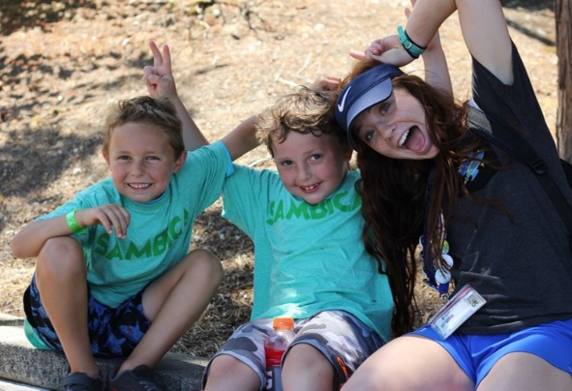
Dear Family & Friends,

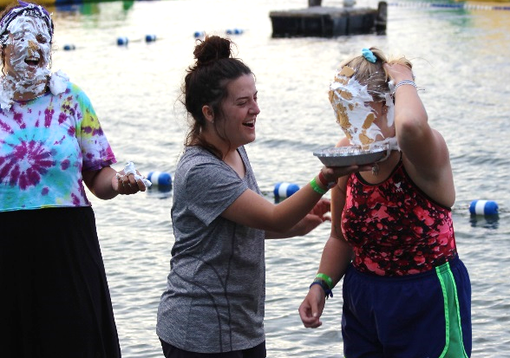
Greetings! I would like to take a few minutes and share some exciting news about my upcoming adventure. This summer, I will be spending my time serving as a <ROLE> at Camp SAMBICA in Bellevue, Washington. SAMBICA is a non-denominational Christian summer camp that has been serving the community since 1919. Set in the middle of the suburbs of Seattle, I will be helping reach an area of this country that is in desperate need of Jesus. In the Pacific Northwest, only one in four people are affiliated with a religion. A majority of the campers that come to SAMBICA come from an unchurched home and are in need of the love of Christ. I will be building relationships through activities and Bible studies with campers and will have the privilege of speaking into their lives about Jesus. Camp starts in mid-June with training and runs through the end of August. More than 2,500 campers, 7 to 17 years old, will spend a week at SAMBICA this summer. Our team consists of 100 college age students who are giving up their summer to serve the kingdom of God in all areas of camp.
I am excited about the opportunity to serve and minister to the needs of campers and I am asking you to join me in this ministry. I am looking to raise $2,000 to be able to spend a summer working in ministry. I am also looking for people who will commit to pray for me throughout the summer. If you are able to assist financially, please mail a check to:
SAMBICA – Summer Staff Fundraising
4114 W Lk Sammamish Pkwy SE
Bellevue, WA 98008
You can also donate online!
Please include the following form as well. Please mark clearly on the memo line of the check - 2021 SAMBICA Team. Do not include my name on the check to ensure tax deductibility of the donation. An accounting of all funds will be available upon completion of the summer. On behalf of everyone at SAMBICA, thank you for your prayers and financial support. May God bless you richly!

Sincerely,

[Staff Member Name]

P.S. If you want to learn more about SAMBICA, visit: www.sambica.com!

SUMMER STAFF
CONTRIBUTION

Please include this form when mailing in contributions

I would like to support the ministry of this summer at SAMBICA. (Staffer’s Name)

My contribution will be .

Contact Information
First Name |  | Last Name
Address |  | City / State / Zip
Email |  | Phone Number

- Checks can be made out to “SAMBICA”.
- Please include “2021 SAMBICA Team” in the memo line.
- DO NOT include the name of the staff member to insure tax deductibility of your donation.
- Contributions are solicited with the understanding that SAMBICA has complete discretion and control over the use of all donated funds.

Please mail check with contribution slip to:

SAMBICA
Summer Fundraising
4114 W Lake Sammamish Pkwy SE
Bellevue, WA 98008

