Atrezzo Connect
MN Provider Portal
End User Guide

Version 1
June 2013
© Copyright 2013, KePRO, 777 East Park Drive, Harrisburg, PA 17111
All rights reserved.

This page intentionally left blank.

Contents
Section 1: Register an Account, Login, & Basic Navigation 3
Register an Account & Login (New Users) 3
Register an Account & Login (New Users), Continued 4
Register an Account & Login (New Users), Continued 5
Resetting a Password 6
Homepage Tabs 7
Requests Tab 8
Search Tab 9
Management Tab 10
Management Tab, Continued 11
Management Tab, Continued 12
Management Tab, Continued 13
Management Tab, Continued 14
Setting User Preferences (Management Tab) 15
Setting User Preferences (Management Tab), Continued 16
My Account Tab 17
My Account Tab, Continued 18
Help Tab 19
Messaging 20
Messaging, Continued 21
Change Context Function (Submitting via a Different NPI) 22
Section 2: Prior Authorization Requests & Questionnaires 23
Prior Authorization Request (Inpatient) 24
Prior Authorization Request (Inpatient), Continued 25
Prior Authorization Request (Inpatient), Continued 26
Prior Authorization Request (Inpatient), Continued 27
Prior Authorization Request (Inpatient), Continued 28
Prior Authorization Request (Inpatient), Continued 29
Prior Authorization Request (Inpatient), Continued 30
Prior Authorization Request (Inpatient), Continued 31
Prior Authorization Request (Inpatient) Summary 32
Prior Authorization Request (Outpatient) 33
Prior Authorization Request (Outpatient), Continued 34
Prior Authorization Request (Outpatient), Continued 35
Prior Authorization Request (Outpatient), Continued 36
Prior Authorization Request (Outpatient), Continued 37
Prior Authorization Request (Outpatient), Continued 38
Prior Authorization Request (Outpatient), Continued 39
Prior Authorization Request (Outpatient), Continued 40
Prior Authorization Request (Outpatient), Continued 41
Prior Authorization Request (Outpatient), Continued 42
Prior Authorization Request (Outpatient) Summary 43
Questionnaires 44
Questionnaires, Continued 45
Extending a Request (Concurrent Review) 46
Extending a Request (Concurrent Review), Continued 47

Section 1: Register an Account, Login, & Basic Navigation

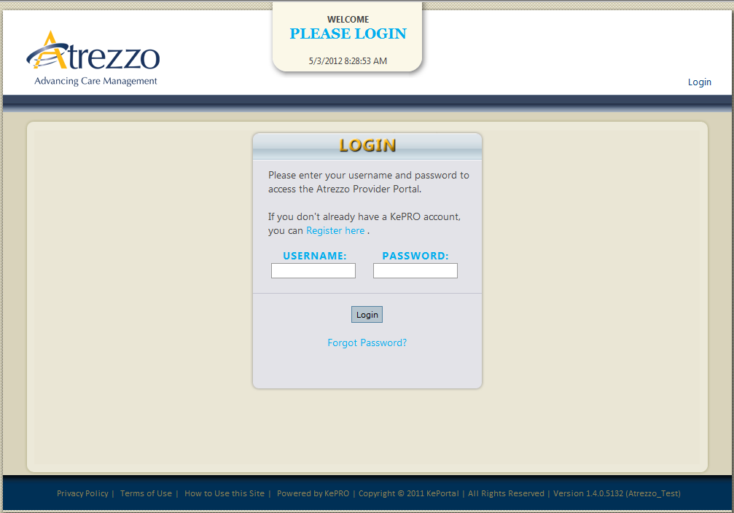

Register an Account & Login (New Users)
Step 1 | Click the Atrezzo button located on the website.
Step 2 | The user is brought to the Login page.
Step 3 | Click the Register Here link to begin the account set up process. | 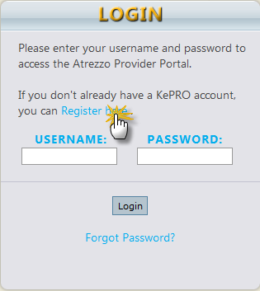
Step 4 | Enter your organization’s NPI and Provider Registration Code.  Click Next. | 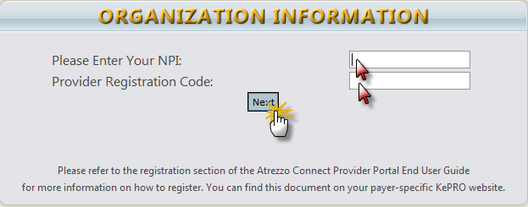
Continued on next page

Register an Account & Login (New Users), Continued
Step 5 | Enter a user name, select and confirm a password (minimum of 8 alpha/numeric characters).  Enter a secret question and secret answer.  Complete the Contact Information.  Note: Fields that have an asterisk (*) by them are required fields.  Click Next. | 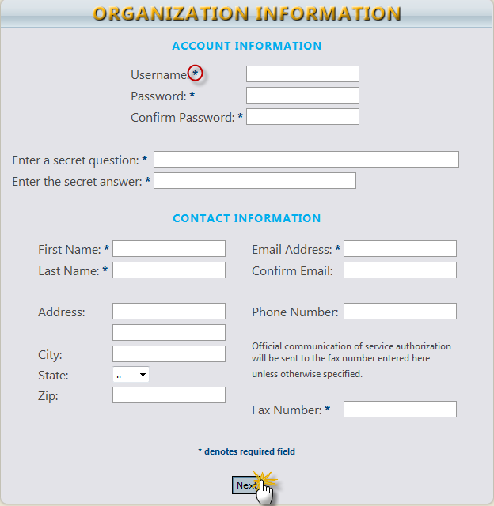
Step6 | Review the Terms of Use Agreement.  Click the checkbox that states “I have read and agree to these terms of use.”  Click Continue. | 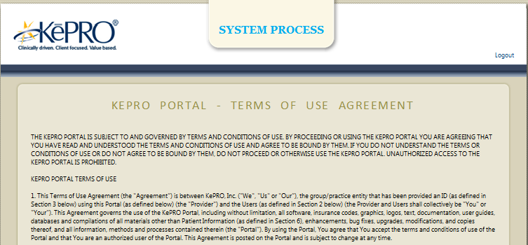  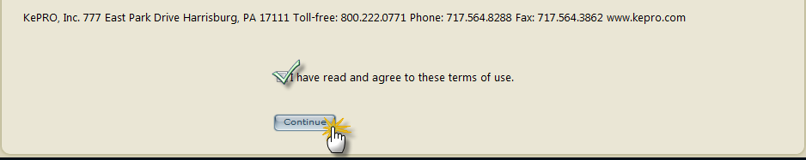
Continued on next page

Register an Account & Login (New Users), Continued
Step 7 | If you complete steps 1 through 6 successfully, the Homepage appears.
END ACCOUNT REGISTRATION AND LOGIN PROCESS FOR NEW USERS

Resetting a Password
Step 1 | Click the Forgot Password link on the Login page. | 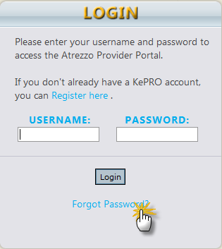
Step 2 | Enter your Username.*  *Please contact Customer Service if you cannot remember your Username.  Click Next. | 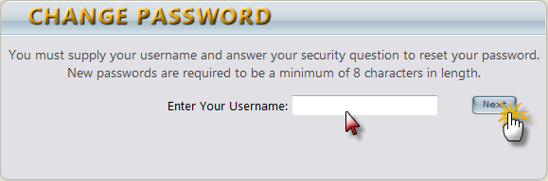
Step 3 | Enter the answer to the secret question you set during the initial registration.  Enter in (and confirm) a new password.*  *New passwords are required to me a minimum of 8 characters in length.  Click Finish.  You will be brought back to the Login page to enter your username and new password. | 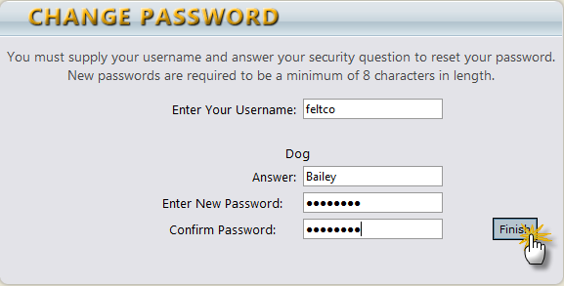

Homepage Tabs
Home Tab (Home Page) | 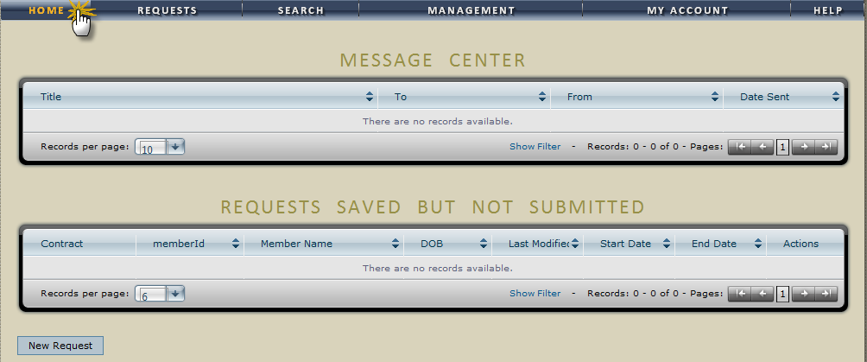
Requests Tab  &  Dropdown Selection | 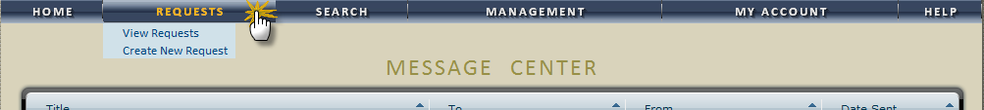
Search Tab  &  Dropdown Selection | 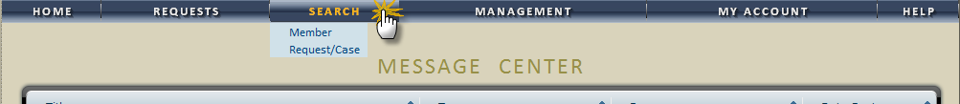
Management Tab & Dropdown Selection | 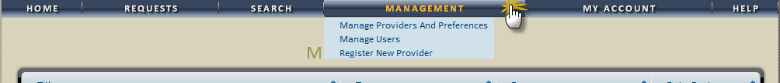
My Account Tab | 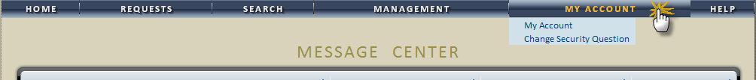
Help Tab  & Dropdown Selection | 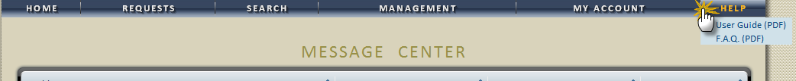

Requests Tab
Request Tab
Click Create New Request on the Request Tab  Search for member by ID or last name and DOB  OR  Click the New Request Button from the Home Tab | 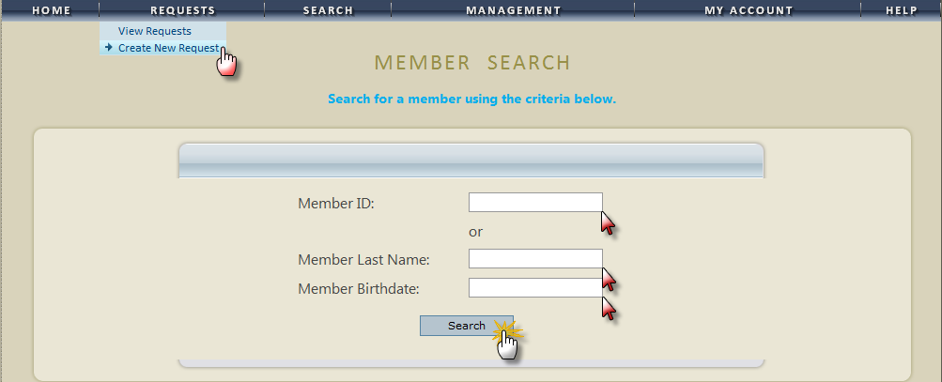
 | 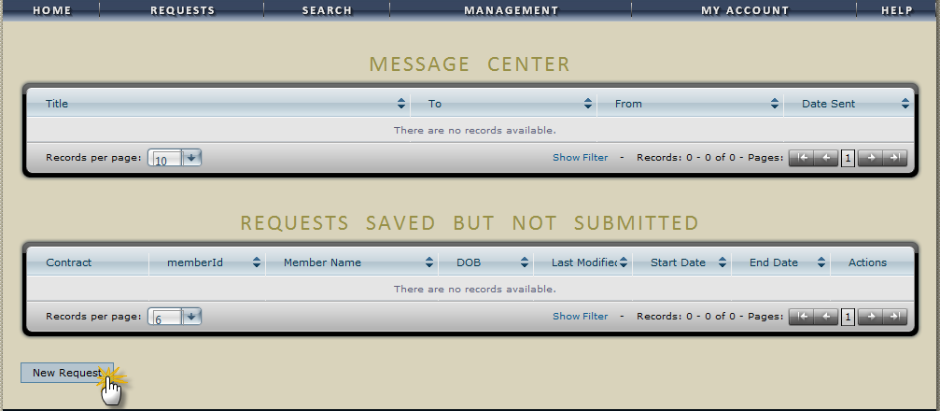
View All Requests  Click the View Request selection from the dropdown to display all requests | 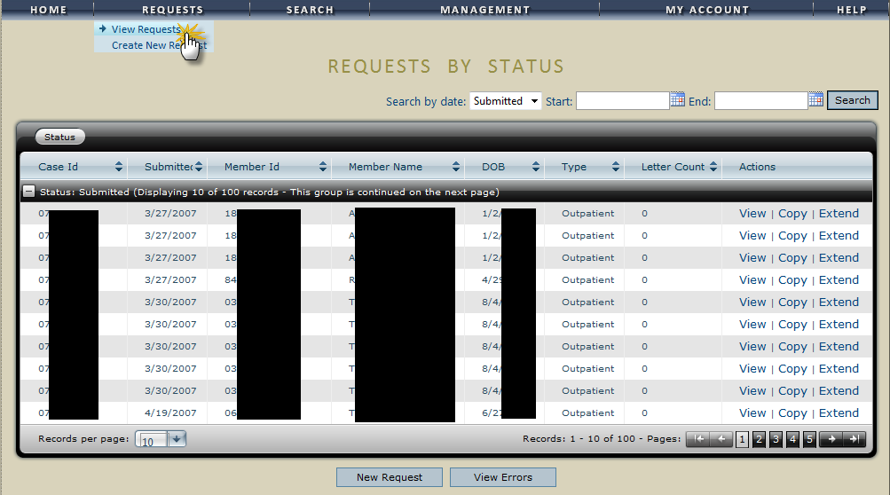

Search Tab
Search Tab
Click Member to search using Member ID  or Last Name/DOB. | 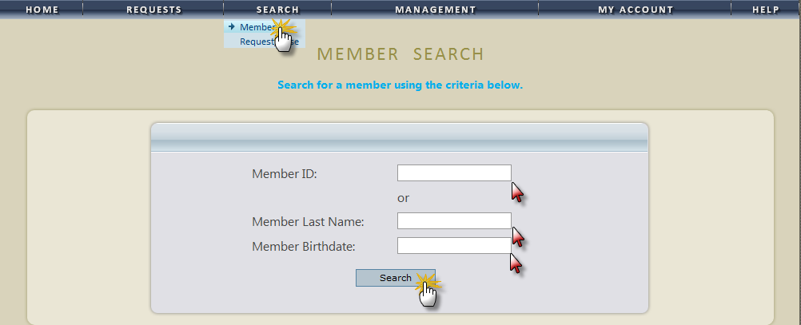
Click Request / Case to search using Case ID, Member Info, or Request Info.  Select desired sorting from the dropdown menu. | 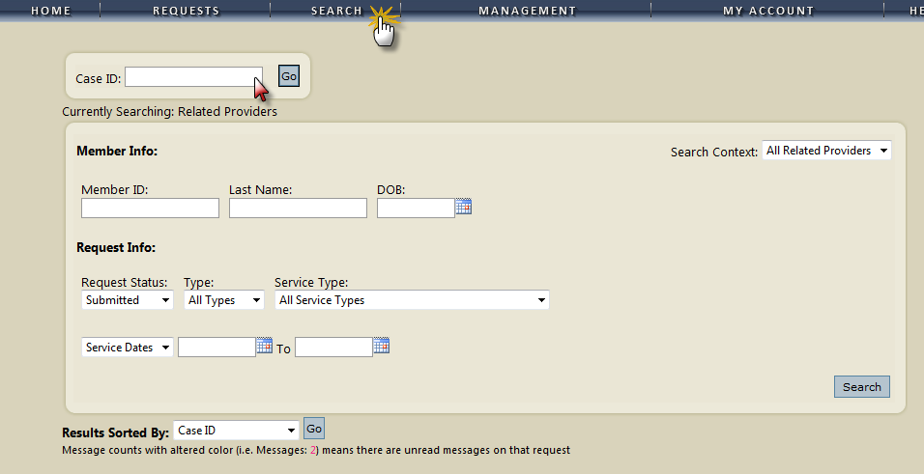  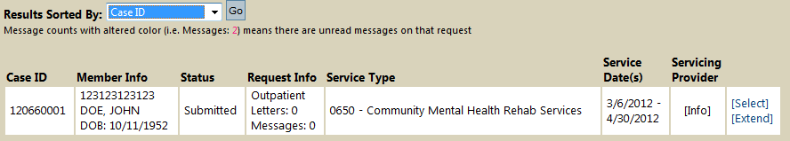  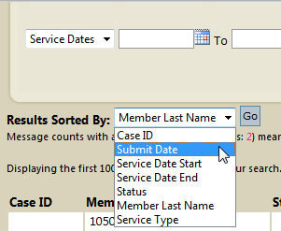

Management Tab
Management Tab
To register a new provider, click Register a New Provider and enter in their NPI and Provider Registration Number and click the Find Provider button. | 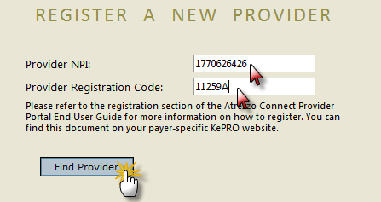
Verify and select the correct address (es) for the new provider (1), and then click the Select button. Your system administrator can provide the provider registration code. | 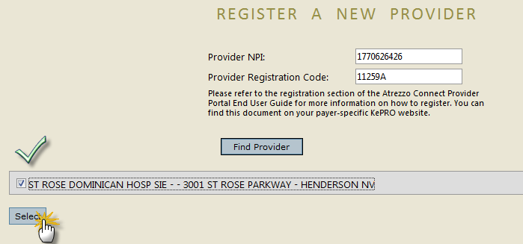
The new provider (s) is now a part of the provider group for this account.  Click Register New NPI to add another provider.. | 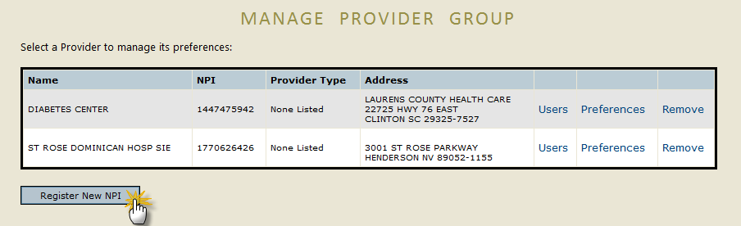
Continued on next page

Management Tab, Continued
Click Manage Users to manage users and providers for users. | 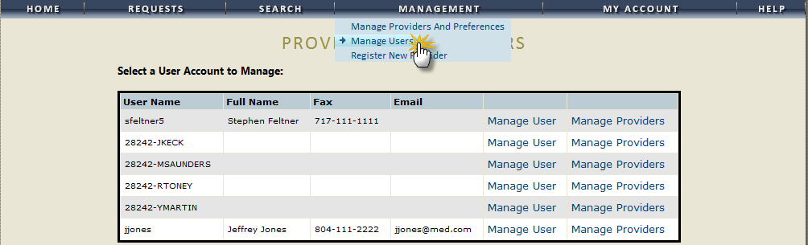
Click Manage User to update specific user information. | 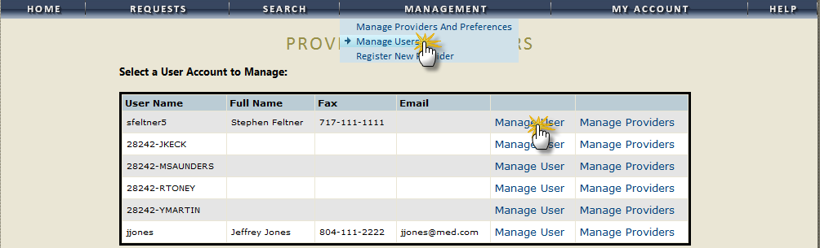  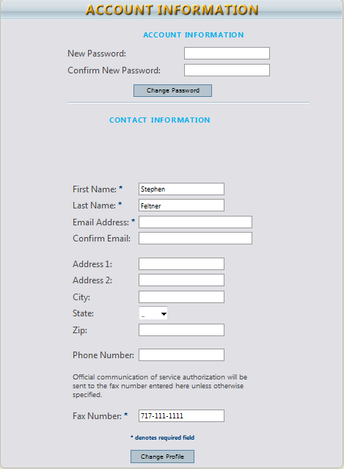
Continued on next page

Management Tab, Continued
Click Manage Providers to manage the access that a user has to a provider or group of providers.  (1) – if this checkbox is checked, the user will have Group Admin access to all providers  (2) – Change access permissions here (or remove a provider)  (3) – Click Save Changes when done updating user permissions. | 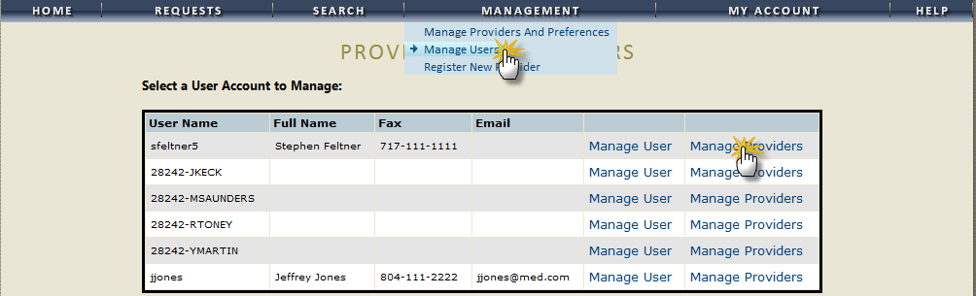  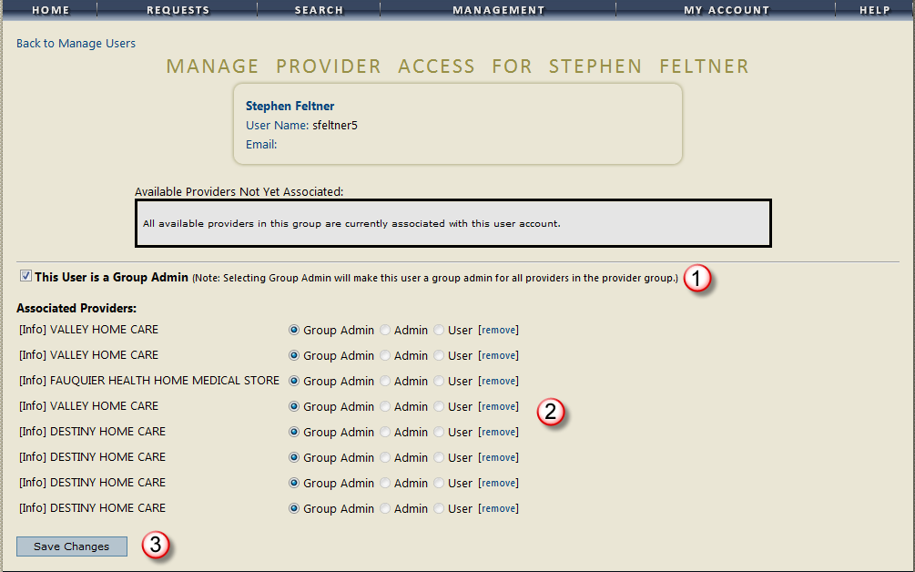  User Definitions  Group Admin Can create users, other admins, other submitting providers, enter cases, perform searches  Admin Can create users, other admins, enter cases, perform searches  User Can enter cases and perform searches
Continued on next page

Management Tab, Continued
Click Manage Providers and Preferences to add new users and set preferences | 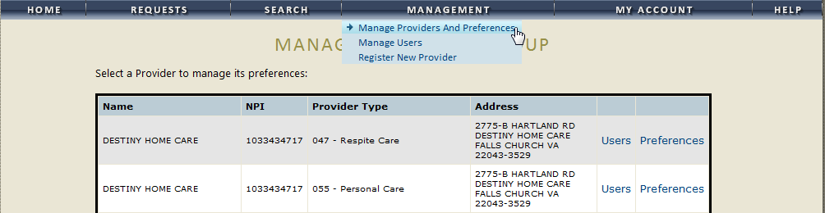
Click Users.  Click Add New User to add a new user for this provider account | 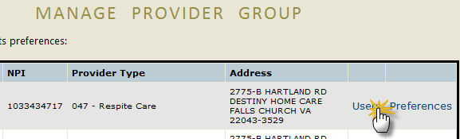  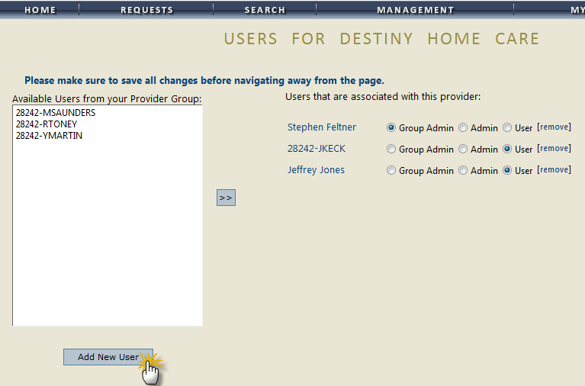
Continued on next page

Management Tab, Continued
Enter the account information for the new user. | 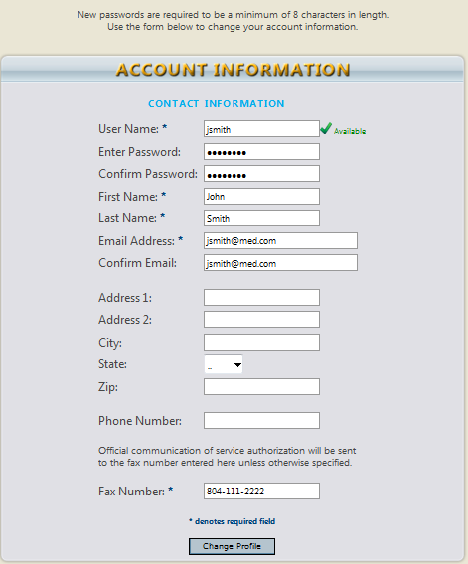
The new user is added to the user group.  Permission access can be set for the user (Group Admin, Admin, User).  Click Save All Changes when finished. | 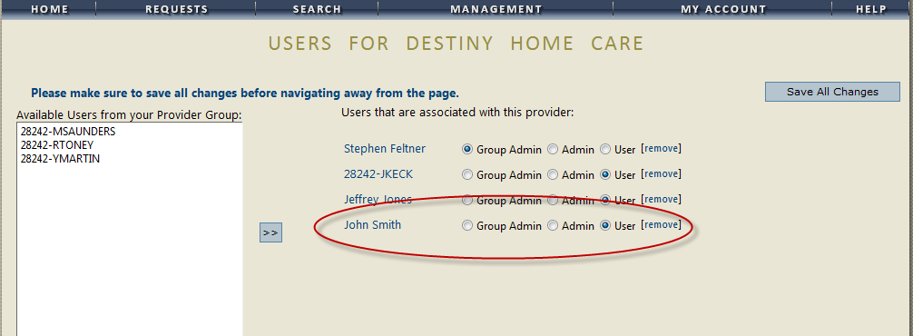
This message window appears when you delete a provider from the group. | 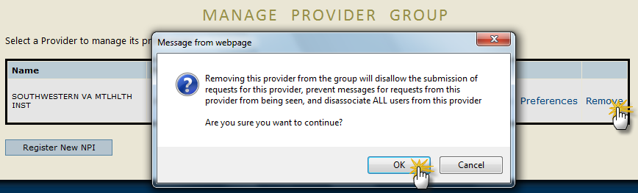

Setting User Preferences (Management Tab)
From the Manage Providers and Preferences dropdown, select Preferences | 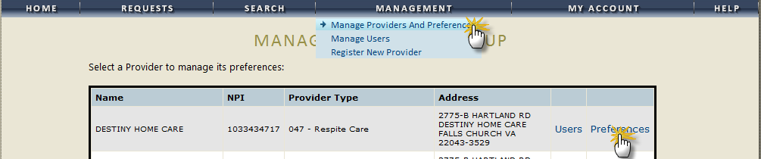
Click Servicing Providers /Facilities to set preferred (favorites) list. | 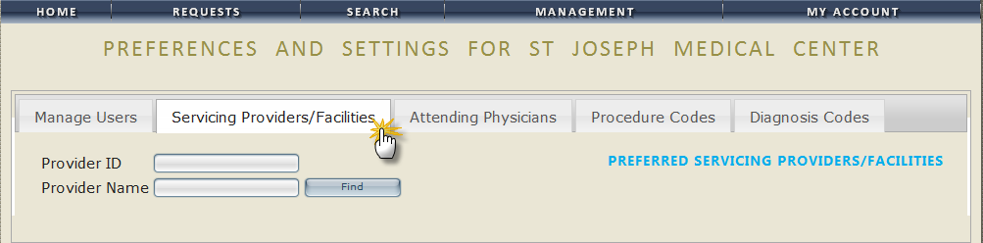
Click Attending Physicians to set preferred (favorites) list. | 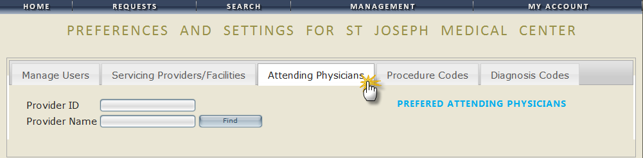
Click Procedure Codes to set preferred (favorites) list. | 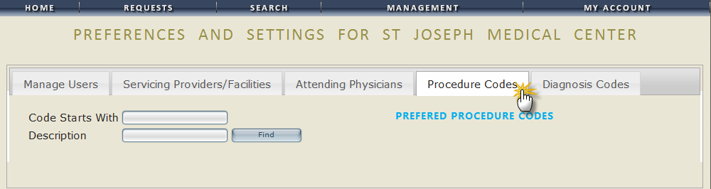
Click Diagnosis Codes to set preferred (favorites) list. | 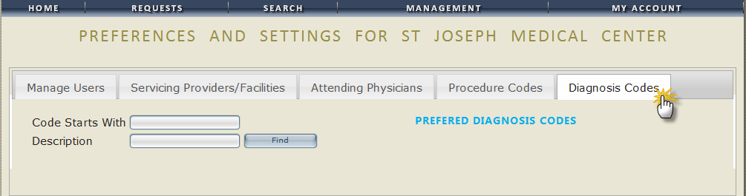
Continued on next page

Setting User Preferences (Management Tab), Continued
Step 1 | Search for Provider (1).  Once you find the provider to add to your preferred (favorites) list, click Select from the search results (2). | 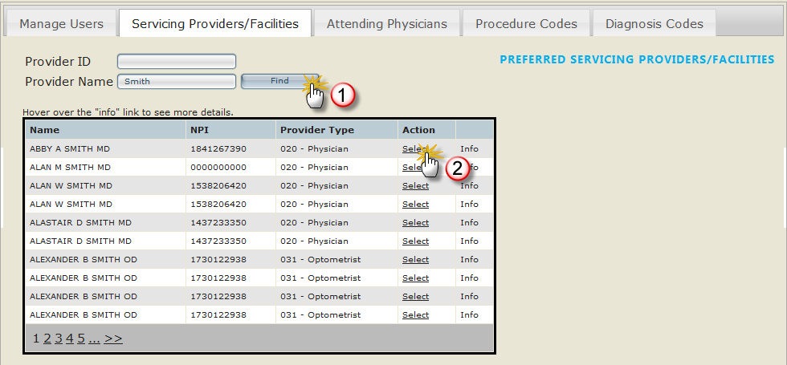
Step 2 | Provider is added to the preferred list.  Click Remove to take off of the list.  This process works the same for Attending Physicians, Procedure Codes, and Diagnosis Codes. | 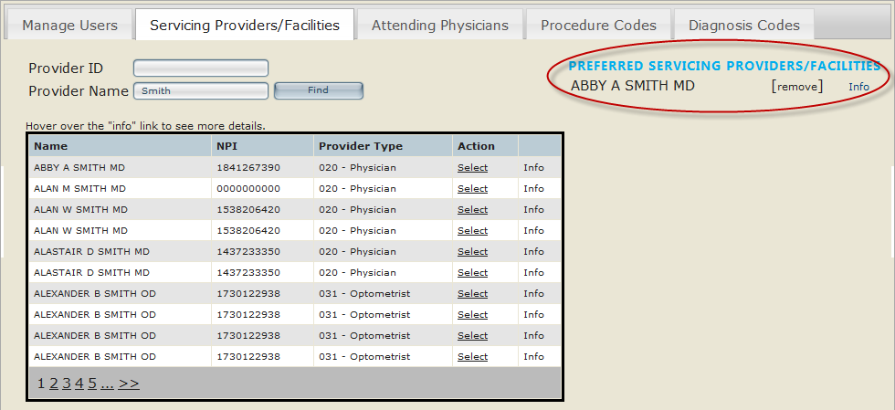

My Account Tab
My Account Tab
Use this tab to change your password or update your contact information. | 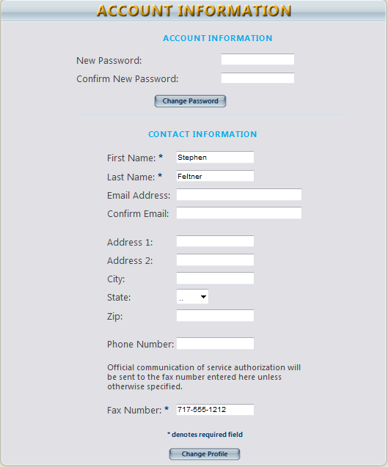
Continued on next page

My Account Tab, Continued
Use this tab to change your secret question and answer for resetting your password. | 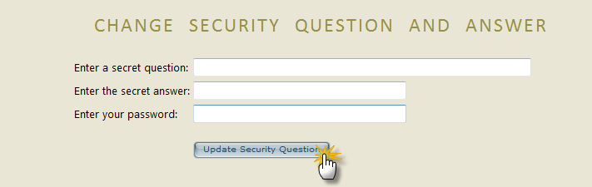

Help Tab
Help
Tab
View  User Guide | 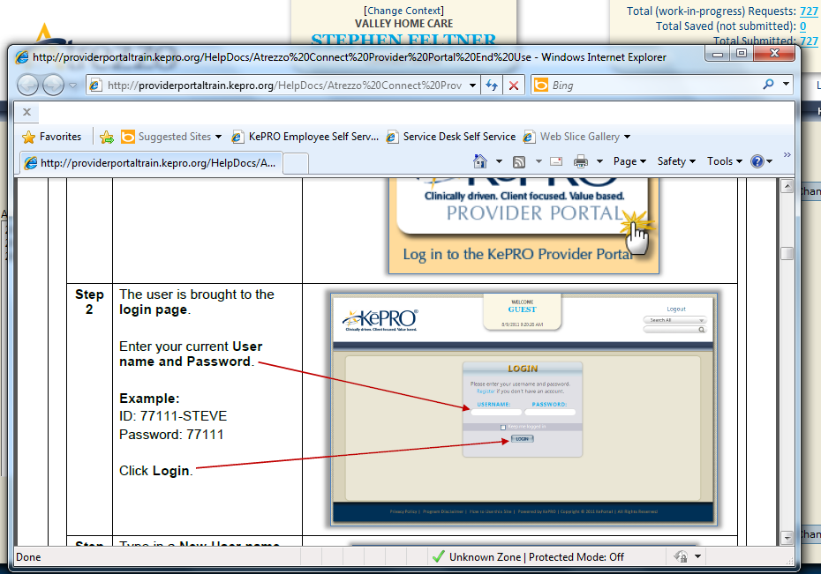
View
FAQs

Messaging
You can access the Messaging Center by clicking the Message Center link on the Home page..  Note: Messages are NOT for attaching clinicals. | 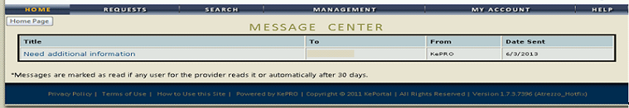
The message appears (1).  To REPLY to the message, type the reply in the space provided (2) and click the Reply button (3). | 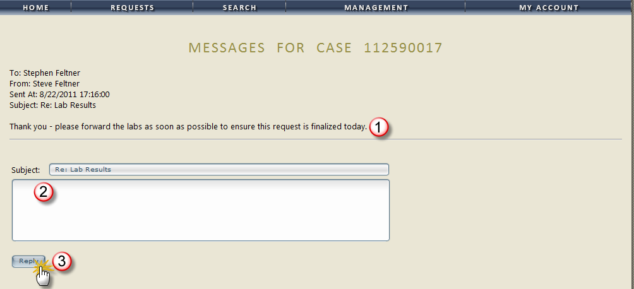
Type in the subject and message body in the space provided and click Reply (or Send) to send the message to KePRO. | 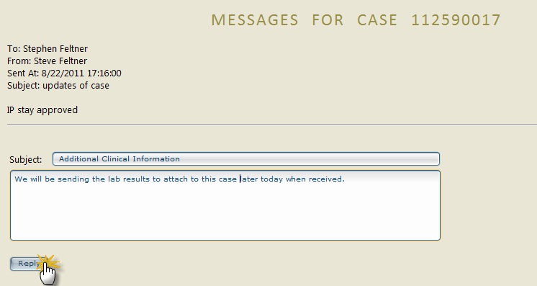
Continued on next page

Messaging, Continued
The message has been sent and is now a part of the request record. | 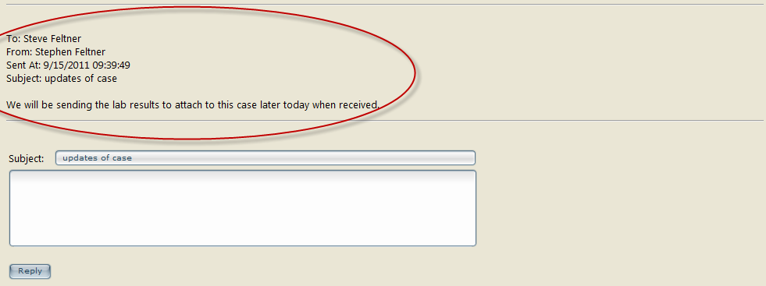
To SEND a message to KePRO about a submitted case, find the case by clicking Search (search by case ID or member)
Click View to bring up the Request Overview | 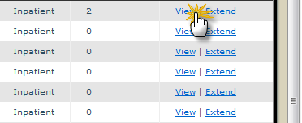
Scroll down to the Messages and Attachments section of the overview and click the Send New Message link. | 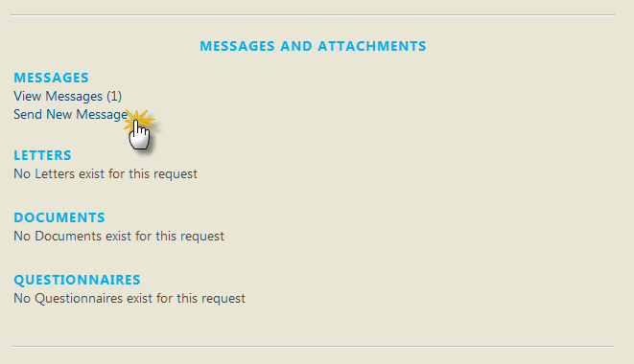

Change Context Function (Submitting via a Different NPI)
Step 1 | To submit a request under a different NPI, click the Change Context link.
Step 2 | Select the provider from the dropdown list that you want to submit a request under.
Step 3 | The provider name has now been changed. Requests will now be submitted under the selected provider.

Section 2: Prior Authorization Requests & Questionnaires

Prior Authorization Request (Inpatient)
Step 1 | Click the New Request button (located at the bottom of the home screen)  Or  Click Create New Request from the Requests tab.
Step 2 | Search for member by:  - Member ID  Or  - Last Name  - Birthdate  Click the Search button. | 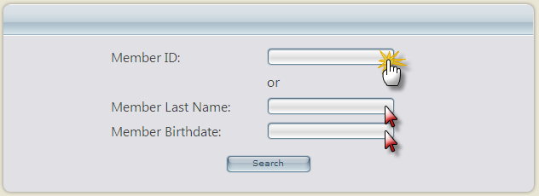
Step 3 | Select the Member from the search results by clicking on the Select link. | 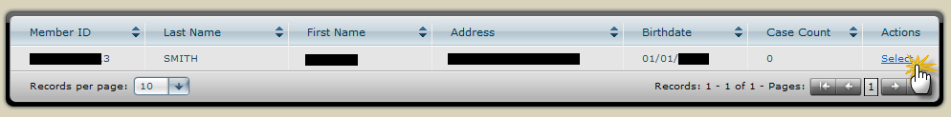
Step 4 | Verify member information and click the New Request button.  Select request type (Inpatient or Outpatient) and click Create Request. | 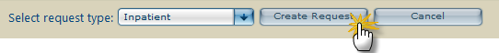
Continued on next page

Prior Authorization Request (Inpatient), Continued
Step 5 | Patient Detail information defaults.  Click either the next section link or the Next button to continue through the Inpatient Service Request process.
Step 6 | Requesting Provider Information defaults.  Note: Enter in the fax # where official communication about this Prior authorization should be sent.  Click either the next section link or the Next button to continue through the Inpatient Service Request process.
Continued on next page

Prior Authorization Request (Inpatient), Continued
Step 7 | Facility information automatically defaults.  If the facility information needs to be changed, use the search function to find and select a different facility.  To search for facility information, click the search button.  Type in a keyword in the Facility Name field and click Find. | 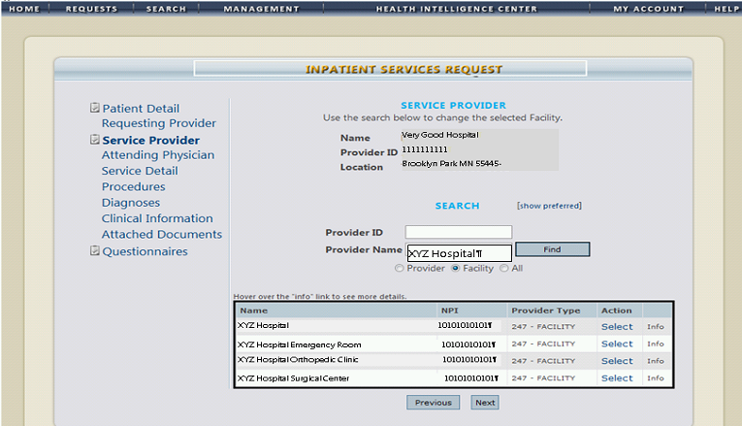
Continued on next page

Prior Authorization Request (Inpatient), Continued
Step 7.1 | Select the facility from the search results.  Note: Hovering the cursor over the Info column will display a bubble with more detailed Facility information that can be reviewed before selecting. | 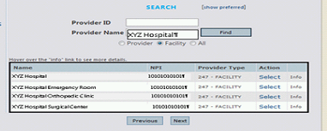  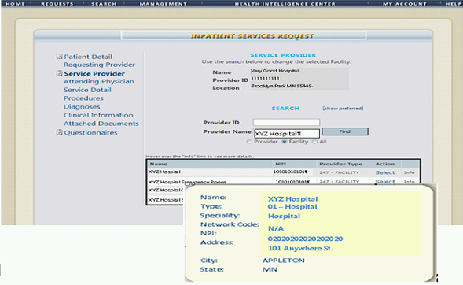
Step 7.2 | Facility information populates the fields from the search selection. | 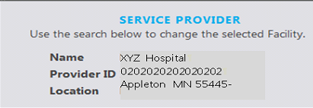
Continued on next page

Prior Authorization Request (Inpatient), Continued
Step 8 | Select the appropriate service detail using the corresponding drop down menus and fields.  Click Next to continue. | 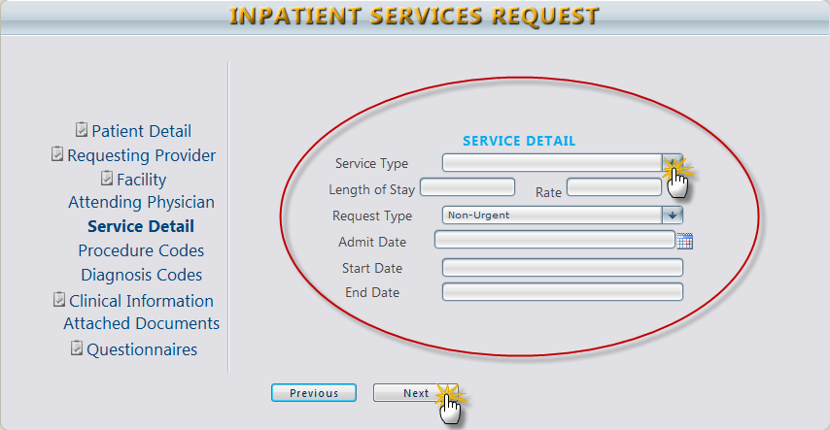
Step 9 | Fill in the required information for Procedure Codes (CPT).
Step 9.1 | If a new code needs to be added, delete the original entry and add the new one.
Continued on next page

Prior Authorization Request (Inpatient), Continued
Step 9.2 | Select the requested date of the procedure by clicking the appropriate date on the dropdown calendar.  To add a new code (1), click the add new code button and select from the search results.  Click Next to continue.
Step 10 | At least one diagnosis code must be attached to the case. If there is more than one, one must be selected as the primary.  If you want to add a second code, delete the original entry and enter the new code or description.
Step 11 | Enter any clinical notes in the text field.  Click Next to continue. | 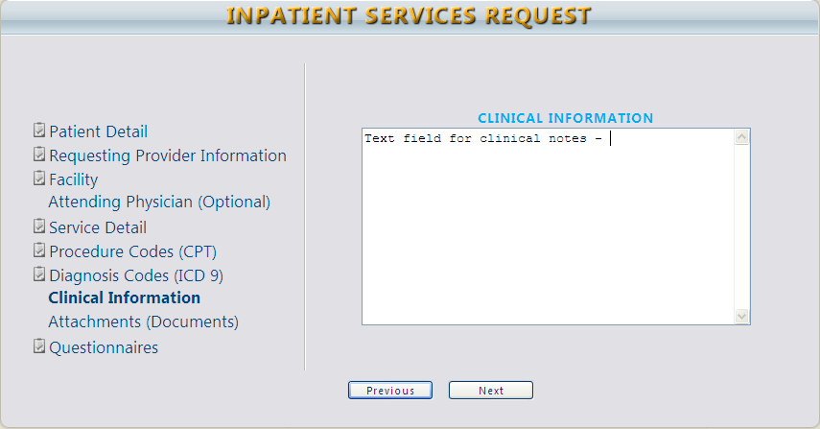
Continued on next page

Prior Authorization Request (Inpatient), Continued
Step 12 | Attach clinical documentation by clicking the browse button. | 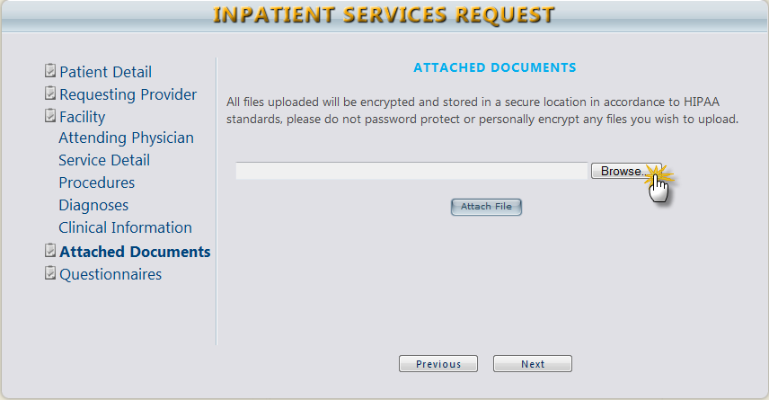
Step 12.1 | Browse and find the file and click Open to attach.  Once attached, click Attach File. | 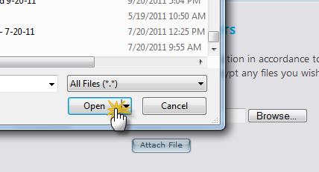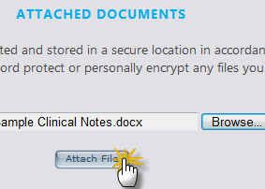
Step 12.2 | File name appears when it is successfully uploaded.  To remove the file, click the Remove link. | 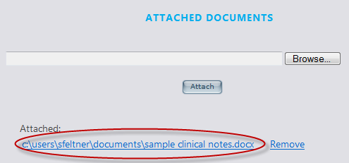
Step 13 | Questionnaires* (Does not apply to all services)  *See the Questionnaires section in this manual for more detailed information | 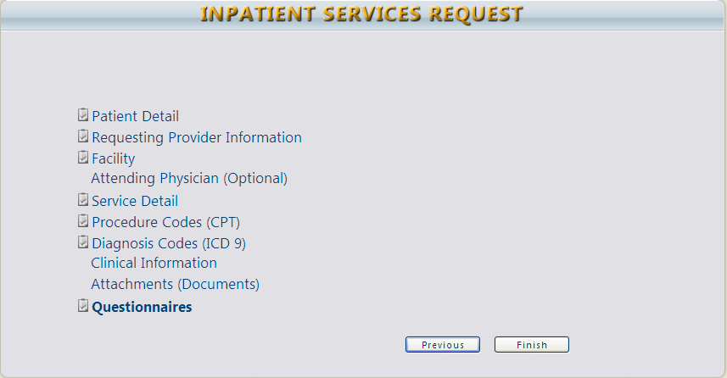
Continued on next page

Prior Authorization Request (Inpatient), Continued
Step 14 | VERY IMPORTANT!  Click the checkbox at the bottom of the page and click either Save for Later or Submit.  You cannot proceed if you do not click the checkbox. | 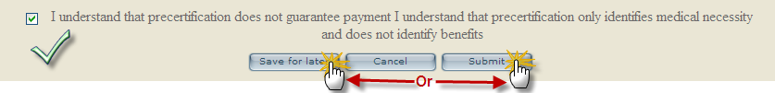  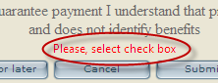
Step 14.1 | If any required portion of the request is missing, these alerts appear. | 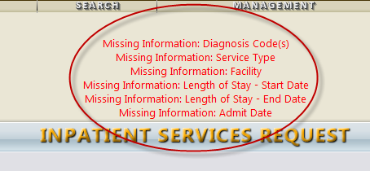
Step 15 | Once a request is successfully submitted, a Request Overview is displayed. | 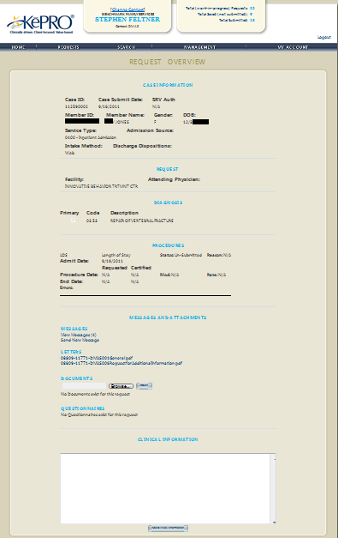

Prior Authorization Request (Inpatient) Summary
Step 1 | - Click the New Request button (located at the bottom of the home screen).
Step 2 | - Search for member by:  - Member ID  OR  - Last Name  - Date of Birth  - Click the Search button.
Step 3 | - Select the Member from the search results by clicking on the Select link.
Step 4 | - Verify member information and click the New Request button.  - Select request type (Inpatient or Outpatient) and click Create Request.
Step 5 | - Enter Patient Detail.  - Click either the next section link or the Next button to continue through the Inpatient Service Request process.
Step 6 | - Enter Requesting Provider Information.  - Click Next to continue.
Step 7 | - Enter Facility information.  - To search for facility information, click the search button.  - Type in a keyword in the Facility Name field and click Find.  - Select the facility from the search results.  - Facility information will populate the fields from the search selection.
Step 8 | - Select the appropriate service detail using the corresponding drop down menus and fields.  - Click Next to continue.
Step 9  optional | - Add CPT Code by clicking the Add New Code button searching and selecting from the search results.  - Select the requested date of the procedure by click the appropriate date on the dropdown calendar.  - If a new code needs to be added, delete the original entry and add the new one.  - Click Next to continue.
Step 10 | - At least one diagnosis code must be attached to the case. If there are more than one, one must be selected as the primary.  - If a new code needs to be added, delete the original entry and add the new one.  - Click Next to continue.
Step 11 | - Enter any clinical notes in the text field.  - Click Next to continue.
Step 12 | - Attach clinical documentation by clicking the browse button.  - Browse and find the file and click Open to attach.  - Once attached, click Submit.
Step 13 | - Questionnaires (if applicable)
Step 14 | - Click the checkbox at the bottom of the page and click either Save for Later or Submit.
Step 15 | - A Request Overview is displayed.
END INPATIENT PROCESS FLOW

Prior Authorization Request (Outpatient)
Step 1 | Once you have located and brought up a member (see steps 1-4 of Inpatient process), Patient Detail information defaults.  Click Next to continue.
Step 2 | Requesting Provider Information data defaults.  Note: Enter in the fax # where official communication about this Prior authorization should be sent.  Click Next to continue.
Step 3 | Service Provider Information defaults. If the Service Provider is different from the Requesting Provider, enter the Provider ID or search by Name. Click the Search button.
Continued on next page

Prior Authorization Request (Outpatient), Continued
Step 3.1 | To search for facility information, click the search button.  Type in a keyword in the Facility Name field and click Find. | 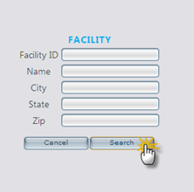
Step 3.2 | Select the facility from the search results.  Note: Hovering the cursor over the Info column will cause a bubble to appear with more detailed Facility information that can be reviewed before selecting.
Continued on next page

Prior Authorization Request (Outpatient), Continued
Step 3.3 | Facility information populates the fields from the search selection. | 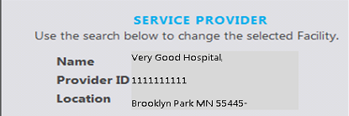
Step 4 | Complete the drop down fields for Service Detail.  Note: The Attending Physician section is optional. | 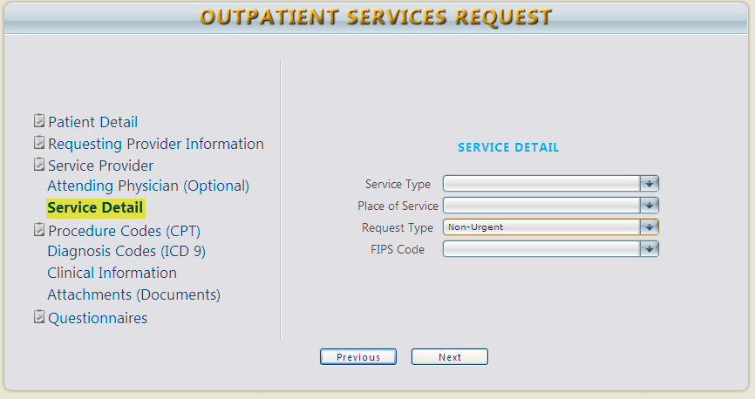
Step 5 | Select the Request Type from the drop down.
Continued on next page

Prior Authorization Request (Outpatient), Continued
Step 6 | Fill in the required information for Procedure Codes (CPT). | 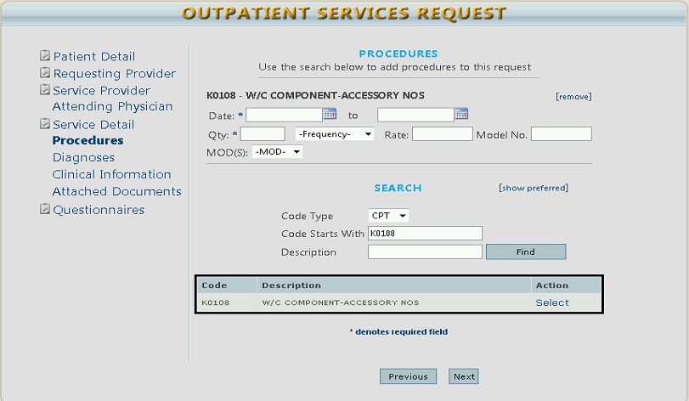
Step 6.1 | Enter the Start Date and End Date using the calendar dropdowns.
Step 6.2 | Enter the quantity. If appropriate, select the number of Units, Visits, etc. from the Frequency dropdown, the rate, and the model number. | 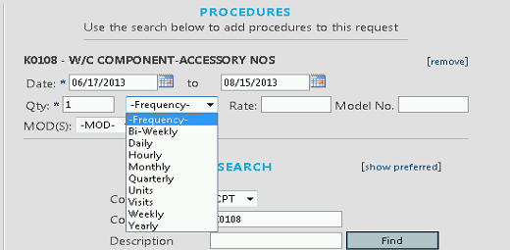
Continued on next page

Prior Authorization Request (Outpatient), Continued
Step 6.3 | If appropriate, choose the modifier from the dropdown. A new field displays after you enter one. The maximum number of modifiers is 3. | 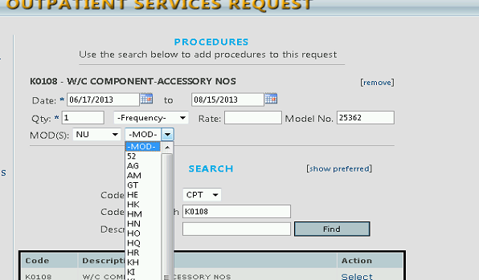
Step 6.4 | If you want to add a second code, delete the original entry and enter the new code or description.  Search for the code using the Code Starts With or Description (1) fields.  Click Find (2).  Select the appropriate CPT code to be added (3).  The code is added to the request. | 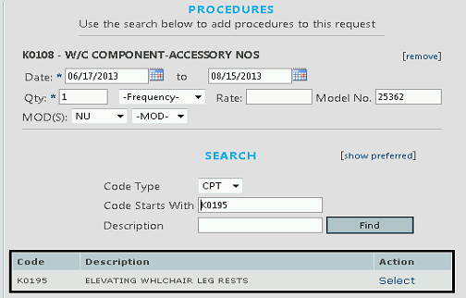  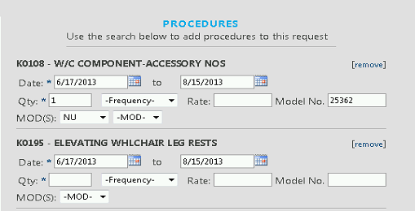
Continued on next page

Prior Authorization Request (Outpatient), Continued
Step 7 | Add Diagnosis Code (ICD 9) by entering the code or description.
Step 7.1 | If you want to add a second code, delete the original entry and enter the new code or description.  Like the CPT Codes, search, locate, and attach Diagnosis Codes by using the search function.  - – Search by Code Starts With or Description  - – Click Search  - – Select the appropriate ICD 9 code | 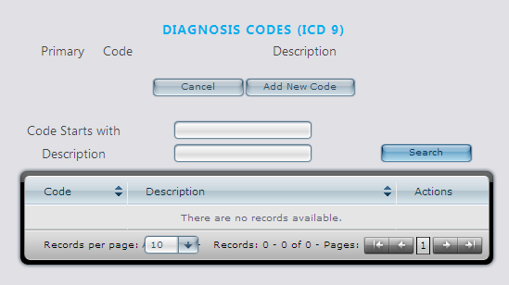  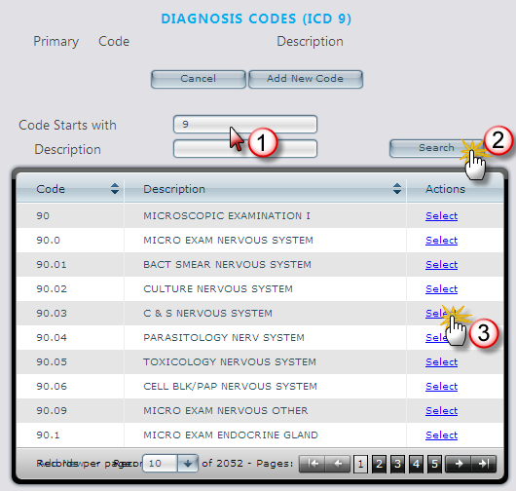
Continued on next page

Prior Authorization Request (Outpatient), Continued
Step 7.2 | At least one diagnosis code must be attached to the case. If there are more than one, one must be selected as the primary.  If you want to add a second code, delete the original entry and enter the new code or description.
Step 8 | Enter any clinical notes in the text field. | 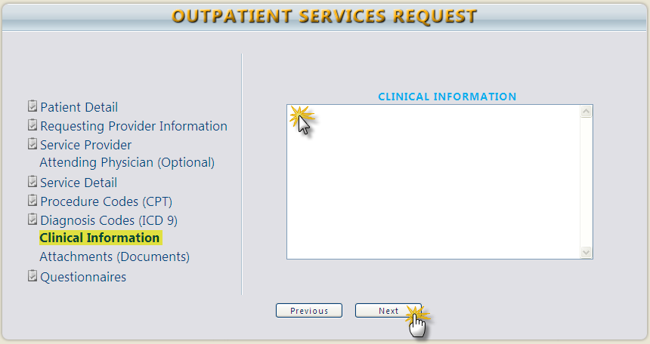
Step 9 | Attach clinical documentation by clicking the browse button. | 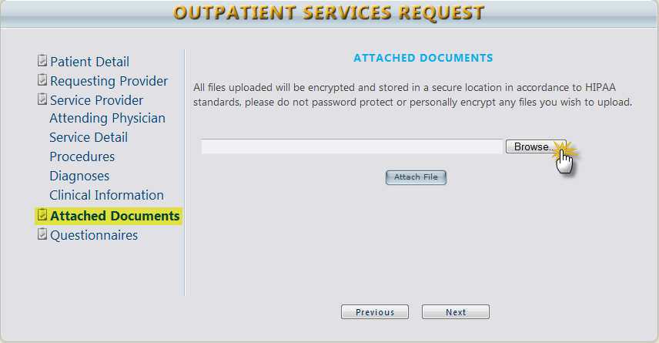
Continued on next page

Prior Authorization Request (Outpatient), Continued
Step 9.1 | Browse and find the file and click Open to attach.  Once attached, click Attach File.
Step 9.2 | File name will appear when it is successfully uploaded.
Step 10 | The indicator icons on the left of the screen should be visible in all service request areas to show that all required data has been inputted. | 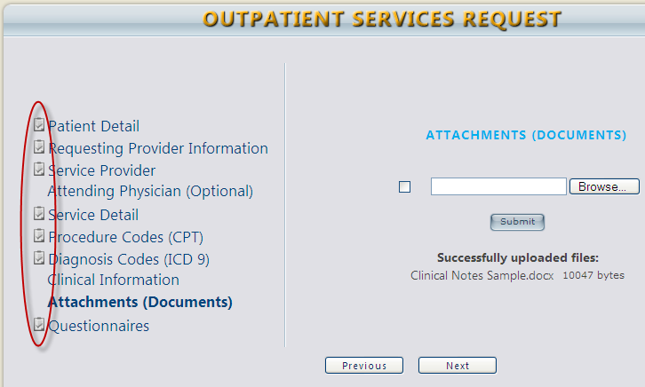
Continued on next page

Prior Authorization Request (Outpatient), Continued
Step 11 | Questionnaires* (Does not apply to all services)  *See the Questionnaires section in this manual for more detailed information
Step 12 | VERY IMPORTANT!  Click the checkbox at the bottom of the page and click either Save for Later or Submit.  You will not be able to proceed if you do not click the checkbox.
Step 12.1 | If any required portion of the request is missing, these alerts will appear. | 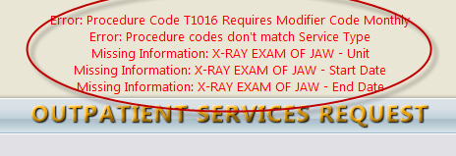
Continued on next page

Prior Authorization Request (Outpatient), Continued
Step 13 | Once a request is successfully submitted, a Request Overview screen displays.

Prior Authorization Request (Outpatient) Summary
Step 1 | - Once you have located and brought up a member (see steps 1-4 of Inpatient process), input Patient Detail.  - Click Next to continue.
Step 2 | - Enter Requesting Provider Information data.  - Click Next to continue.
Step 3 | - Enter in Service Provider Information. If not known, click the Search button.  - To search for facility information, click the search button.  - Type in a keyword in the Facility Name field and click Find.  - Select the facility from the search results.
Step 4 | - Complete the drop down fields for Service Detail.  - Note: The Attending Physician section is optional.
Step 5 | - Select the Request Type from the drop down menu.
Step 6 | - Fill in the required information for Procedure Codes (CPT).  - Enter the Start Date and End Date using the calendar dropdowns.  - Enter the quantity and select the number of Units, Hours, etc. from the dropdown, rate and model number.  - Enter the modifier(s), to a maximum of three  - If a new code needs to be added, delete the original entry and add the new one.  - Search for the code using the Code Starts With or Description fields.  - Click Find.  - Select the appropriate CPT code to be added.
Step 7 | - Add Diagnosis Code (ICD 9) by clicking the Add New Code button.  - Like the CPT Codes, search, locate, and attach Diagnosis Codes by using the search function.  - Search by Code Starts With or Description.  - Click Search.  - Select the appropriate ICD 9 code.  - At least one diagnosis code must be attached to the case. If there are more than one, one must be selected as the primary.  - If a new code needs to be added, delete the original entry and add the new one.
Step 8 | - Enter any clinical notes in the text field.  - Click Next to continue.
Step 9 | - Attach clinical documentation by clicking the browse button.  - Browse and find the file and click Open to attach.  - Once attached, click Submit.
Step 10 | - The indicator icons on the left of the screen should be visible in all service request areas to show that all required data has been inputted.
Step 11 | - Questionnaires (if applicable)
Step 12 | - Click the checkbox at the bottom of the page and click either Save for Later or Submit.  - You will not be able to proceed if you do not click the checkbox. An error message will appear as shown to the right.
Step 13 | - The Request Overview is displayed.
END OUTPATIENT PROCESS FLOW

Questionnaires
Step 1 | If a review requires the completion of a questionnaire, one will appear as link as shown.
Step 2 | Click the questionnaire link to begin completing it.
Step 3 | Complete the questionnaire.  The status (1) is displayed in the center.  Click in the fields or checkboxes to complete the questionnaire (2).  Once complete, click Save Changes or Mark as Completed (3).  Click the Return to Request link to return to the request (4).
Continued on next page

Questionnaires, Continued
Step 4 | Once the questionnaire has been completed, the status changes to Completed as shown.  In addition, the Questionnaire section of the workflow is noted with a checkmark denoting that  this step has been completed. | 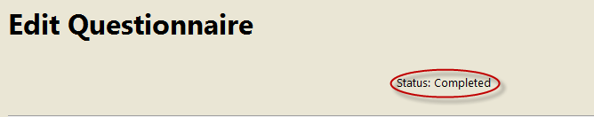

Extending a Request (Concurrent Review)
Step 1 | Locate the request that requires an extension. (Request/case or Member search)  Click the Extend link on the case line. | 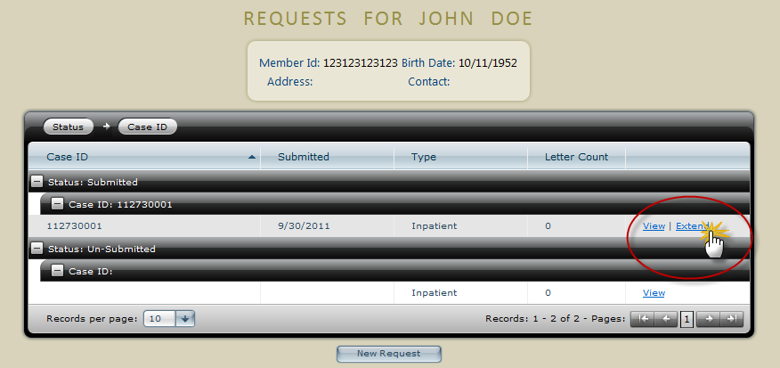
Step 2 | As an example, to add a day to a request, click Service Detail (1), and type in “1” in the Length of Stay field (2).  Click Next (3). | 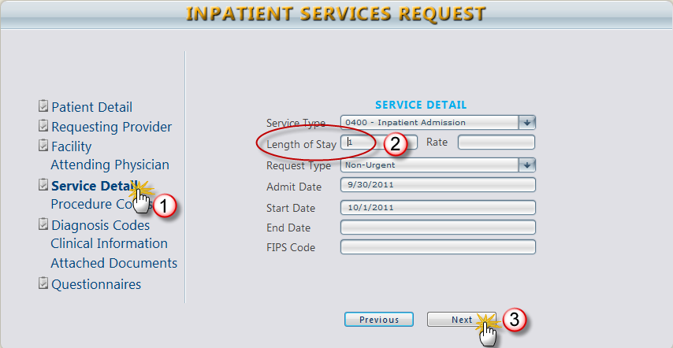
Step 3 | Update, add, delete, or change the remaining steps of the service request as needed.  (Ex., add a diagnosis code, add additional clinical information, or attach additional documents) | 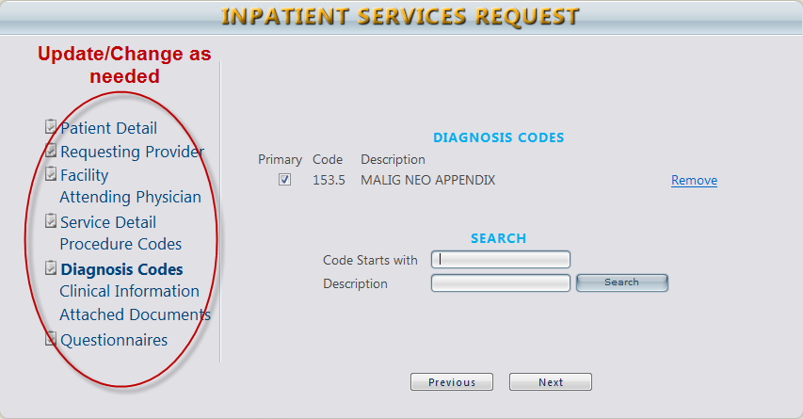
Continued on next page

Extending a Request (Concurrent Review), Continued
Step 4 | Click the disclaimer checkbox and click Submit. | 