10 June 2021
For Immediate Release

SDSC Launches Campaign to Rally Singapore Behind National Athletes
- Over 2000 students from seven schools have committed to the campaign to date
- Campaign includes distribution of children’s storybooks featuring world No. 1 para archer Nur Syahidah Alim, and buddy runs

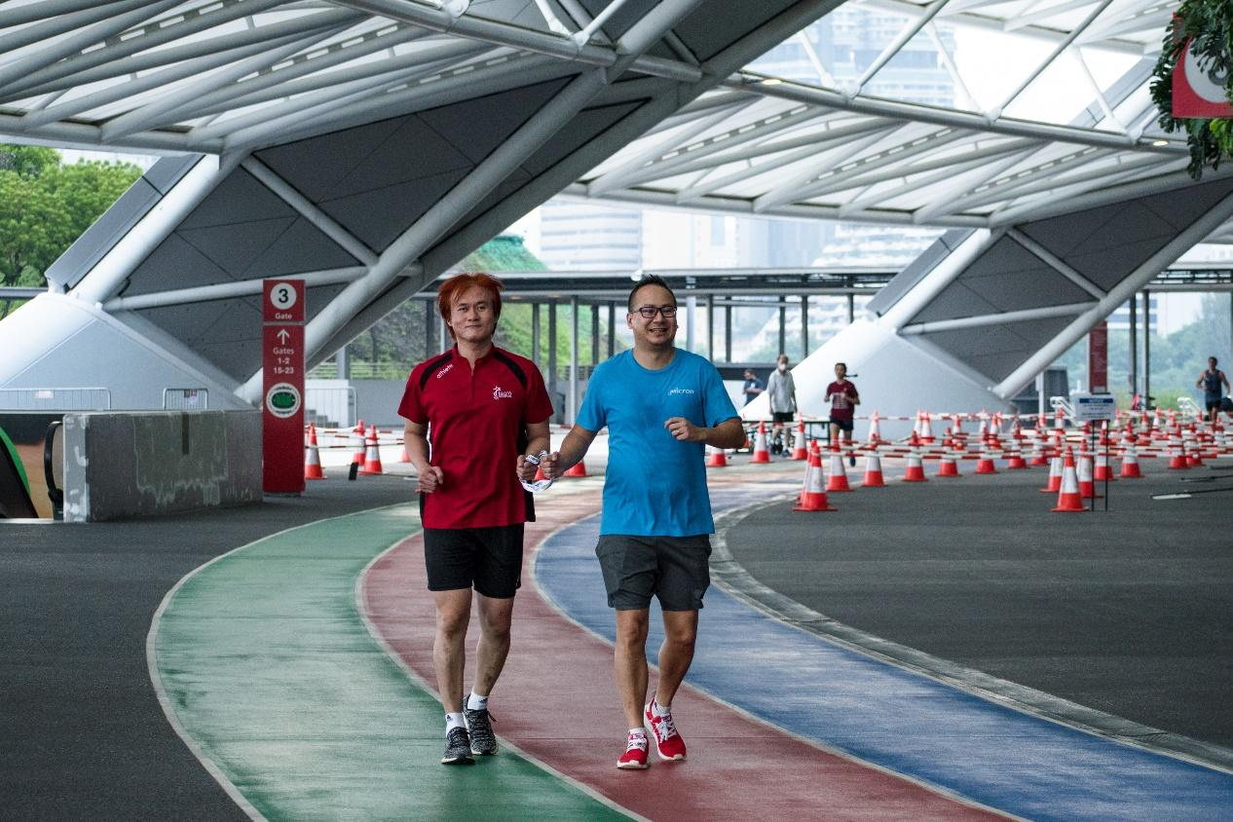
Singaporeans are encouraged to pair up to participate in the I’mPOSSIBLE Buddy Run 2021, like para athlete Mr Steve Tee (left) and Mr Kent Ho, Senior Manager, Micron (right), to try and achieve a collective distance of 10,625km in support of Singapore’s Paralympic team.

The Singapore Disability Sports Council (SDSC) has launched a campaign to rally Singaporeans to root for national athletes who are in their last stretch of qualifications for the Tokyo 2020 Paralympic Games. The campaign, called I’mPOSSIBLE Celebrations, will last till the end of the Paralympic Games in September 2021.

The highlight of the I’mPOSSIBLE Celebrations is the I’mPOSSIBLE Buddy Run 2021, a virtual run targeting a total collective distance of 10,625 km from participants. The figure marks a round-trip between Singapore and Tokyo, and symbolises a journey taken together with national athletes towards their aspirations. The run also takes on an interesting concept, where participants are encouraged to participate in pairs ($32), and take turns to blindfold themselves during the run. Modelled after the guided run event in the Paralympic Games that is designed for visually challenged competitors, it offers Singaporeans an experience of how Paralympians conquer their fears to achieve.

“Losing my sight made it seem impossible for me to play sports. Having a guide, for running, and a pilot, for cycling, makes it possible. When racing in the velodrome, I rely only on the words of my pilot and my blind faith in him. I am heartened to have the understanding and support from Singaporeans through this campaign. This helps make the impossible possible,” said Mr Steve Tee, a para cyclist who has qualified for the Tokyo 2020 Paralympic Games. This would be Singapore’s debut in the sport at the Paralympics Games.

To date, about 2,000 youth have collectively clocked a distance of 691 km through buddy runs organised by their schools. The SDSC hopes that more schools and members of the public can register for the run and play a part in achieving the distance of 10,625 km together.

The I’mPOSSIBLE Celebrations 2021 is made possible by Micron Foundation. Other activities that have been introduced as part of this campaign include colouring, drawing, writing and cheer competitions, and the launch of young reader storybooks featuring the story of Syahidah Alim, national archer and current world ranked number 1 in the Women’s Compound category for para archery.

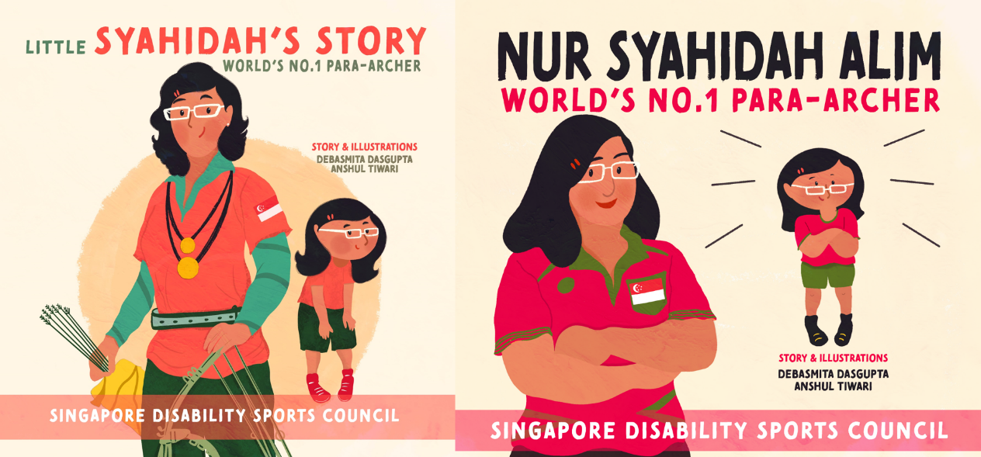The two storybooks about Nur Syahidah Alim’s sports journey are targeted at those aged 12 and below. Physical copies of the storybooks are on sale at $20 each.

“It takes enormous mental strength to reach the top. Often, an athlete gives up years of his or her life for that chance, while friends and peers move on ahead in theirs. Through this campaign, we want to tell our national athletes that we know what they’ve put in, and Singapore is behind them. We are grateful that Micron understands that, from their long-term partnership with us, and agreed to take this step with us,” shared Ms Kelly Fan, Executive Director, SDSC.

“We are committed to using Micron’s strengths and influence to create and promote an inclusive and equitable culture inside and outside of our business,” said Mr Chen Kok Sing, corporate vice president and Singapore country manager at Micron. “We are proud to partner with SDSC and support Singapore’s para athletes through this inspiring community event.”

Schools and members of the public are encouraged to visit https://sdsc.org.sg/impossible-celebrations-2021 to find out how they can participate in the campaign.

###

For high-resolution images (please credit SDSC or otherwise stated), download from: http://bit.ly/MediaImPOSSIBLECelebrations2021

Annex A: I’mPOSSIBLE Celebrations 2021
Annex B: I’mPOSSIBLE Buddy Run 2021
Annex C: I’mPOSSIBLE Storybooks
Annex D: I’mPOSSIBLE Colouring Competition

For media enquiries and interviews, please direct to:
Ms Stefanie Pitchian
Corporate Communications Executive
Singapore Disability Sports Council
Email: stefanie.pitchian@sdsc.org.sg
Contact: 8157 4165

Mr Lim Wei Hao
Acting Assistant Manager, Corporate Communications
Singapore Disability Sports Council
Email: lim.weihao@sdsc.org.sg
Contact: 9189 2553

About Singapore Disability Sports Council
The SDSC is the national sports body for Persons with Disabilities (PWDs), founded in 1973. It aims to transform the lives of PWDs through sport as a form of rehabilitative therapy, and means to realise their potential. Besides providing platforms for learning sport, SDSC trains talents to represent Singapore at regional and international competitions. Our success stories include Yip Pin Xiu, who was Singapore's first Paralympic gold medallist and the first para athlete to become a Nominated Member of Parliament. Find out more at www.sdsc.org.sg.

About Micron and Micron Foundation
We are an industry leader in innovative memory and storage solutions. Through our global brands — Micron® and Crucial® — our broad portfolio of high-performance memory and storage technologies, including DRAM, NAND, and NOR, is transforming how the world uses information to enrich life. Backed by more than 40 years of technology leadership, our memory and storage solutions enable disruptive trends, including artificial intelligence, 5G, machine learning and autonomous vehicles, in key market segments like mobile, data center, client, consumer, industrial, graphics, automotive, and networking. Our common stock is traded on the Nasdaq under the MU symbol.

Since its founding in 1999, the Micron Foundation, a private non-profit entity has contributed over $100 million through philanthropy and people to communities where our team members live and work. The Foundation and Micron's corporate giving are driven by the Micron Gives organization with grants, programs and volunteer efforts focused on promoting science and engineering education, addressing basic human needs, as well as providing equitable opportunities to succeed.

To learn more about Micron Technology, Inc. (Nasdaq: MU), visit www.micron.com.

Annex A: I’mPOSSIBLE Celebrations 2021

Activities under I’mPOSSIBLE Celebrations 2021

Activities | Date | Target Audience | Deadline for Submission
I’mPOSSIBLE Storybooks | 26 April to 30 September 2021 | Preschool students  Primary School students | Ordering of storybooks: 9 July 2021
I’mPOSSIBLE Buddy Run 2021 (decentralised) | 18 February to 30 September 2021 | Primary School students  Secondary School students  Tertiary School students | 30 September 2021
I’mPOSSIBLE Colouring Competition | 18 February to 30 June 2021 | Preschool students | 30 June 2021
I’mPOSSIBLE Creative Cheer Competition | 18 February to 30 June 2021 | Preschool students  Primary School students  Secondary School students  Tertiary School students | 30 June 2021
I’mPOSSIBLE Art Competition | 18 February to 30 September 2021 | Primary School Students (P1-P3) | 30 September 2021
I’mPOSSIBLE Creative Writing Competition | 18 February to 30 September 2021 | Primary School students (P4-P6) | 30 September 2021
I’mPOSSIBLE Buddy Run 2021 | 10 June to 31 August 2021 | Public | 30 September 2021

Annex B: I’mPOSSIBLE Buddy Run 2021

Price Table and Entitlements

I’mPOSSIBLE Buddy Run 2021
Category | Minimum Distance | Price | Entitlements
Individual | 4.8km | $18 | 1 x medal  1 x e-certificate
Pair | 4.8km | $32 | 2 x medal  2 x e-certificates

I’mPOSSIBLE Buddy Run 2021 Registration Link

Members of the public can register here: http://bit.ly/BuddyRun2021

Key Dates

Date | Action
10 June 2021 | Registration for I’mPOSSIBLE Buddy Run 2021 opens
30 August 2021 | Registration for I’mPOSSIBLE Buddy Run 2021 closes
30 September 2021 | Submission of run results and achievements
1 to 30 November 2021 | Entitlements to be mailed out

Annex C: I’mPOSSIBLE Storybooks

I’mPOSSIBLE E-storybooks

Little Syahidah's Story (Beginners Book for ages 6 and below):
http://bit.ly/SDSCEBookLittleSyahidah

Nur Syahidah Alim (Early Reader Book for ages 7 to 12) http://bit.ly/SDSCEBookSyahidah

Members of the public are invited to order physical versions of the I’mPOSSIBLE Storybooks here: http://bit.ly/PublicOrderSDSCBooks

Annex D: I’mPOSSIBLE Colouring Competition

Open to children aged 6 and below, the I’mPOSSIBLE Colouring Competition invites participants to express creativity as they colour templates of Singapore’s aspiring Paralympians, such as Nur Syahidah Alim and Steve Tee Wee Leong.

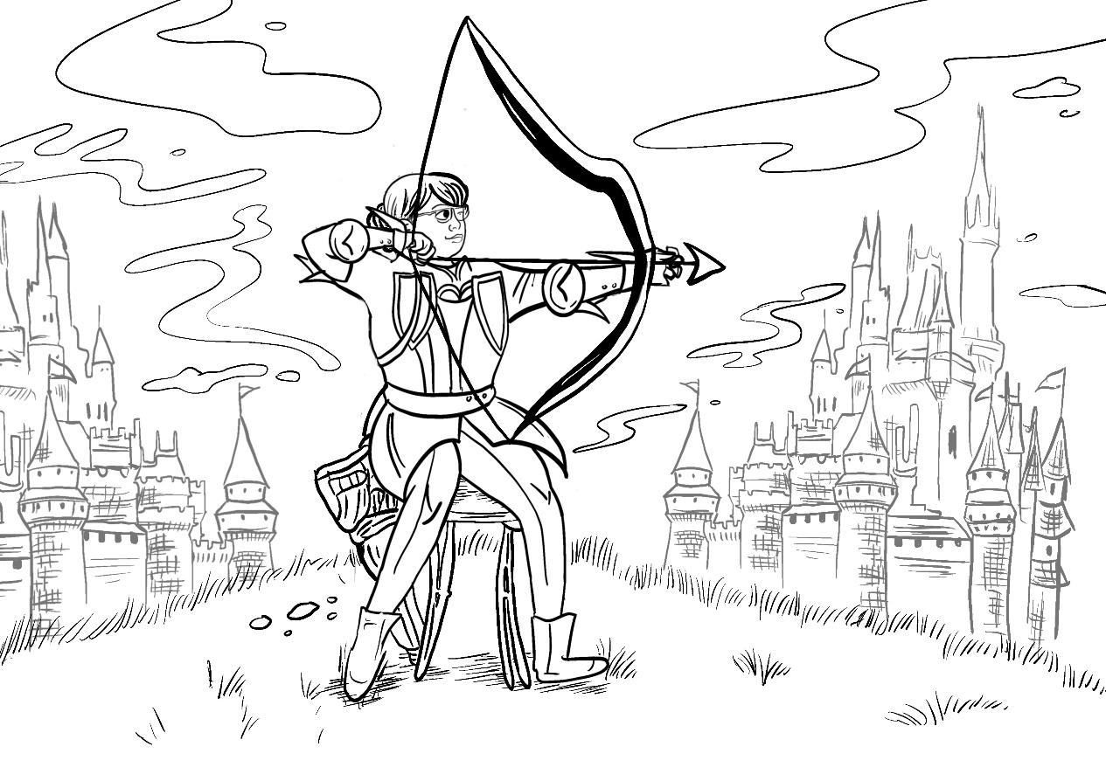
Shown above is Nur Syahidah Alim
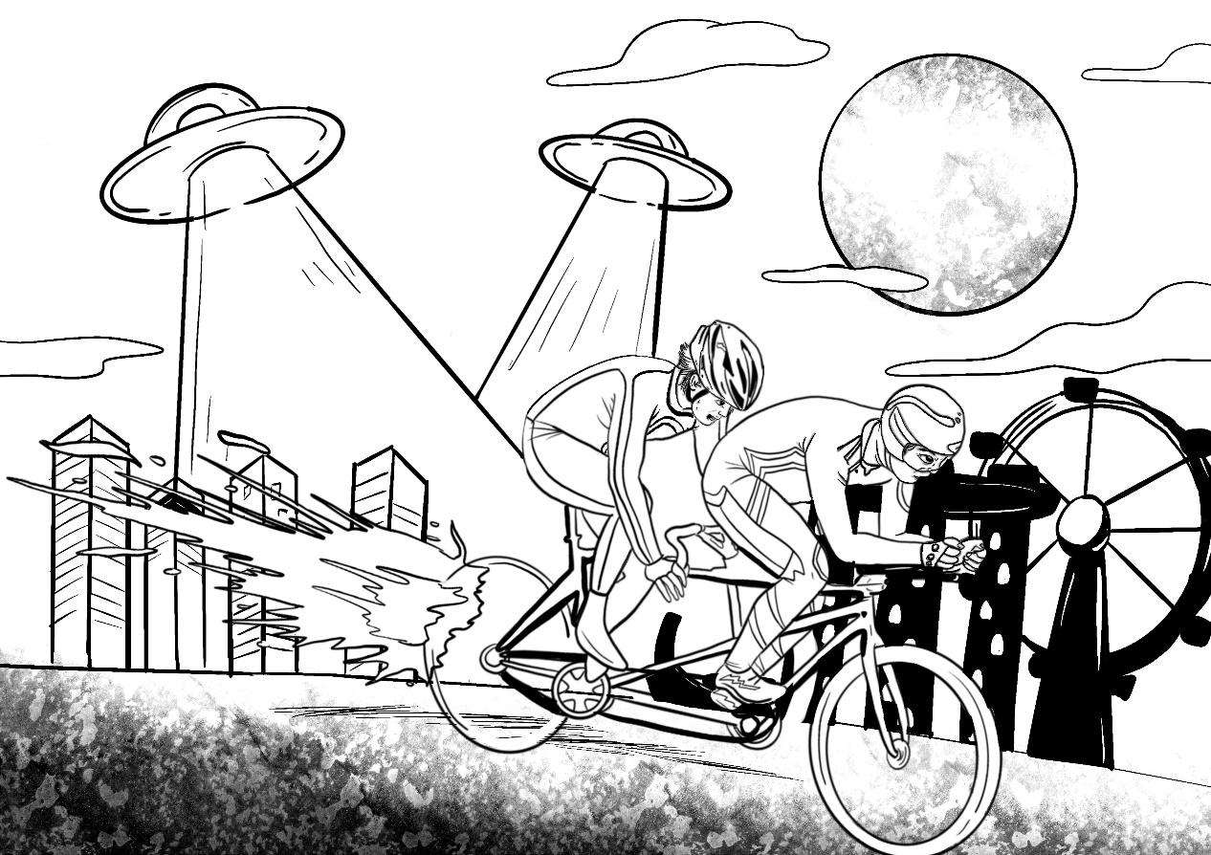
Shown above are Steve Tee (left) and pilot Ang Kee Meng (right)

