PERALTA COMMUNITY COLLEGE DISTRICT
District Academic Senate
District Academic Senate Special Meeting
Tuesday, January 29, 2019, 2:30 – 4:30 PM
District Board Room

Present: Donald Moore (President), Kelly Pernell (VP), Rochelle Olive (Treasurer), Mario Rivas, (Secretary),Fred Bourgoin, President Laney; Joseph Bielanski (BCC); Eleni Gastis (Laney), Blake Johnson (Laney); Catherine Nicholls (BCC), Thomas Renbarger

Absent:
Guest(s): Inger Start; Siri Brown; Scott Hoshida
AGENDA ITEM | SUMMARY OF DISCUSSION | FOLLOW UP ACTION
- Call to Order: Agenda Review | Agenda Approved unanimously  Motion to move action items up tp 1 | Gastis, Bourgoin
2. No review of previous minutes
- For Action and/or Consideration:  - Status and timeline for ONE Peralta  - VCAA Brown update  DAS call for No-confidence or censure call toward Chancellor and/or BOT  Motion to extend meeting by 10 minutes approved  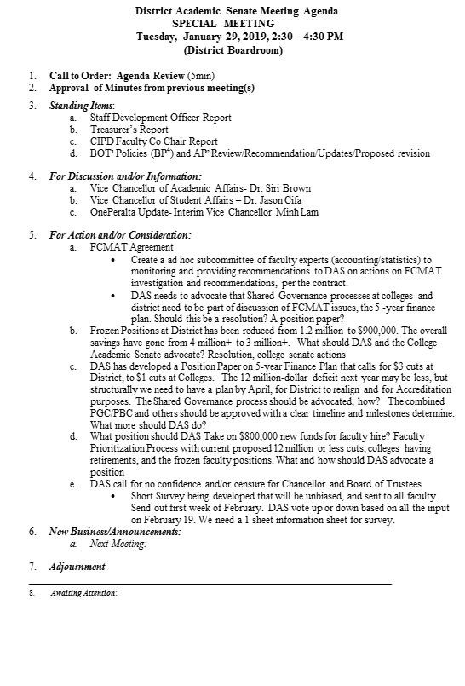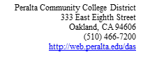  - Treasurer’s Report  - CIPD Faculty Co Chair Report  - BOT¹ Policies (BP⁴) and AP² Review/Recommendation/Updates/Proposed revision  - For Discussion and/or Information:  - Vice Chancellor of Academic Affairs- Dr. Siri Brown  - Vice Chancellor of Student Affairs – Dr. Jason Cifa  - OnePeralta Update- Interim Vice Chancellor Minh Lam  - College DE committee appointments  - New Business/Announcements:  - Next Meeting:  - Adjournment  _______________________________________________________________________  - Awaiting Attention: | 3a. VC Mihn Lam presented status of ONE Peralta.  All money previously allocated to ONE Peralta has been spent. Initially, underlining details were not defined as well as costs were not detailed for HR; The Student portion was also not well-developed, including project scope and timeline, e.g., we did not have a clear production process in place, which eventually fell apart.  Finance portion of ONE Peralta has been completed, and now moving into next steps for ONE Peralta, including integration of 4 systems: Finance, HR, Student, and Passport.  Time frame: overall project will depend on scope of project:  The plan will describe all that needs to be done, and will include costs.  Important: We need to have a clear delineation of all aspects of the work that will be completed including total costs.  “As we move forward, can we afford to wait for a new version. Build efficiency in the current system…but tailor what we build to be able to adapt more easily to a new system, version.”  What are the immediate milestones and timelines: getting committees together; what does it take to move to the azure cloud, including costs; increasing “mobility” w/o changing the look of the system…issue: we’re still not seeing timelines and deliverables.  Action: DAS is requesting an Executive Summary for the ONE Peralta project, including the committee structure that will support the project effectively moving the ONE Peralta project to completion.  VCAA Brown noted that VCIT Lam will be facilitating the development of a new Technology Plan for PCCD  DAS senators should be completing reaction to PCCD Non-Credit Plan  FCMAT: Should DAS have a group of faculty experts that familiarize themselves on FCMAT recommendations, and then make recommendations to DAS regarding  Motion: Create an ad hoc subcommittee of faculty experts (accounting/statistics) to monitor and provide recommendations to DAS on actions on FCMAT investigation and recommendations.  One argument for the motion is that in taking this action we are building capacity among the faculty  to be more knowledgeable about finance and auditing procedures.  One argument against the motion is that a faculty-only group is leaving out classified and administrative individuals who should be involved in understanding finance.  Motion was tabled following the FCMAT orientation that will be conducted at the beginning of February.  PCCD Response to ACCJC request for a Peralta 5-year Plan to improve fiscal viability.  Two meetings are planned for Friday, February 1 to organize the work of two committees, a Finance-focused committee and an Enrollment Management and Student Success Committee-focused committee.  Discussion ensued regarding the importance of ensuring that faculty at all the campuses are informed about the on-going process of the work to respond to the ACCJC request for a 5-year fiscal plan for PCCD;  VCAA Brown was cautioned regarding the importance for on-going work on the ACCJC response to constantly pay attention to faculty input and consultation. She assured DAS that this would happen.  Discussion addressed how to move forward on whether or not to move forward on a vote of Confidence/No Confidence vote on Chancellor Laguerre’s administration.  All the colleges have done some discussion with faculty regarding the issue of how to challenge the perceived problems on the part of the Chancellor and/or BOT with respect to running the district.  The Merritt College discussions led to a request that DAS develop an information update and request for direction from all faculty in the district regarding how to proceed with respect to challenging the administration of the Chancellor and/or BOT. A sample survey was shared with DAS.  In the DAS discussions of this topic, there was some confusion regarding how the DAS is to proceed to the vote of No-Confidence and/or Censure of the Chancellor and/or BOT. DAS President Moore was adamant that the action to be taken will be by the DAS members, with input from campus faculty following sharing of the concerns of the DAS regarding the Chancellor and Board. This means that in the end the DAS will vote on what action to take regarding challenging the Chancellor and/or Board.  It was suggested that the DAS needs to monitor use of Robert’s Rules to ensure completing meeting agenda items within the time allotted for the meeting.

Abbreviations:
- DAS – District Academic Senate
- PCCD – Peralta Community College District
- BOT – Board of Trustees
- DAC – District Administrative Center
- AP – Administrative Procedure
- BP – Board Policy

Title 5 §53200 DEFINITIONS [Source: http://www.asccc.org/communities/local-senates/handbook/partI. Retrieved 10/28/11.]
Academic Senate means an organization whose primary function is to make recommendations with respect to academic and professional matters.
Academic and Professional matters means the following policy development matters:
1. Curriculum, including establishing prerequisites.
2. Degree and certificate requirements.
3. Grading policies.
4. Educational program development.
5. Standards or policies regarding student preparation and success.
6. College governance structures, as related to faculty roles.
7. Faculty roles and involvement in accreditation processes.
8. Policies for faculty professional development activities.
9. Processes for program review.
10. Processes for institutional planning and budget development.
11. Other academic and professional matters as mutually agreed upon.
Consult collegially means that the district governing board shall develop policies on academic and professional matters through either or both of the following:
1. Rely primarily upon the advice and judgment of the academic senate, OR
2. The governing board, or its designees, and the academic senate shall reach mutual agreement by written resolution, regulation, or policy of the governing board effectuating such recommendations.
§ (SECTION) 53203 POWERS
A) The governing board shall adopt policies for the appropriate delegation of authority and responsibility to its college academic senate.
B) In adopting the policies described in section (a), the governing board or designees, shall consult collegially with the academic senate.
C) While consulting collegially, the academic senate shall retain the right to meet with or appear before the governing board with respect to its views and recommendations. In addition, after consultation with the administration, the academic senate may present its recommendations to the governing board.
D) The governing board shall adopt procedures for responding to recommendations of the academic senate that incorporate the following:
1. When the board elects to rely primarily upon the advice and judgment of the academic senate, the recommendation of the senate will normally be accepted, and only in exceptional circumstances and for compelling reasons will the recommendations not be accepted.

