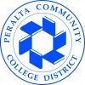
2020-21 Program Review – Instructional

Program Overview
Please verify the mission statement for your program. If there is no mission statement listed, please add it here.

List your Faculty and/or Staff

The Program Goals below are from your most recent Program Review or APU. If none are listed, please add your most recent program goals. Then, indicate the status of this goal, and which College and District goal your program goal aligns to. If your goal has been completed, please answer the follow up question regarding how you measured the achievement of this goal.

Describe your current utilization of facilities, including labs and other space

Enrollment Trends
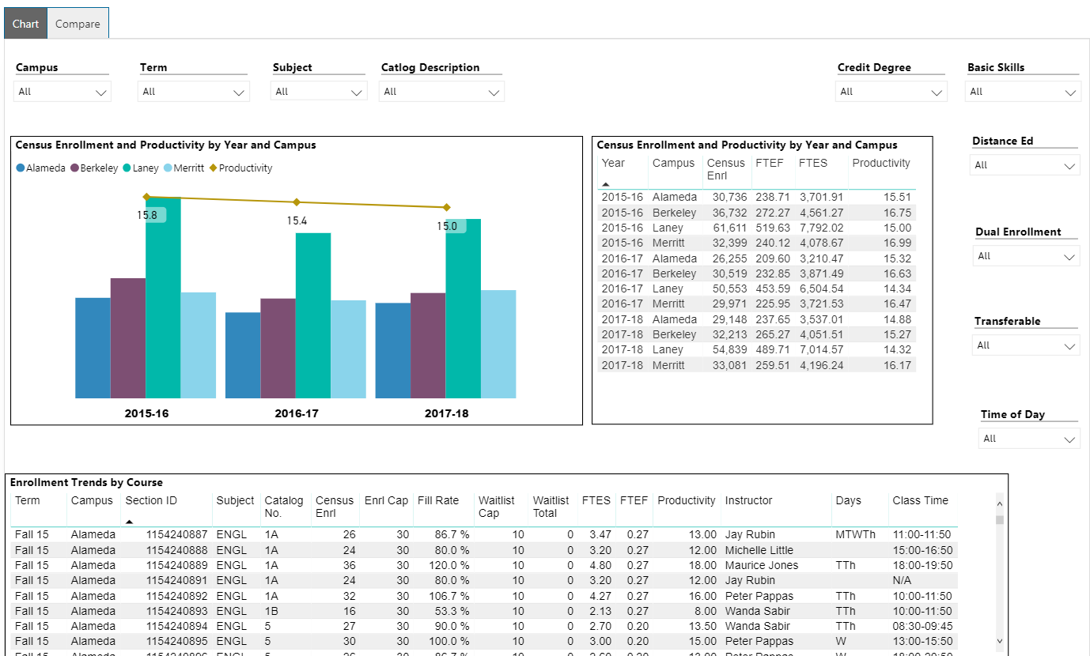
Enrollment Trends Power BI dashboard
Note: Please consider the most recent 3 years when answering the questions below.
Set the filters above to your discipline, and discuss enrollment trends over the past three years

Set the filter above to consider whether the time of day each course is offered meets the needs of students.

Are courses scheduled in a manner that meets student needs and demands? How do you know?

Describe effective and innovative teaching strategies used by faculty to increase student learning and engagement.

How is technology used by the discipline, department?

How does the discipline, department, or program maintain the integrity and consistency of academic standards with all methods of delivery, including face to face, hybrid, and Distance Education courses?

Curriculum
Please review your course outlines of record in CurricUNet Meta to determine if they have been updated or deactivated in the past three years. Specify when your department will update each one, within the next three years.

CurriQunet Meta
Please summarize the Discipline, Department or program of study plans for curriculum plans for improvement. Below, please provide details for individual course improvement. Add plans for new courses here.

Assessment – Instructional
Student Learning Outcomes Assessment
List your Student Learning Outcomes

Were there any obstacles experienced during assessment? What worked well? (Mainly based on evidence in the report, attach other evidence as necessary)

What percent of your programs have been assessed? (mainly based on evidence in the report, attach other evidence as necessary; note: a complete program assessment means all Program Learning Outcomes (PLOs) have been assessed for that program)

How has your dept worked together on assessment (planning together)? Describe how your dept works well on assessment? Describe things that went well or obstacles. What aspects of assessment work went especially well in your department and what improvements are most needed?
Collaboration

Leadership Roles

Planning Process

Dept meetings for Collaboration

Data Analysis

What were the most important things your department learned from assessment? Did implementation of your action plans result in better student learning? In other words, how has your department used the results of assessment to improve student learning and/or curriculum? Please be as detailed as possible.

Does your department participate in the assessment of multidisciplinary programs? If Yes, Describe your department's participation and what you learned from the assessment of the program that was applicable to your own discipline.

Does your department participate in your college's Institutional Learning Outcomes (ILOs) assessment? If Yes, Please describe your departments participation in assessing Institutional Learning Outcomes.

What support does your department need from administrators, assessment coordinators and/or your campus assessment committee to continue to make progress in assessment of outcomes and implementation of action plans?

Please verify the mission statement for your program. If there is no mission statement listed, please add it here.
Course Completion
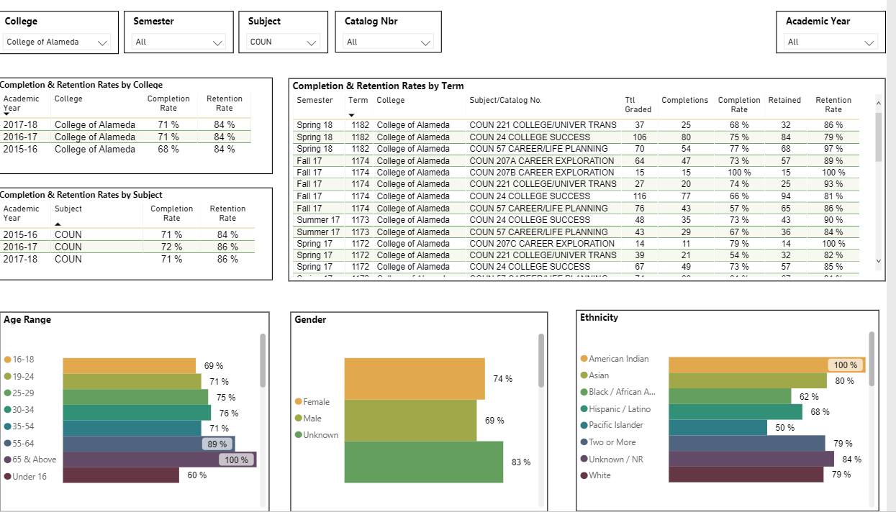
Course Completion Power BI Dashboard
Consider your course completion rates over the past three years (% of student who earned a grade of "C" or better).
Use the filters on the top and right of the graphs to disaggregate your program or discipline data. When disaggregated, are there any groups whose course completion rate falls more than 3% points below the discipline average? If so, indicate yes and explain what your department is doing to address the disproportionate impact for the group.
Age

Ethnicity

Gender
Foster Youth Status

Disability Status

Low Income Status

Veteran Status

Consider your course completion rates over the past three years by mode of instruction. What do you observe?
Face-to-Face

Hybrid

100% Online

Dual Enrollment

Day time

Evening

How do the course completion rates for your program or discipline compare to your college's Institution-Set Standard for course completion?

How do the department's Hybrid course completion rates compare to the college course completion standard?

Are there differences in course completion rates between face to face and Distance Education/hybrid courses? If so, how does the discipline, department or program deal with this situation? How do you assess the overall effectiveness of Distance Education/hybrid course?

Describe the course retention rates over the last three years. If your college has an Institution-Set Standard for course retention, how does your program or discipline course retention rates compare to the standard?

What has the discipline, department, or program done to improve course completion and retention rates?

Degrees & Certificates Conferred
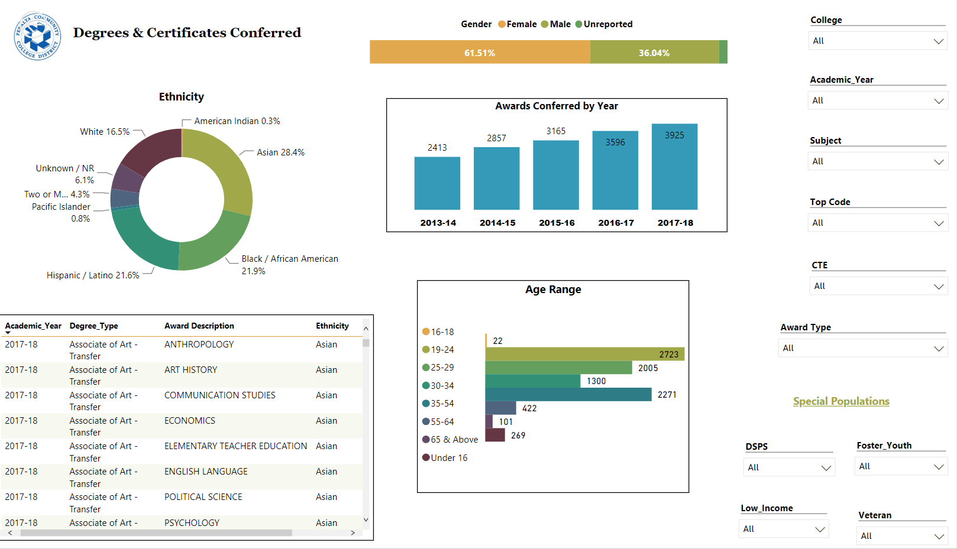
Degrees & Certificates Power BI dashboard
What has the discipline, department, or program done to improve the number of degrees and certificates awarded? Include the number of degrees and certificates awarded by year, for the past three years.

Over the next 3 years, will you be focusing on increasing the number of degrees and certificates awarded?

What is planned for the next 3 years to increase the number of certificates and degrees awarded?

Engagement
Discuss how faculty and staff have engaged in institutional efforts such as committees, presentations, and departmental activities. Please list the committees that full-time faculty participate in.

Discuss how faculty and staff have engaged in community activities, partnerships and/or collaborations.

Discuss how adjunct faculty members are included in departmental training, discussions, and decision-making.

Prioritized Resource Requests Summary
In the boxes below, please add resource requests for your program. If there are no resource requested, leave the boxes blank.
Resource Category | Description/Justification | Estimated Annual Salary Costs | Estimated Annual Benefits Costs | Total Estimated Cost
Personnel: Classified Staff

Personnel: Student Worker

Personnel: Part Time Faculty

Personnel: Full Time Faculty

Resource Category | Description/Justification | Total Estimated Cost
Professional Development: Department wide PD needed

Professional Development: Personal/Individual PD needed

Prioritized Resource Requests Summary - Continued

Resource Category | Description/Justification | Total Estimated Cost
Supplies: Software

Supplies: Books, Magazines, and/or Periodicals

Supplies: Instructional Supplies

Supplies: Non-Instructional Supplies

Supplies: Library Collections

Resource Category | Description/Justification | Total Estimated Cost
Technology & Equipment: New

Technology & Equipment: Replacement

Prioritized Resource Requests Summary - Continued

Resource Category | Description/Justification | Total Estimated Cost
Facilities: Classrooms

Facilities: Offices

Facilities: Labs

Facilities: Other

Resource Category | Description/Justification | Total Estimated Cost
Library: Library materials

Library: Library collections

Resource Category | Description/Justification | Total Estimated Cost
OTHER

