2020-21 Program Review – Student Services

Program Overview
Please verify the mission statement for your program. If there is no mission statement listed, please add it here.

List your Faculty and/or Staff

The Program Goals below are from your most recent Program Review or APU. If none are listed, please add your most recent program goals. Then, indicate the status of this goal, and which College and District goal your program goal aligns to. If your goal has been completed, please answer the follow up question regarding how you measured the achievement of this goal.

Describe your current utilization of facilities, including labs and other space

Students Served
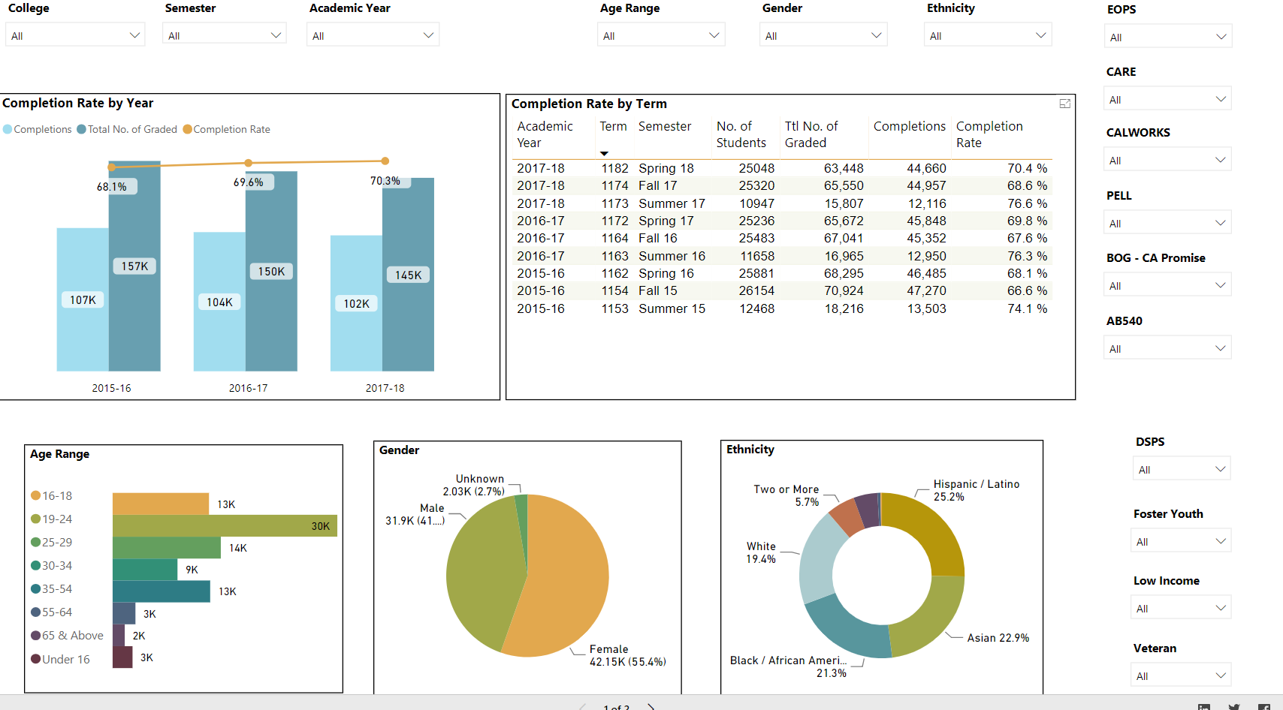
Special Populations Power BI dashboard
Please enter your College Mission Statement

Please enter your Student Services Mission Statement

Please include the essential functions of your department, program or unit, any unique characteristics or trends affecting the unit, as well as a description of how the unit aligns with the college mission

Please discuss the relationship and engagement with other support services, programs, and/or instruction or administrative units and how these relationships support the department, program or unit to meet its goals.

Please describe how external factors (if applicable), such as State and Federal laws, advisory board recommendations, changing demographics, etc. have an impact on the support services your department, program or administrative unit provides.

Filter for your Service Area's Student Group in the data dashboard above. Examine the demographics of the students your Area has served over the past three years. Be sure to consider student sub-populations, particularly student status in terms of: gender, race and ethnicity, age range, veterans’ status, foster youth status, disability status, low income status. Briefly explain the changes in students served by your department or unit over the past three years and any disparities in outcomes. If there are disparities, please create an 'improvement action' below to address them.

Does your department, program or service area provide Student Success & Support Program (SSSP) services?

Please provide the following information about these specific SSSP services, as applicable, for students in your program or college over the past three years:
# of student that completed orientation

# of students that completed assessment

# of completed Student Educational Plans (SEPs)

# of Abbreviated versus Comprehensive SEPs

Total # of follow-up services

What has your service area done over the last 2-3 years to improve SSSP services?

Describe your current level of staff, including full-time and part-time faculty, classified staff, and other categories of employment.

Students Served – Assessment
List your Service area outcomes

How does your department, program, or unit ensure that students are aware of learning or service area outcomes?

Where are the service area and/or program level outcomes published? If on a website, please specify the URL.

Briefly describe at least three of the most significant changes/improvements your department, program or service area made in the past three years as a response to analysis and discussion of program level outcomes and/or service area assessment results. Please state the service area outcome and assessment cycle (year) for each example.

Briefly describe three of the most significant plans for service area improvements for the next three years as a result of what you learned during the Assessment process.

What do members of your service area do to ensure that meaningful dialogue takes place in both developing and assessing your service area outcomes?

Briefly describe the results of any student satisfaction surveys or college surveys that included evaluation and/or input about the effectiveness of the services provided by your department, program or administrative unit. How has this information informed department, program or administrative unit planning and goal setting?

How do you know that your program is effective? What are the indicators that measure your effectiveness? What are the expected results of these indicators?

Engagement
Discuss how faculty and staff have engaged in institutional efforts such as committees, presentations, and departmental activities. Please list the committees that full-time faculty participate in.

Discuss how faculty and staff have engaged in community activities, partnerships and/or collaborations.

Discuss how adjunct faculty members are included in departmental training, discussions, and decision-making.

Prioritized Resource Requests Summary
In the boxes below, please add resource requests for your program. If there are no resource requested, leave the boxes blank.
Resource Category | Description/Justification | Estimated Annual Salary Costs | Estimated Annual Benefits Costs | Total Estimated Cost
Personnel: Classified Staff

Personnel: Student Worker

Personnel: Part Time Faculty

Personnel: Full Time Faculty

Resource Category | Description/Justification | Total Estimated Cost
Professional Development: Department wide PD needed

Professional Development: Personal/Individual PD needed

Prioritized Resource Requests Summary - continued

Resource Category | Description/Justification | Total Estimated Cost
Supplies: Software

Supplies: Books, Magazines, and/or Periodicals

Supplies: Instructional Supplies

Supplies: Non-Instructional Supplies

Supplies: Library Collections

Resource Category | Description/Justification | Total Estimated Cost
Technology & Equipment: New

Technology & Equipment: Replacement

Prioritized Resource Requests Summary – continued

Resource Category | Description/Justification | Total Estimated Cost
Facilities: Classrooms

Facilities: Offices

Facilities: Labs

Facilities: Other

Resource Category | Description/Justification | Total Estimated Cost
Library: Library materials

Library: Library collections

Resource Category | Description/Justification | Total Estimated Cost
OTHER

