2020-21 Annual Program Update

Program Overview
Please verify the mission statement for your program. If there is no mission statement listed, please add it here.

List your Faculty and/or Staff

The Program Goals below are from your most recent Program Review or APU. If none are listed, please add your most recent program goals. Then, indicate the status of this goal, and which College and District goal your program goal aligns to. If your goal has been completed, please answer the follow up question regarding how you measured the achievement of this goal.

Describe your current utilization of facilities, including labs and other space

Program Update
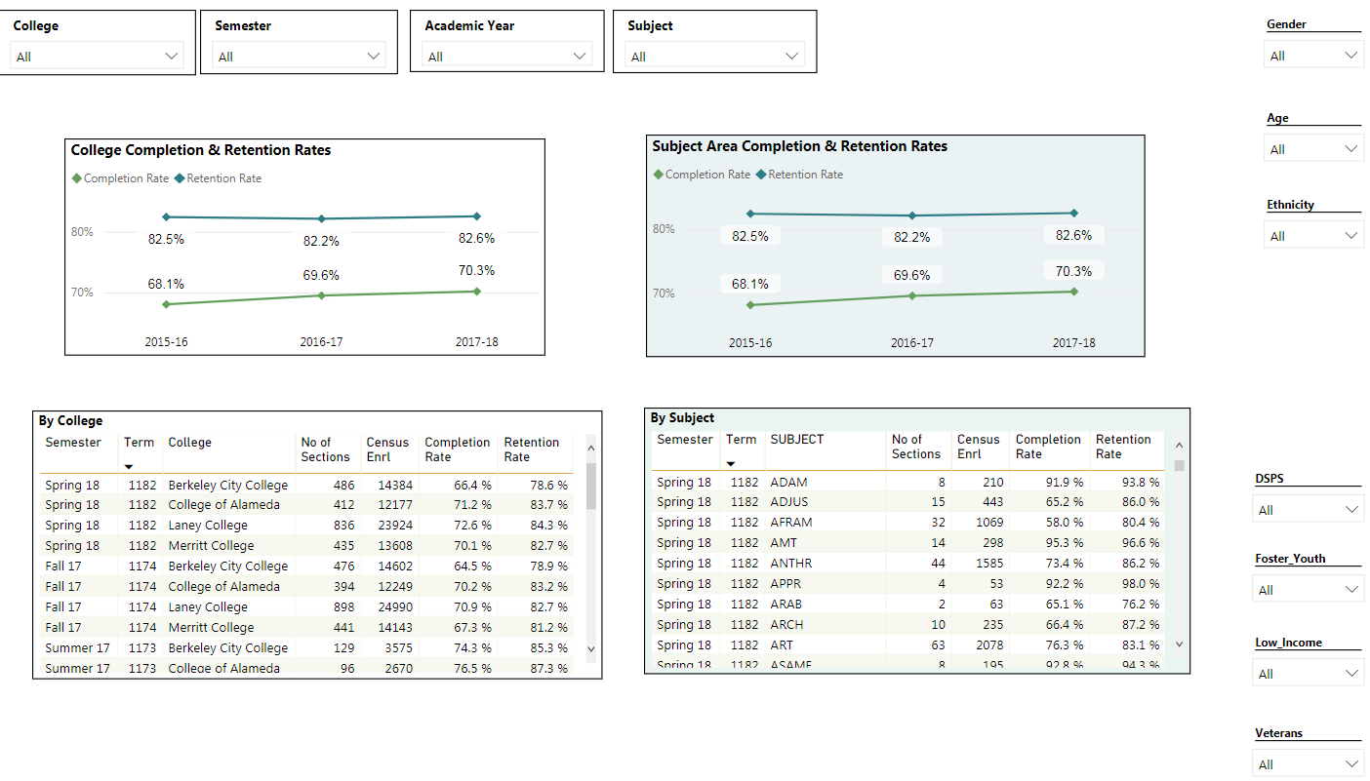
Program Update Power BI dashboard
Using the dashboard, review and reflect upon the data for your program. Describe any significant changes and discuss what the changes mean to your program. Consider whether performance gaps exist for disproportionality impacted students. Focus upon the most recent year and/or the years since your last comprehensive program review. Cite data points from the dashboard to support your answer.

Describe the department's progress on Student Learning Outcomes (SLOs) and/or Administrative Unit Outcomes (AUOs) since the last Program Review/APU. If your discipline offers a degree or certificate, please describe the department progress on Program Learning Outcomes (PLOs).

Describe the outcomes and accomplishments from previous year’s funded resource allocation request.
Brief description of funded request | Source (any additional award outside your base allocation) | Total Award Amount | Outcome/Accomplishment

Prioritized Resource Requests Summary
In the boxes below, please add resource requests for your program. If there are no resource requested, leave the boxes blank.
Resource Category | Description/Justification | Estimated Annual Salary Costs | Estimated Annual Benefits Costs | Total Estimated Cost
Personnel: Classified Staff

Personnel: Student Worker

Personnel: Part Time Faculty

Personnel: Full Time Faculty

Resource Category | Description/Justification | Total Estimated Cost
Professional Development: Department wide PD needed

Professional Development: Personal/Individual PD needed

Prioritized Resource Requests Summary - Continued

Resource Category | Description/Justification | Total Estimated Cost
Supplies: Software

Supplies: Books, Magazines, and/or Periodicals

Supplies: Instructional Supplies

Supplies: Non-Instructional Supplies

Supplies: Library Collections

Resource Category | Description/Justification | Total Estimated Cost
Technology & Equipment: New

Technology & Equipment: Replacement

Prioritized Resource Requests Summary - Continued

Resource Category | Description/Justification | Total Estimated Cost
Facilities: Classrooms

Facilities: Offices

Facilities: Labs

Facilities: Other

Resource Category | Description/Justification | Total Estimated Cost
Library: Library materials

Library: Library collections

Resource Category | Description/Justification | Total Estimated Cost
OTHER

