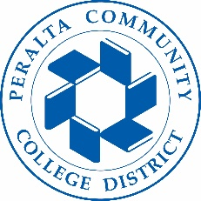

Office of Academic Affairs
AB 705: Planning for Student Success
July 11, 2018

Agenda

- Agenda Review:
- Clarify the Charge of the Group -- Siri and Amy – 10 min
  - Consistency in course offerings
  - Identify the research for support services and curricular changes
  - Guidance around legislation.
    - Data and methodology definitions
    - Clarifying the language and provide examples
- Update from English Faculty – 7/9 meeting – 30 min
- Cal Pass Plus/Launchboard Throughput data – Samantha and Dom – 30 min
- Review of Merritt tutoring – Samantha – 20 min

