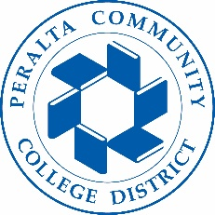

Office of Academic Affairs
AB 705: District Wide Planning/Preparation
October 23, 2018

Agenda

- Linked vs. Corequisites (10 minutes, Amany ElMasry, Curriculum Analyst)
- Credit to Noncredit Enrollment (10 minutes, Amany ElMasry, Curriculum Analyst)
- Onelin e English 1A Corequisite (5 minutes, Siri Brown, VC)
- Math Prerequisites (10 minutes, Siri Brown, VC)
- COA Self-Guided Placement Tool (15 minutes, Tina Vasconcellos, VPSS)
- Update from Key Areas:
  - Institutional Research
  - English
  - Math
  - Counseling
- Next Steps and Reminders:
  - October 31st all Colleges must decide on Math and English Courses for mandate
  - Curriculum Updates & New Courses to College CIC this Fall term
  - Chairs submit summer and FALL 2019 Schedule

