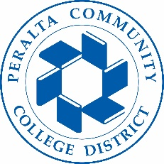

Office of Academic Affairs
AB 705: District Wide Planning/Preparation
September 23, 2018

Agenda

- July 11 Paper on AB 705 (Siri Brown, Lisa Cook)
- Timeline to Meet the Mandate (Siri Brown and All)
- Guiding Framework for Eng/Math Retreats (Lisa Cook)
- Math Report Out (Kathy Williamson and Dan Lawson)
- English Report Out (Eleni Grastis)
- Counseling Report Out
- Institutional Research Report Out (Dominique Benavides)
- Next Steps (All)

