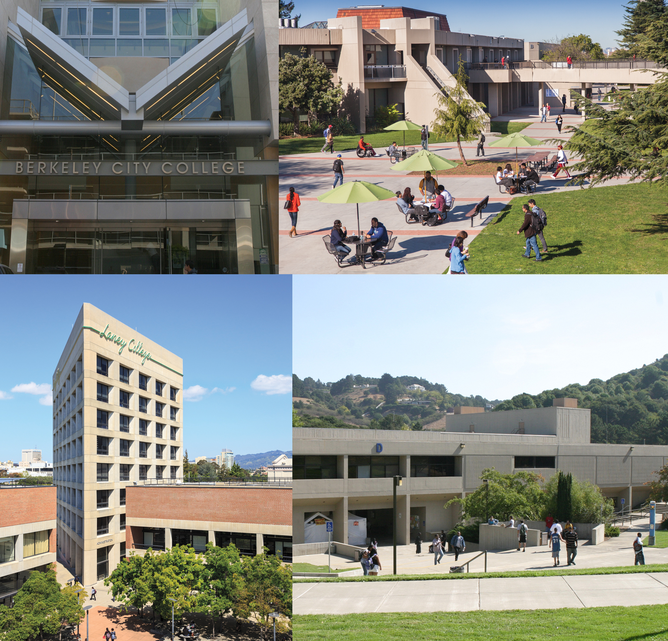

Peralta Community College District
2015 Strategic Plan

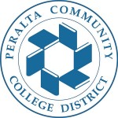

Peralta Community College District

2015 Strategic Plan

Message from the Chancellor
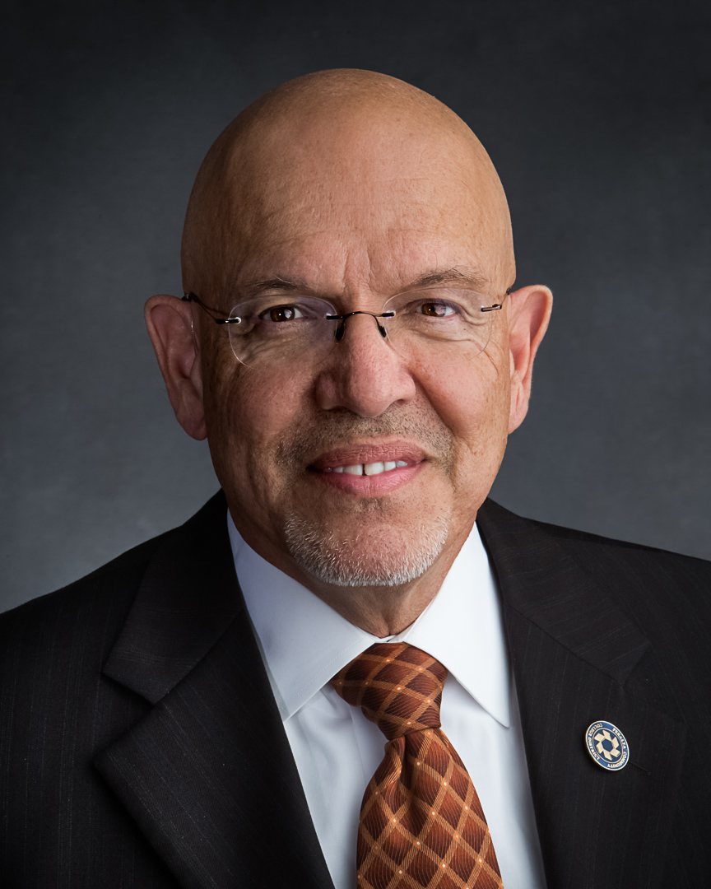
Since July 1, 1964, the Peralta Community College District has educated, trained, and mentored over a million individuals, and has developed and delivered programs to meet the educational demands of our community.
As we celebrate our 50th anniversary I am proud to say that Berkeley City College, College of Alameda, Laney College, and Merritt College have played a significant role in shaping the future and fabric of our community. Our priority has been student engagement and student success. For this to happen effectively, we focus on strategic planning, setting annual institutional objectives, and annually measuring our achievement of those objectives.
The Bay Area economy and job market have changed since 1964, and Peralta has been in sync with that change by delivering programs and services that sustainably enhance the region’s human, economic, environmental, and social development. Together with our educational and community partners, we provide our diverse students and communities with equitable access to educational resources, and life-long learning opportunities.
The Peralta Community College District 2015 Strategic Plan presents the strategic goals and institutional objectives the District’s four colleges will pursue in response to the rapidly changing educational and economic environment in the San Francisco Bay Area, and the State of California.
We are proud of our role in providing 50 years of public higher education to the East Bay and beyond, and invite you to learn more about the work we do. Take the time to read through this plan. Learn more about the strategic planning of our District as we reach out into the community to engage individuals to become students and achieve their long held dreams.
We look forward to 50 more successful years.
José M. Ortiz, Ed.D.
Chancellor
Peralta Community College District
Acknowledgements

Board of Trustees
Julina Bonilla
Meredith Brown, Board President
Cy Gulassa
Linda Handy
Carl Oliver, Student Trustee
William “Bill” Riley, Board Vice President
Jeramy Rolley, Student Trustee
Bill Withrow
Nicky Gonzalez Yuen

Faculty and Staff
Dr. Joseph Bielanski, Institutional Effectiveness Coordinator
PCCD Academic Senate
PCCD Classified Senate
Peralta Student Council
Planning and Budgeting Integration Model (PBIM) Committees:
District Education Committee (DEC)
District Facilities Committee (DFC)
District Technology Committee (DTC)
Planning and Budgeting Council (PBC)
Dr. Eun Rhee, Office of Institutional Research

Contents

I. Introduction 1
Historical Overview of the District 2
Plan Overview 3
Purpose of the Plan 4
2014-15 Strategic Planning Update Process 5

II. Guiding Framework 6
Mission 7
Principles 8
Values 9

II. Strategic Planning Context: Challenges and Opportunities 10
Mega Trends: Key Issues for Planning 11
External Scan: Alameda County 14
Internal Scan: PCCD Demographic Trends and Student Success Measures 24
Summary of Trends 36

IV. Strategic Goals and Institutional Objectives 37

V. Implementing the Strategic Plan 41

VI. Appendix 43

