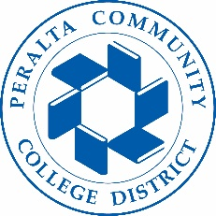

Office of Academic Affairs
AB 705: English
May 21, 2018

Agenda

- AB705: language and guidelines:

- Campus discussions on AB705 to date:

- English pathways at each college:

- District Wide coordination:

Next Steps:

