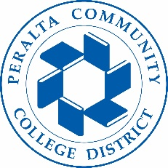

Office of Academic Affairs
AB 705: Math
May 22, 2018

Agenda

- AB705: language and guidelines:

- Campus discussions on AB705 to date:

- Math pathways at each college:

- District-w ide coordination:

Next Steps:

