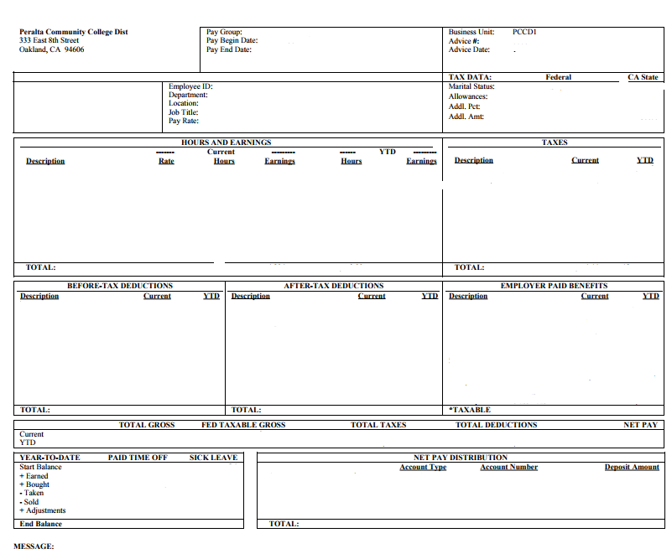

Your pay statement contains the following sections:

- Pay Period: Pay Begin and Pay End Date along with the Pay Group (used for payroll processing). These dates will reflect the period for which you are being paid. Your earnings may be increased or decreased based on certain events (such as eligible overtime worked, shift pay, or unpaid time off) that may have occurred from a previous period.

- Employee Specific Information: The Employee ID number is your identifier within the payroll system. Your Department, Location, Job Title and Pay Rate are shown here as they exist on your job record in Human Resources.

- Tax Data: This section shows the withholding allowances you are claiming for Federal and State along with any additional amount you have requested.

- Hours and Earnings: Shows the hours and earnings for which you are being paid this period. The earnings you have been paid during the calendar year – year to date (YTD) are also shown.

- Taxes: This section shows the taxes withheld from your current pay along with the YTD amounts withheld.

- Before-Tax Deductions: These items are deductions from your pay before federal and state withholding and, in some cases, before Medicare and Social Security taxes are calculated. This includes your cost of the benefits you have selected and contributions to your retirement account(s).

- After-Tax Deductions: These deductions are also withheld from your pay, but do not have an impact on your taxable wages. Deductions such as union dues, insurance deductions, garnishments, charity, etc.

- Employer-Paid Benefits: This section shows the value of any benefits paid by PCCD, such as employer paid retirement portions or employer paid medical/dental costs. Note: items marked with an asterisk * add to taxable wages as defined by IRS guidelines.

- Federal Taxable Gross: The amount that is subject to federal withholding taxes.

- Net Pay Total: Your net pay is your total gross earnings less taxes and any before or after tax deductions withheld. Net pay is also referred to as “take home” pay.

- Direct Deposit (Net Pay) Distribution: For direct deposit, this section shows how much of your net pay was deposited into your Checking or Savings Account.

