Hey Neighbor!
I have an important message for you regarding New York’s Fastest Fiber-Optic Internet Provider, Greenlight Networks. Greenlight Networks is company founded in Rochester, NY that is expanding to Buffalo, NY and building a fiber-optic network right to the home. Fiber-optic internet is faster and more affordable!
Greenlight is currently working on the pre-construction of the initial districts (find out what district you’re in on their interactive map ). The pre-construction process includes designing the network, acquiring access from the utility pole owners, preparing space on the utility poles for our fiber, and obtaining required easements from homeowners. Service is expected to be in the initial districts starting in late 2021. If you’re interested in learning more about the construction of a fiber-optic network, read their "5 Steps to Fiber" blog today!
The best way to stay in the loop with the status of your district is by signing up on greenlightnetworks.com! The Greenlight team will communicate changes in your district as they progress with their construction in the Buffalo area. Make sure you are not left behind! For more ways to help spread the word and educate about Greenlight, click here!
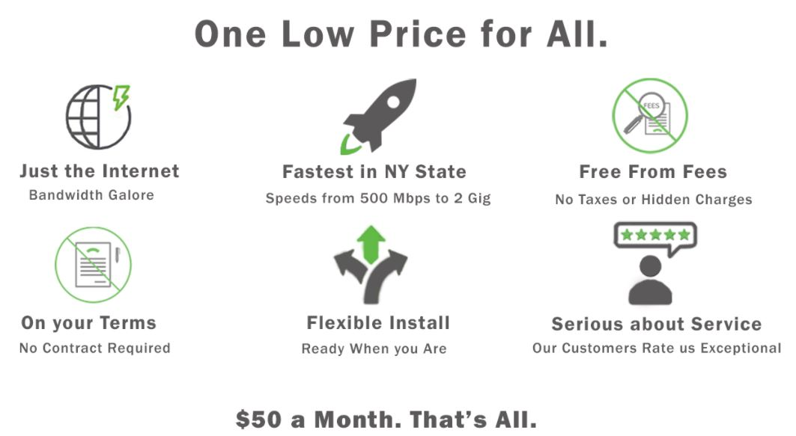

Sincerely,
(insert your name here)

