EXAMPLE EMAIL
We can email your clients their letters on your behalf. We’ve included the email template we use below. If you would like to include a personal message, please complete the form on the next page and your message will be included in the black box.
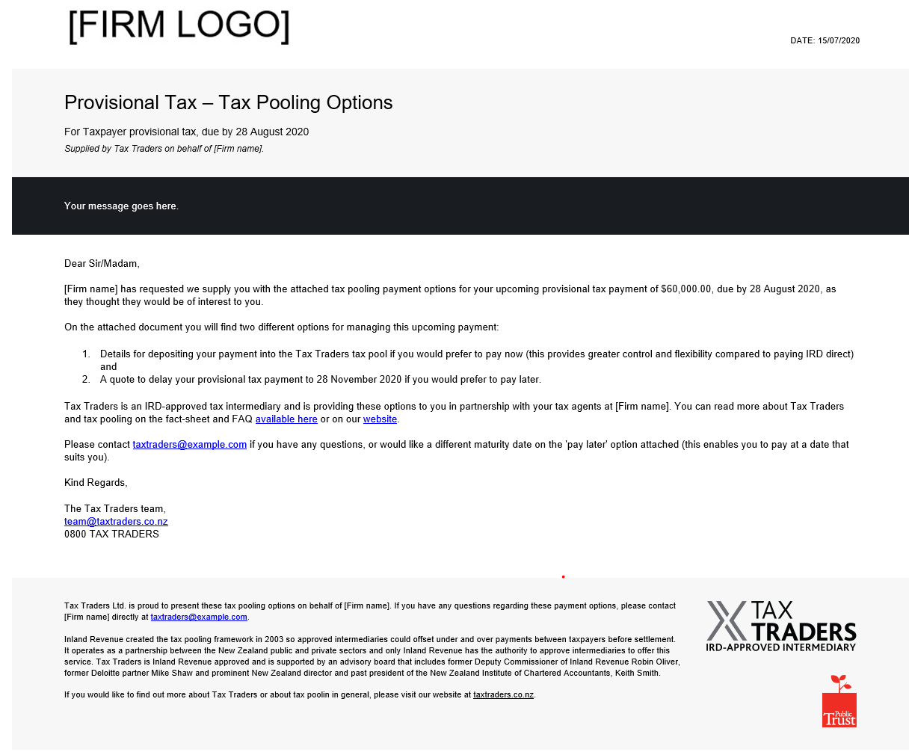

YOUR MESSAGE
Please include your message in the box below:
[Your message here]
Notes:
- Please keep your message to 2-3 sentences.
- You message will appear in plain text.
- Please do not include any italics, bold or other formatting such as hyperlinks or pictures.

