GREEN PACKET BOASTS STRONGER
POSITIVE EBITDA OF RM9.2 MILLION IN3Q
Records 19% increase in group revenue to RM159.8 million
Key Highlights:
- Group EBITDA increases to RM9.2 million, a 527% improvement Y-o-Y
- Group revenue for 3Q 2012 of RM159.8 million – an increase of 19% Y-o-Y
- P1 Pillar EBITDA contributes RM8.4 million, surges 49% in Q-o-Q, 182% Y-o-Y
- Revenue from P1 pillar improves 14%Y-o-Y through improved churn rate of 2.7% and strong ARPU of RM78
- Exceeds 500,000 total subscriber basewith 505,000 total, from last quarter’s 467,000
Kuala Lumpur, 28 November 2012: During the third financial quarter, Green Packet Berhad (The Group) delivered higher revenue of RM159.8 million, a 16% rise from RM138.3 million in quarter-on-quarter comparison. It also registered a better-than-expected RM9.2 million EBITDA in 3Q, 114% up from previous quarter’s RM4.3 million. Thus the Group has recorded three consecutive EBIDTA positive quarters throughout this year.
“It has been a good quarter for Green Packetagainst the backdrop of an overall lackluster period for the industry.We kept on saying the Group wouldturn-around and transform this year and so far we have delivered on this objective.We believe the positive trend will continue if we remain financially-disciplined in our operations and by applying stringent cost controls,”said Puan Chan Cheong, Group Chief Executive Officer and Group Managing Director of Green Packet Berhad.
Key Results
The Group’s P1 pillar contributes RM82 million to the Group’s revenue and registers a positive EBITDA ofRM8.4 million for the third quarter 2012. This represents a 182% improvement y-o-y from the loss reported previously.
An additional 38,000 customers signed up for P1’s latest broadband plans and services, lifting total number of subscribers to 505,000 as at end of September 2012. It has thus exceeded the expectation of 500,000 total subscribers target by year-end and reached its new milestone of 500,000 subscribers ahead of target.
It also posted a better than industry average Churn rate of 2.7% and a favourable APRU of RM78.
“P1is successfully leveraging its unique strategic position as a nationwide, full-fledged fixed, nomadic broadband and fiber optics operator with nearly 1,800 base stations throughout Malaysia. It has continued to invest in transformational initiatives and networks, especially with the newly launched 4G broadband in sub-urban areas and its new venture in Kota Kinabalu, Sabah, while delivering strong revenue performance,” said Puan.
As to the Greenpacket Solutions pillar, it has inked another quarter of solid performance with higher revenue of RM41 million, a 95% jump from last quarter' RM21 million. The growth was contributed by the device business as Greenpacket Solutions has steadily increased market reach and completed several device shipments this quarter. Furthermore, the continuous increase of activities in emerging and developing markets in the Middle East and Africa region contributed 34% to the business growth.
With its many international business endeavors Greenpacket Solutions’ carrier software business continues to be the leading provider of connection management solutions in Asia. It recently incorporated the Wi-Fi QoS feature into the portfolio of Carrier Wi-Fi Experience Management and Mobile Data Offload solutions, aimed at bringing a fresh perspective in the areas re-defining the user Wi-Fi experience by aiding prioritisation and selection of Wi-Fi networks vital to broadband developments ahead of industry.
Future Outlook
P1 has been recognised as staple industry player, by having beingappointed to the Global TD-LTE Initiative (GTI) Steering Committee, which is the decision-making board for the 4G TD-LTE technology global movement.
“Since 2008, Green Packet and P1 have been working tirelessly to shape the 4G broadband industry with WiMAX products and services. Now, we will join the ranks of the highest decision-making board in TD-LTE technology. We will steer the TD-LTE ecosystem as a major standard in mobile broadband technology and drive early development of next generation mobile broadband networks,” Puan added.
The Greenpacket Solutions pillar achieved another milestone with the recent IOT completion with ZTE Corporation, the dual-mode WiMAX/LTE device is on track to include a further line-up of several Tier 1 and Tier 2 infrastructure vendor engagements to promote a healthy mix of compatible device and infrastructure ecosystem. Crossing the divide of multiple networks, Greenpacket Solutions are in talks with over 20 operators with strong determination to globally drive WiMAX + LTE ecosystem leadership through closer collaborations.
Meanwhile, on the carrier software front, Mobile Data Offload and Carrier Wi-Fi Experience Management solutions continue with positive pick-up in the North American and European region. Greenpacket Solutions’ recent incorporation of Wi-Fi QoS features into its software portfolio was crucial in securing one of the matured market plans for soon to be commercial rollout. The Wi-Fi QoS feature will assert Greenpacket Solutions’ market leadership going into the next generation of Wi-Fi experience for which network operators as well as content providers aggressively require the next level of service competitiveness.
“Notwithstanding the more competitive environment in Malaysia and the TD-LTE development in the region, we have emerged stronger. Our solid performance attests to our commitment to breaking barriersto innovate and deliver value, and to building bonds with our customers and stakeholders. We continued to focus on maximising the value of ourexisting businesses,” Puan added.
Forward looking statements
This news release may contain forward looking statements by Green Packet Berhad that reflect management’s current expectation, beliefs, hopes, intentions or strategies regarding the future and assumptions in light of currently available information. These statements are subject to a number of risks and uncertainties that could cause actual results, performance or achievements to differ materially from those discussed in the forward looking statements. Such statements are not and should not be construed as a representation as to the future performance or achievements of Green Packet Berhad and Green Packet Berhad assumes no obligation to update any such statements.

INCOME STATEMENT
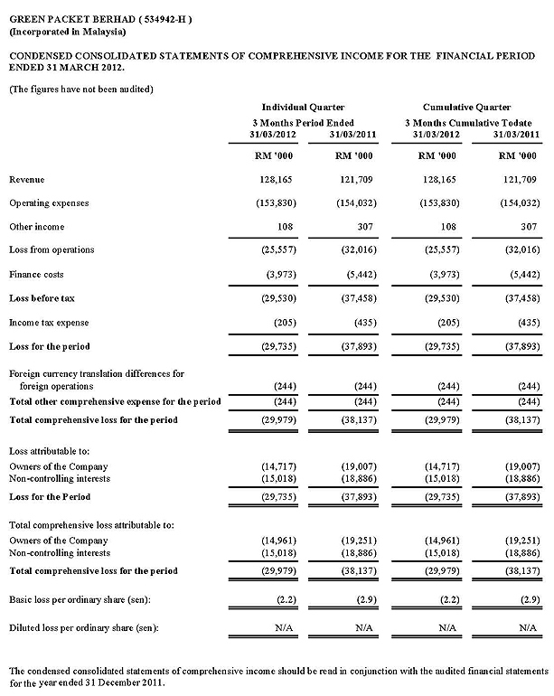
About Green Packet Berhad :
Listed on the Main Board of the Malaysian Bourse, Green Packet Berhad (“The Group”) aims to be the visionary global leader providing best connectivity to enrich lives. It provides best-of-class technologies, devices and services to simplify and enhance connectivity and communications. The Group offers a wide array of 4G and LTE products and services through its two main business pillars:
The Greenpacket Solutions pillar
Greenpacket Solutions provides 4G WiMAX global services, discounted and wholesale voice services are via its Alternative Voice Services group.
The P1 pillar
Packet One Networks (Malaysia) Sdn Bhd serves as the 4G operator and service provider arm, comprising of other companies or subsidiaries.

