Low mail-order Rx utilization

Problem
- Only 1% of medications for chronic conditions went through mail-order pharmacy for this group

Solution
- Through zConnect, we ran a communication campaign to encourage members to utilize mail-order pharmacy

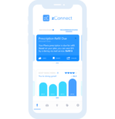

Impact
- 40% of medications for chronic conditions went through mail-order pharmacy after the campaign was sent out

