Visual storytelling of data helps a large supermarket client with strategic decisions

Problem
- The employees belong to a low-income group and the healthcare costs are rising by the year
- The employer is unable to understand the cost drivers
- They are finding it difficult to reach out to the members with directed actions

Solution
- The visual dashboard of zAnalytics told a clear story of the cost drivers and pain-points
- Dynamic reporting highlighted the main problems with this group including high ED utilization etc.
- The Track section showed data drilled down to member-level to understand engagement metrics

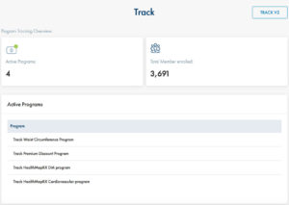

Impact
Strategies were put in place to decrease ED utilization and also evaluate the member outreach platform to keep members engaged
- The employer was able to set a clear strategy for the condition management program in place and also for future programs.
- The employer is evaluating zConnect to communicate with the employees regarding actions and steps that can be taken to better their health. Since the employees are away from their computers because of the nature of their work, it is not easy for the employer to engage with them. Using zConnect, the employer believes that it will help them reach out to their population and keep them engaged.

