zAnalytics insights transforms TPA offerings

Problem
- Bringing diverse datasets from multiple sources was challenging
- Reporting lacked direction and tangible action opportunities

Solution
- Visual dashboard tells a compelling story about where to focus
- Reporting includes decision-support for opportunities and action

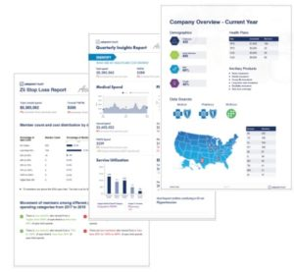

Impact
Client retention and growth achieved through specific, data-driven policy and program optimization:
- Leverage our visual and actionable dashboard to support benefit consultants and employers to identify 10-15% worth of cost containment, empowering their account execs
- Support care management by bringing predictive risks and all member level financial, utilization, condition risk and response data in one place. By identifying 25% more high risk members, and reducing the call time by 15 minutes, they are able to deliver better risk and cost containment
- Our member centric recommendation, notification and communication tool is helping employers, benefit consultants and the TPA to turn insights into member actions that are tracked. Eg., for one employer, 67% of identified members closed one or more gaps in care
- AI Chat bot has the potential to reduce 50% – 70% of the calls to the TPA, generating immediate value and improved member experience and opportunity to re-direct members pro-actively to better places of care

