Subject: On-Demand Access to the Angst Documentary and Discussion
Dear (Colleagues / Employees / Partners),

Following the successful and well-attended screening of Angst on Day, Date at XX:XX AM/PM, we are delighted to make both the film and the expert panel discussion featuring (insert names) / testimonial led by (insert names) available to all employees to have the opportunity to view if they missed the live screening, re-watch, and watch at home with family or friends.

Angst will be available to watch from now until (insert date) and can be accessed on any device by clicking on this link (insert link)
The documentary lasts for 43 / 56 minutes, and the 45 minute discussion follows immediately afterwards

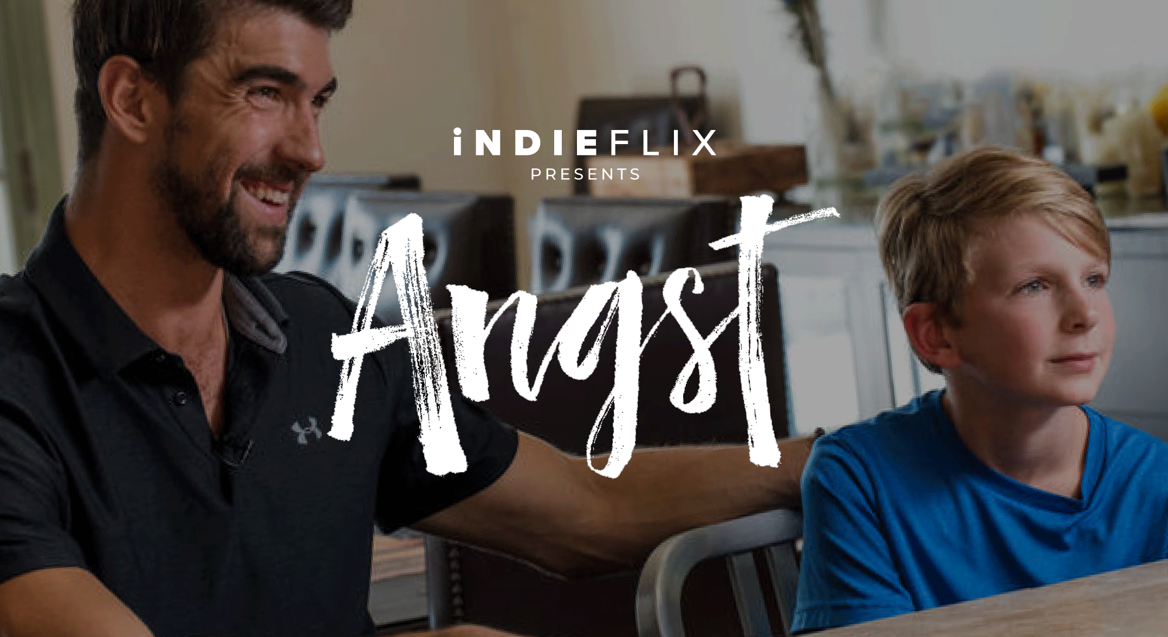

Angst covers all aspects of anxiety, how to deal with its symptoms and support others who suffer from it. Angst features World Champion Swimmer Michael Phelps, experts in the field, and regular teenagers, who provide a candid but optimistic view of this most common (but 100% treatable) disorder. It is as relevant to us as adults as it is to our teenage children, has been screened multiple times within corporations such as Microsoft and HPE, and is well worth your time.

“Angst had a huge ripple down effect…it has probably saved a couple of lives within our organization as it got people to reach out and start talking”
Allison Stark: Manager, Global Wellness, Hewlett Packard Enterprise

“In a media landscape becoming increasingly filled with conversations about mental health, iNDIEFLIX’s educational programming is the gold standard of content that actually changes lives. iNDIEFLIX’s programs set the bar for how mental health content can truly help people — their films tell critical stories and share transformative knowledge, allowing people to feel less alone and more powerful”
Jesse Israel, Founder, The Big Quiet

