Subject: Join Us For a Screening of the Documentary Angst
Dear (Colleagues / Employees / Partners),

Join us for a...

Screening of the Documentary
Angst, Raising Awareness around Anxiety

Day, Date at XX:XX AM/PM
at (Registration Link)
Film plus discussion will last 1 hour, 40 minutes

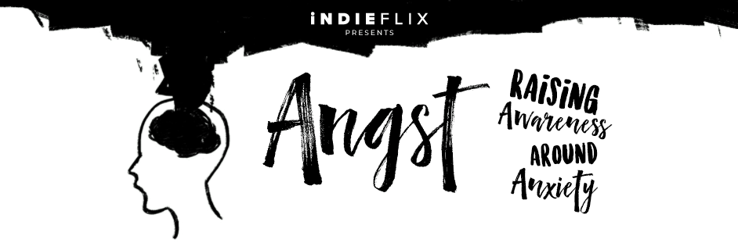

This short documentary covers all aspects of anxiety, how to deal with its symptoms and support others who suffer from it. Angst features World Champion Swimmer Michael Phelps, experts in the field, and regular teenagers, who provide a candid but optimistic view of this most common (but 100% treatable) disorder. It is as relevant to us as adults as it is to our teenage children, has been screened to multiple times within corporations such as Microsoft and HPE, and is well worth your time.

Please join us! The film and following conversation can be accessed confidentially via any device that you choose.

The live screening will be followed by a 45-minute expert panel discussion and Q&A, moderated by insert name(s)

OR: This live screening will be followed by a personal testimonial from insert name(s)

Register to join us here: (registration link)

“Angst helped us start the conversation so people were normalizing that all of us go through different issues and problems, so how do we talk about it, how do we get help?” Julie Krause, Benefits Manager, Microsoft Global Wellness

“iNDIFLIX promotes public health by enlightening viewers about complicated emotional topics which are usually associated with fear, silence and stigma. Addressing societal problems like anxiety, social media, bullying and race, we learn about real people who grapple with challenges and overcome them. iNDIFLIX provides education and inspiration and encourages all of us to improve our own and others’ emotional well-being.” Laura Kastner, Ph.D., Clinical Professor Psychiatry and Behavioral Sciences, University of Washington

